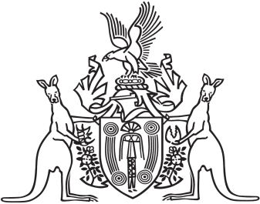
Northern Territory of Australia

Government Gazette
ISSN-0157-833X
No. S112 20 December 2018
Northern Territory of Australia

Professional Standards Act
Notification
The Australian Computer Society Professional Standards Scheme
I, Natasha Kate Fyles, Attorney-General and Minister for Justice, under section 13(1) of the Professional Standards Act and with reference to section 14(1)(a) of the Act, give notice that:
(a) a scheme entitled "The Australian Computer Society Professional Standards Scheme" has been approved by the Professional Standards Council constituted under section 39 of the Professional Standards Act 1994 (NSW) (the Council); and
(b) the scheme commences on 1 January 2019; and
(c) copies of the scheme are available from the Council at Level 2 St James Centre, 111 Elizabeth Street, Sydney NSW 2000 and the Council's Website at www.psc.gov.au.
Dated 20 December 2018
N. K. Fyles
Attorney-General and Minister for Justice

