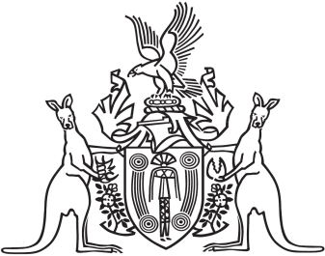
Northern Territory of Australia

Government Gazette
ISSN-0157-833X
No. S60 1 August 2018
Northern Territory of Australia

Interpretation Act
Notification of Making of By-Laws
Under Local Government Act
I, Gerald Francis McCarthy, Minister for Housing and Community Development, under section 63(3) of the Interpretation Act, give notice that the Tiwi Islands Regional Council has made the following by-laws under section 188(1) of the Local Government Act:
Subordinate Legislation No. 22 of 2018: |  | Tiwi Islands Regional By-laws 2018
Copies of the by-laws may be purchased from the Print Management Unit, Department of Corporate and Information Services, Level 10, Charles Darwin Centre, 19 The Mall, Darwin (email pmu.ntg@nt.gov.au or phone (08) 8999 6727).
Dated 30 July 2018
G. F. McCarthy
Minister for Housing and Community Development

