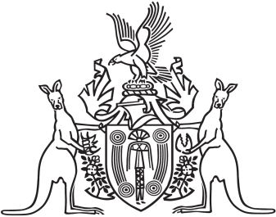
Northern Territory of Australia

Government Gazette
ISSN-0157-833X
No. S32 16 June 2017
Northern Territory of Australia

Local Government Act
Coomalie Shire and Tiwi Islands Region
Wards
I, Gerald Francis McCarthy, Minister for Housing and Community Development, under section 9(2) of the Local Government Act and with reference to section 9(1)(f) to (i) of the Act:
(a) for the Coomalie Shire;
(i) abolish the existing wards and create 3 wards; and
(ii) assign to those wards the names of Adelaide River Ward, Batchelor Township Ward and Coomalie Rural Ward; and
(iii) define the boundaries of those wards to be as shown on Plan S2017/069 kept at the office of the Surveyor-General; and
(iv) determine that 2 members are to be elected for each ward; and
(b) for the Tiwi Islands Region;
(i) abolish Nguiu and Wurankuwu Wards and create 1 ward; and
(ii) assign the name of Bathurst Island Ward to that ward; and
(iii) define the boundary of that ward to be as shown on Plan S2017/068 kept at the office of the Surveyor-General; and
(iv) determine that 6 members are to be elected for that ward; and
(c) make these changes for the purpose of conducting the next general election to be held for the Coomalie Shire and Tiwi Islands Region and determining the composition of each Council after that election.
Dated 16 June 2017
G. F. McCarthy
Minister for Housing and Community Development
Note
Compiled Plans S2017/68 and S2017/69 may be inspected at the Office of the Surveyor-General, Level 1, Arnhemica House, 16 Parap Road, Parap NT 0820.

