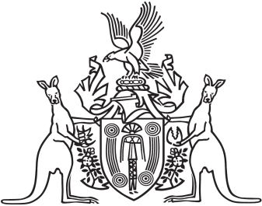
Northern Territory of Australia

Government Gazette
ISSN-0157-833X
No. S7 14 March 2017
Northern Territory of Australia

Interpretation Act
Determination of Exercise of Power by Administrator
I, John Laurence Hardy, Administrator of the Northern Territory of Australia, acting with the advice of the Executive Council, under section 34(2)(b) of the Interpretation Act, determine the Administrator's power to accept the resignation of a person appointed under an Act to be a power that may be exercised without reference to the Executive Council.
Dated 13 March 2017
J. L. Hardy
Administrator
By His Honour's Command
N. K. Fyles
Attorney-General and Minister for Justice

