

Northern Territory of Australia

Government Gazette

ISSN-0157-8324

No. G45 9 November 2016

**Christmas/New Year publication**

# The last General Gazette for 2016 will be published on Wednesday 21 December.

The first General Gazette for 2017 will be published on Wednesday 4 January.

Urgent publication of a Gazette notice required between Thursday 22 December 2016 and Tuesday 3 January 2017 can be arranged by following the usual procedures.

**Please note General and Special Gazettes will not be published on Public Holidays**.

# General information

The Gazette is published by the Office of the Parliamentary Counsel.

The Gazette will be published every **Wednesday**, with the closing date for notices being the previous Friday at 4.00 pm.

Notices not received by the closing time will be held over until the next issue.

Notices will not be published unless a Gazette notice request form together with a copy of the signed notice and a clean copy of the notice in Word or PDF is emailed to [gazettes@nt.gov.au](mailto:gazettes@nt.gov.au)

Notices will be published in the next issue, unless urgent publication is requested.

# Availability

The Gazette will be available online at 12 Noon on the day of publication at <http://www.nt.gov.au/ntg/gazette.shtml>

Unauthorised versions of Northern Territory Acts and Subordinate legislation are available online at <http://www.legislation.nt.gov.au>

Northern Territory of Australia

*Education Act*

**Change of Name of Government School**

I, Eva Dina Lawler, Minister for Education, under section 15(5)(c) of the *Education Act*, change the name of the Government school known as "Palmerston Special School" to "Forrest Parade School".

Dated 25 October 2016

E. D. Lawler

Minister for Education

***Legal Profession Act 2006***

1. The Law Society Northern Territory pursuant to section 375(2) of the *Legal Profession Act* 2006 (the Act) exempts Hieu Nguyen from compliance with the section 376 of the Act and Regulations.
2. Pursuant to section 375(2) of the Act, the period of exemption shall be from **4.00pm on 26 October 2016 to 4.00pm on 30 June 2017**, unless the instrument is earlier terminated by the Law Society Northern Territory.
3. This exemption is subject to the following conditions:
4. This exemption is limited to the activities of Hieu Nguyen whilst acting within his role as an employee of Territory Generation.

Dated this 28th day of October 2016

Ms Kellie Anne Grainger

Executed by the Acting CEO

Pursuant to a delegation from the Law Society Northern Territory under section 647 of the Act

**Northern Territory of Australia**

# *Geothermal Energy Act*

**Reservation of Blocks – GRO 6**

I, Debby Anne James, the Director Petroleum Tenure, as the delegate of the Minister for Primary Industry and Resources, in pursuance of section 6(1) of the *Geothermal Energy Act*, reserve each block within the area, shown bounded by a black line on the plan in the Schedule, from exploration for, or the extraction or production of, geothermal energy resources or geothermal energy.

Dated 1 November 2016

D. A. James

Director Petroleum Tenure

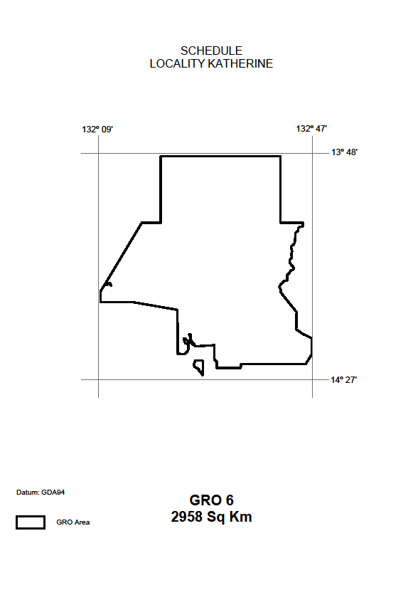

**Northern Territory of Australia**

# *Petroleum Act*

**Reservation of Blocks – RB 67**

I, Debby Anne James, the Director Petroleum Tenure, as the delegate of the Minister for Primary Industry and Resources, in pursuance of section 9(1) of the *Petroleum Act*, declare that the blocks within the area, shown on the plan in the Schedule are not to be the subject of a grant of an exploration permit or licence.

Dated 1 November 2016

D. A. James

Director Petroleum Tenure

**Schedule**

**SD53 Roper River**

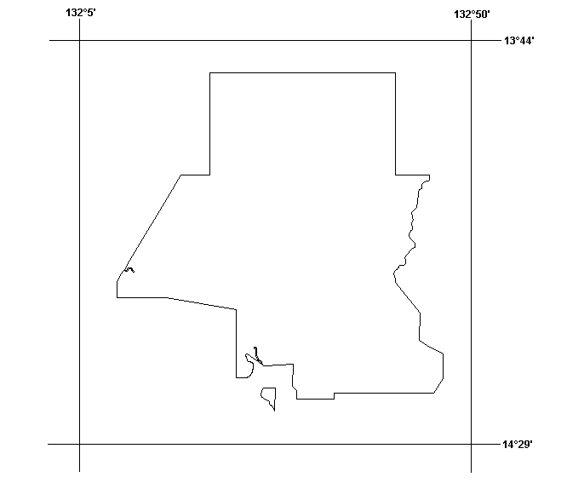

**RB 67**

**2958 Sq. Km**

*Datum: The displayed grid defining the 5’x 5’ blocks is AGD66 and coordinates shown are GDA94*

Northern Territory of Australia

*Mineral Titles Act*

**General Reservation of Land**

**(RL 31387)**

I, Alan Charles Holland, Senior Director Mines/Director Mineral Titles, as the delegate of the Minister for Primary Industry and Resources, under section 113 of the *Mineral Titles Act*:

(a) reserve the land in the Katherine locality that is shown within the thick black lines on the plan in the Schedule from the following activities:

(i) exploration for minerals generally;

(ii) extraction of minerals generally;

(iii) exploration for extractive minerals;

(iv) extraction of extractive minerals; and

(b) give notice that:

(i) the reservation takes effect on the day this notice is published in the *Gazette*; and

(ii) the land specified in paragraph (a) (***general reserved land***) is being reserved to prevent the activities mentioned in paragraph (a) from taking place in Nitmiluk National Park; and

(iii) a person is not entitled to apply for the grant of any mineral title in relation to the general reserved land.

Dated 1 November 2016

A. C. Holland

Senior Director Mines/Director Mineral Titles

Locality Katherine RL 31387


**Notice of Dissolution of Partnership**

Notice is given that the partnership formerly subsisting between Charlie Kathopoulis and Kalotina Kathopoulis as trustees of the N. T. B Family Trust and Pantelis Elenis as trustee of the P. Elenis Family Trust carrying on business of roofing contractors at Berrimah in the Northern Territory under the name of NT Roofing Solutions has been dissolved by mutual consent as from 31 October 2016.

4 November 2016

|  |  |  |
| --- | --- | --- |
| Signed by Charlie Kathopoulis as trustee for the N. T. B. Family Trust in the presence of: | )  )  ) | C. Kathopoulis  Charlie Kathopoulis |
| D. M. Morgan |  |  |
| Witness |  |  |

|  |  |  |
| --- | --- | --- |
| Signed by Kalotina Kathopoulis as trustee for the N T B Family Trust in the presence of: | )  )  ) | K. Kathopoulis  Kalotina Kathopoulis |
| D. M. Morgan |  |  |
| Witness |  |  |

|  |  |  |
| --- | --- | --- |
| Signed by Pantelis Elenis as trustee for the P Elenis Family Trust in the presence of: | )  )  ) | P.Elenis  Pantelis Elenis |
| D. M. Morgan |  |  |
| Witness |  |  |