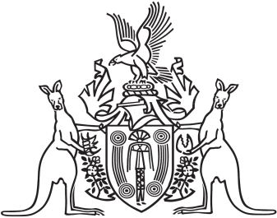
Northern Territory of Australia

Government Gazette
ISSN-0157-833X
No. S107 17 October 2016
Northern Territory of Australia

Menzies School of Health Research Amendment Act 2016
Commencement Notice
I, John Laurence Hardy, Administrator of the Northern Territory of Australia, under section 2 of the Menzies School of Health Research Amendment Act 2016 (No. 18 of 2016), fix the day on which this notice is published in the Gazette as the day on which the Act commences.
Dated 22 September 2016
J. L. Hardy
Administrator

