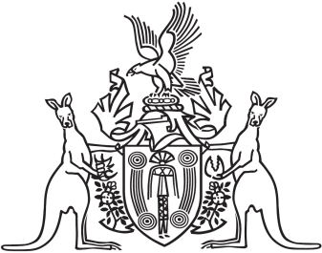

Northern Territory of Australia

Government Gazette

ISSN-0157-833X

No. S40 12 May 2016

Assent To Proposed Laws

His Honour the Administrator assented to the following proposed laws:

10 May 2016

Appropriation Acts Repeal Act 2016 (Act No. 11 of 2016)

Red Tape Reduction (Miscellaneous Amendments) Act 2016 (Act No. 12 of 2016)

Yours sincerely

Michael Tatham

Clerk of the Legislative Assembly