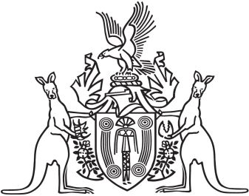
Northern Territory of Australia

Government Gazette
ISSN-0157-833X
No. S34 29 April 2016
Northern Territory of Australia

Local Court (Repeals and Related Amendments) Act 2016
Commencement Notice
I, John Laurence Hardy, Administrator of the Northern Territory of Australia, under section 2 of the Local Court (Repeals and Related Amendments) Act 2016 (No. 9 of 2016), fix 1 May 2016 as the day on which that Act commences.
Dated 21 April 2016
J. L. Hardy
Administrator

