Road Agency Approval Process – Minor Developments
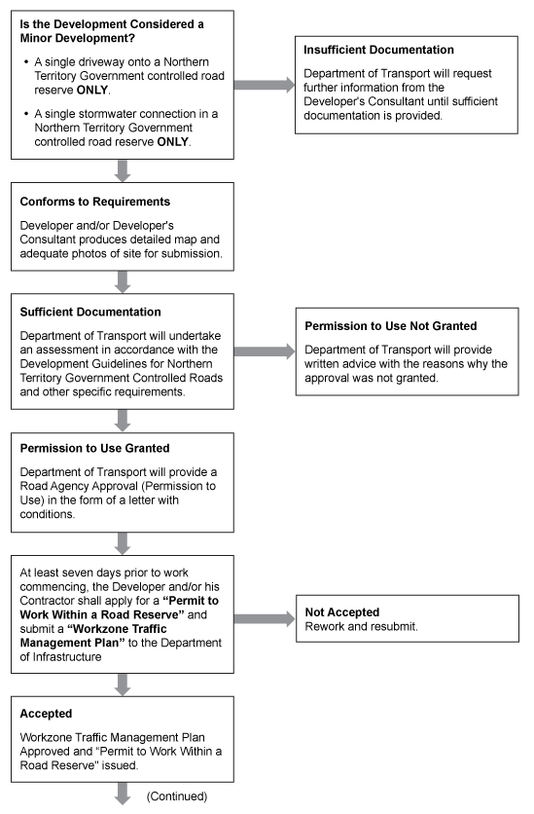
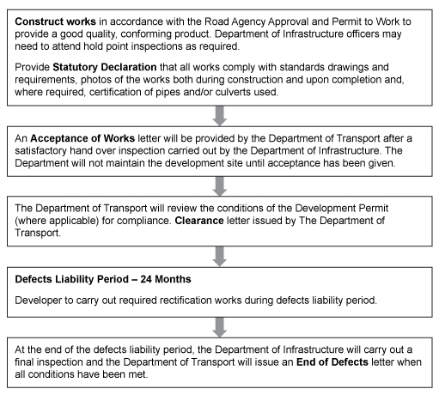

Flowchart steps
- Is the Development Considered a Minor Development?
  - A single driveway onto a Northern Territory Government controlled road reserve ONLY.
  - A single stormwater connection in a Northern Territory Government controlled road reserve ONLY.
OR
1.1 Insufficient Documentation
Department of Transport will request further information from the Developer's Consultant until sufficient documentation is provided.

- Conforms to Requirements
Developer and/or Developer's Consultant produces detailed map and adequate photos of site for submission.

- Sufficient Documentation
Department of Transport will undertake an assessment in accordance with the Development Guidelines for Northern Territory Government Controlled Roads and other specific requirements.

OR
3.1 Permission to Use Not Granted
Department of Transport will provide written advice with the reasons why the approval was not granted.

- Permission to Use Granted
Department of Transport will provide a Road Agency Approval (Permission to Use) in the form of a letter with conditions.

- At least seven days prior to work commencing, the Developer and/or his Contractor shall apply for a “Permit to Work Within a Road Reserve” and submit a “Workzone Traffic Management Plan” to the Department of Infrastructure

OR

5.1 Not Accepted
Rework and resubmit.

- Accepted
Workzone Traffic Management Plan Approved and “Permit to Work Within a Road Reserve" issued.

- Construct works in accordance with the Road Agency Approval and Permit to Work to provide a good quality, conforming product. Department of Infrastructure officers may need to attend hold point inspections as required.

Provide Statutory Declaration that all works comply with standards drawings and requirements, photos of the works both during construction and upon completion and, where required, certification of pipes and/or culverts used.

- An Acceptance of Works letter will be provided by the Department of Transport after a satisfactory hand over inspection carried out by the Department of Infrastructure. The Department will not maintain the development site until acceptance has been given.

- The Department of Transport will review the conditions of the Development Permit (where applicable) for compliance. Clearance letter issued by The Department of Transport.

- Defects Liability Period – 24 Months
Developer to carry out required rectification works during defects liability period.

- At the end of the defects liability period, the Department of Infrastructure will carry out a final inspection and the Department of Transport will issue an End of Defects letter when all conditions have been met.

