Mineral Titles Act 2010
NOTICE OF LAND CEASING TO BE A MINERAL TITLE AREA
Title Type and Number: | Exploration Licence 33331
Area Ceased on: | 02 February 2026
Area: | 246 Blocks, 802.06 km²
Locality: | CORELLA CREEK
Name of Applicant(s)/Holder(s): | 100% BAUDIN RESOURCES PTY LTD [ACN. 618 455 593]
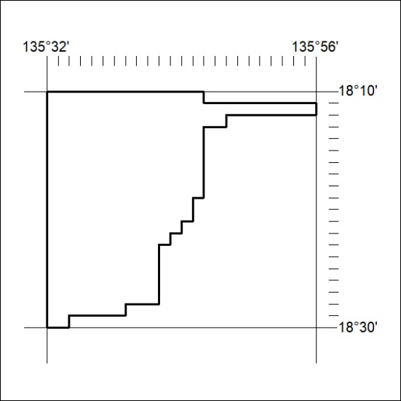

42/26

