Mineral Titles Act 2010
NOTICE OF LAND CEASING TO BE A MINERAL TITLE AREA
Title Type and Number: | Exploration Licence 32290
Area Ceased on: | 22 April 2025
Area: | 13 Blocks, 41.99 km²
Locality: | TENNANT CREEK
Name of Applicant(s)/Holder(s): | 100% BARKLY OPERATIONS PTY LTD [ACN. 641 856 706]
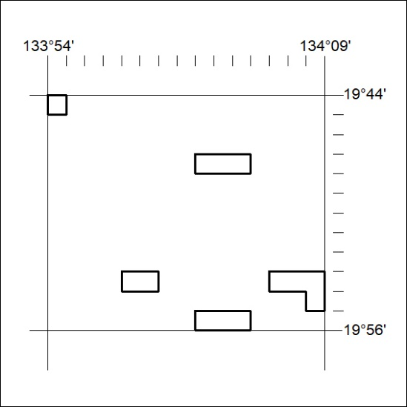

320/25

Mineral Titles Act 2010
NOTICE OF LAND CEASING TO BE A MINERAL TITLE AREA
Title Type and Number: | Exploration Licence 32291
Area Ceased on: | 22 April 2025
Area: | 82 Blocks, 266.04 km²
Locality: | FLYNN
Name of Applicant(s)/Holder(s): | 100% BARKLY OPERATIONS PTY LTD [ACN. 641 856 706]
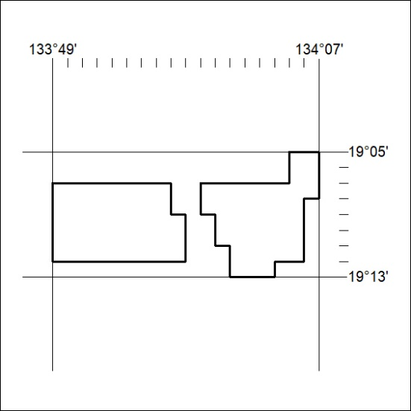

321/25

Mineral Titles Act 2010
NOTICE OF LAND CEASING TO BE A MINERAL TITLE AREA
Title Type and Number: | Exploration Licence 32304
Area Ceased on: | 22 April 2025
Area: | 12 Blocks, 38.75 km²
Locality: | FAVENC
Name of Applicant(s)/Holder(s): | 100% BARKLY OPERATIONS PTY LTD [ACN. 641 856 706]
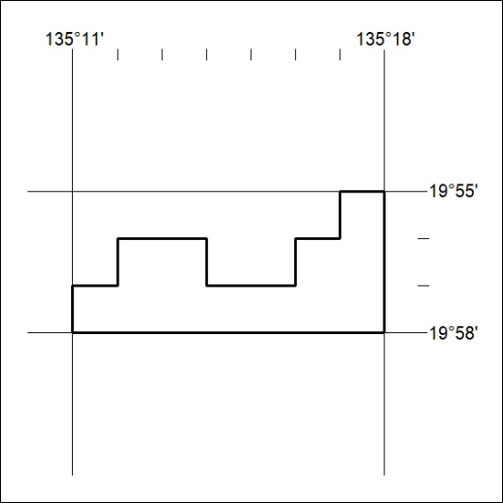

322/25

Mineral Titles Act 2010
NOTICE OF LAND CEASING TO BE A MINERAL TITLE AREA
Title Type and Number: | Exploration Licence 32305
Area Ceased on: | 22 April 2025
Area: | 10 Blocks, 31.58 km²
Locality: | COOLIBAH
Name of Applicant(s)/Holder(s): | 100% BARKLY OPERATIONS PTY LTD [ACN. 641 856 706]
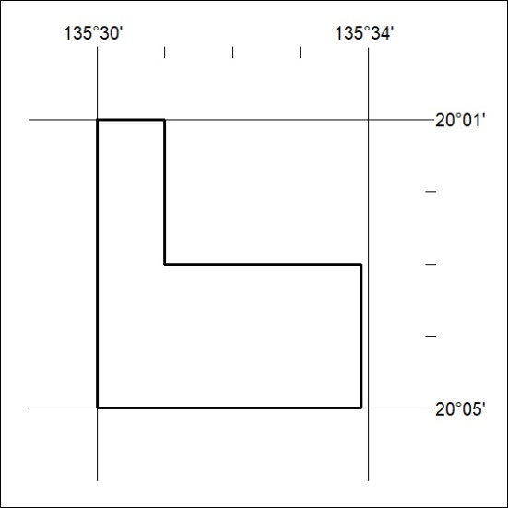

323/25

Mineral Titles Act 2010
NOTICE OF LAND CEASING TO BE A MINERAL TITLE AREA
Title Type and Number: | Exploration Licence 32496
Area Ceased on: | 22 May 2025
Area: | 143 Blocks, 463.29 km²
Locality: | LULU
Name of Applicant(s)/Holder(s): | 100% BREMA RESOURCES PTY LTD [ACN. 643 480 693]
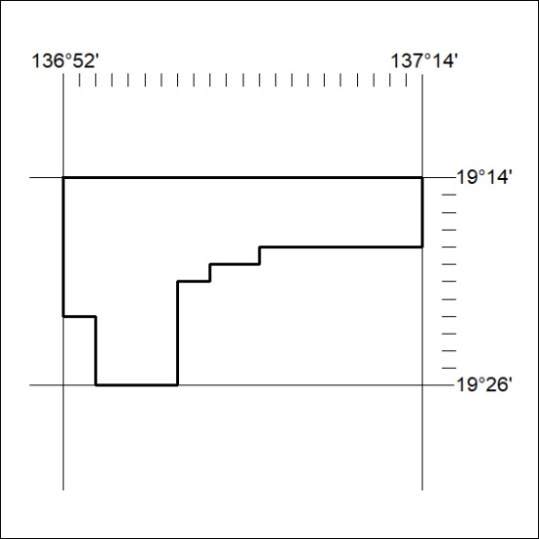

324/25

Mineral Titles Act 2010
NOTICE OF LAND CEASING TO BE A MINERAL TITLE AREA
Title Type and Number: | Exploration Licence 33595
Area Ceased on: | 19 May 2025
Area: | 80 Blocks, 253.11 km²
Locality: | ALCOOTA
Name of Applicant(s)/Holder(s): | 100% PURE EXPLORATION PTY LTD [ACN. 669 443 636]
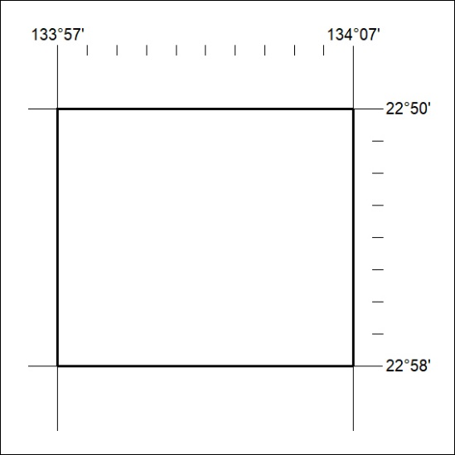

325/25

