Mineral Titles Act
NOTICE OF GRANT OF A MINERAL TITLE
Title Type and Number: | Exploration Licence 34006
Granted: | 01 May 2025, for a period of 6 Years
Area: | 31 Blocks, 92.85 km²
Locality: | WINGATE MOUNTAINS
Name of Holder/s: | 100% LITHIUM PLUS MINERALS LTD [ACN. 653 574 219]
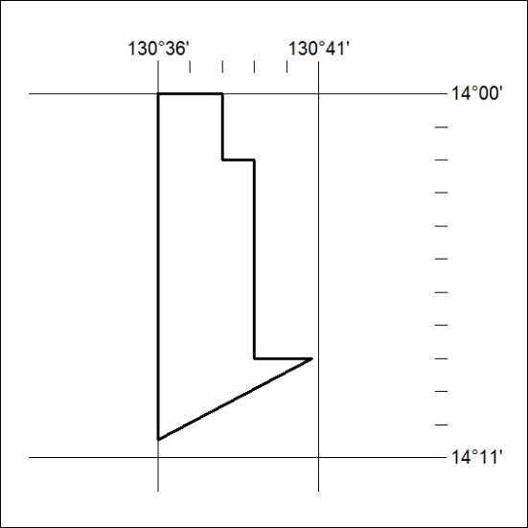
Area granted is indicated above. The titleholder is not permitted to exercise occupational rights on any land that is subject to a development title, or an application for a development title. Any land the subject of a Reserved Land gazettal under the Mineral Titles Act and all land vested in the Commonwealth of Australia is also excluded by description but not excised from the grant area.
294/25

Mineral Titles Act
NOTICE OF GRANT OF A MINERAL TITLE
Title Type and Number: | Exploration Licence 34007
Granted: | 01 May 2025, for a period of 6 Years
Area: | 66 Blocks, 199.08 km²
Locality: | MOYLE
Name of Holder/s: | 100% LITHIUM PLUS MINERALS LTD [ACN. 653 574 219]
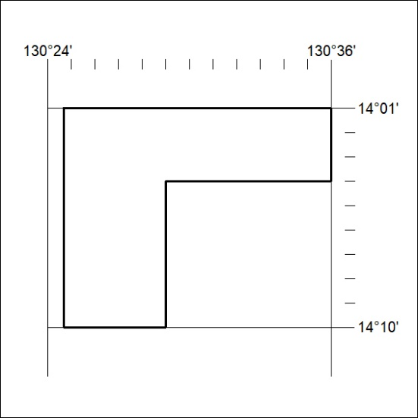
Area granted is indicated above. The titleholder is not permitted to exercise occupational rights on any land that is subject to a development title, or an application for a development title. Any land the subject of a Reserved Land gazettal under the Mineral Titles Act and all land vested in the Commonwealth of Australia is also excluded by description but not excised from the grant area.
295/25

