Mineral Titles Act 2010
NOTICE OF LAND CEASING TO BE A MINERAL TITLE APPLICATION AREA
Title Type and Number: | Exploration Licence 33889
Area Ceased on: | 28 April 2025
Area: | 194 Blocks, 611.93 km²
Locality: | BURT
Name of Applicant(s)/Holder(s): | 100% LITCHFIELD MINERALS LIMITED* [ACN. 612 660 429]
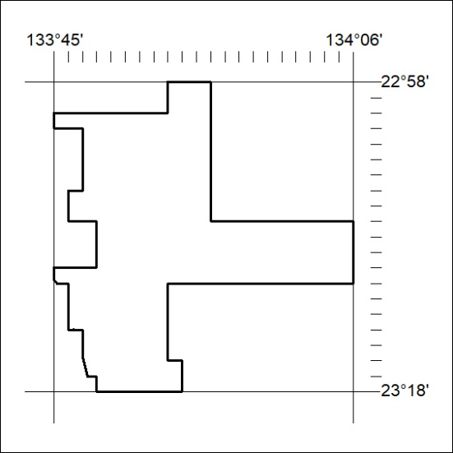

292/25

