Mineral Titles Act 2010
NOTICE OF LAND CEASING TO BE A MINERAL TITLE AREA
Title Type and Number: | Exploration Licence 32292
Area Ceased on: | 23 April 2025
Area: | 7 Blocks, 22.65 km²
Locality: | LIGNUM
Name of Applicant(s)/Holder(s): | 100% BARKLY OPERATIONS PTY LTD [ACN. 641 856 706]
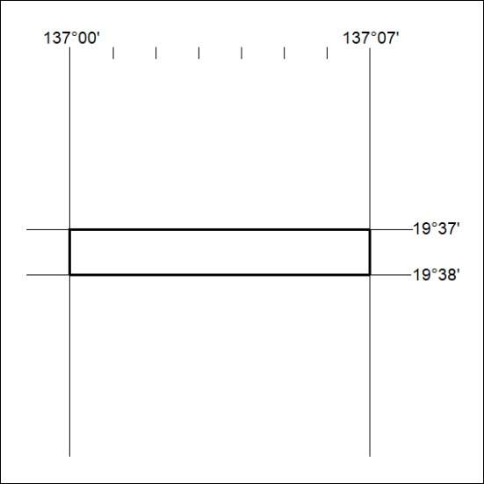

290/25

Mineral Titles Act
NOTICE OF GRANT OF A MINERAL TITLE
Title Type and Number: | Exploration Licence 33888
Granted: | 22 April 2025, for a period of 6 Years
Area: | 245 Blocks, 778.28 km²
Locality: | ALKEA
Name of Holder/s: | 100% LITCHFIELD MINERALS LIMITED* [ACN. 612 660 429]
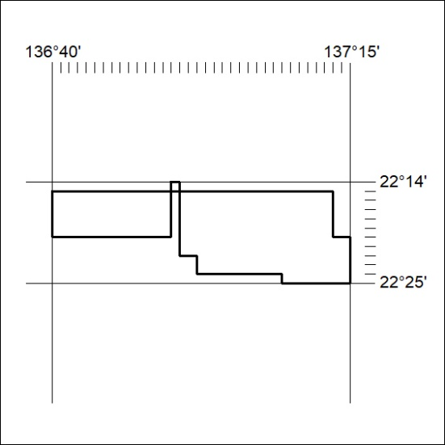
Area granted is indicated above. The titleholder is not permitted to exercise occupational rights on any land that is subject to a development title, or an application for a development title. Any land the subject of a Reserved Land gazettal under the Mineral Titles Act and all land vested in the Commonwealth of Australia is also excluded by description but not excised from the grant area.

291/25

