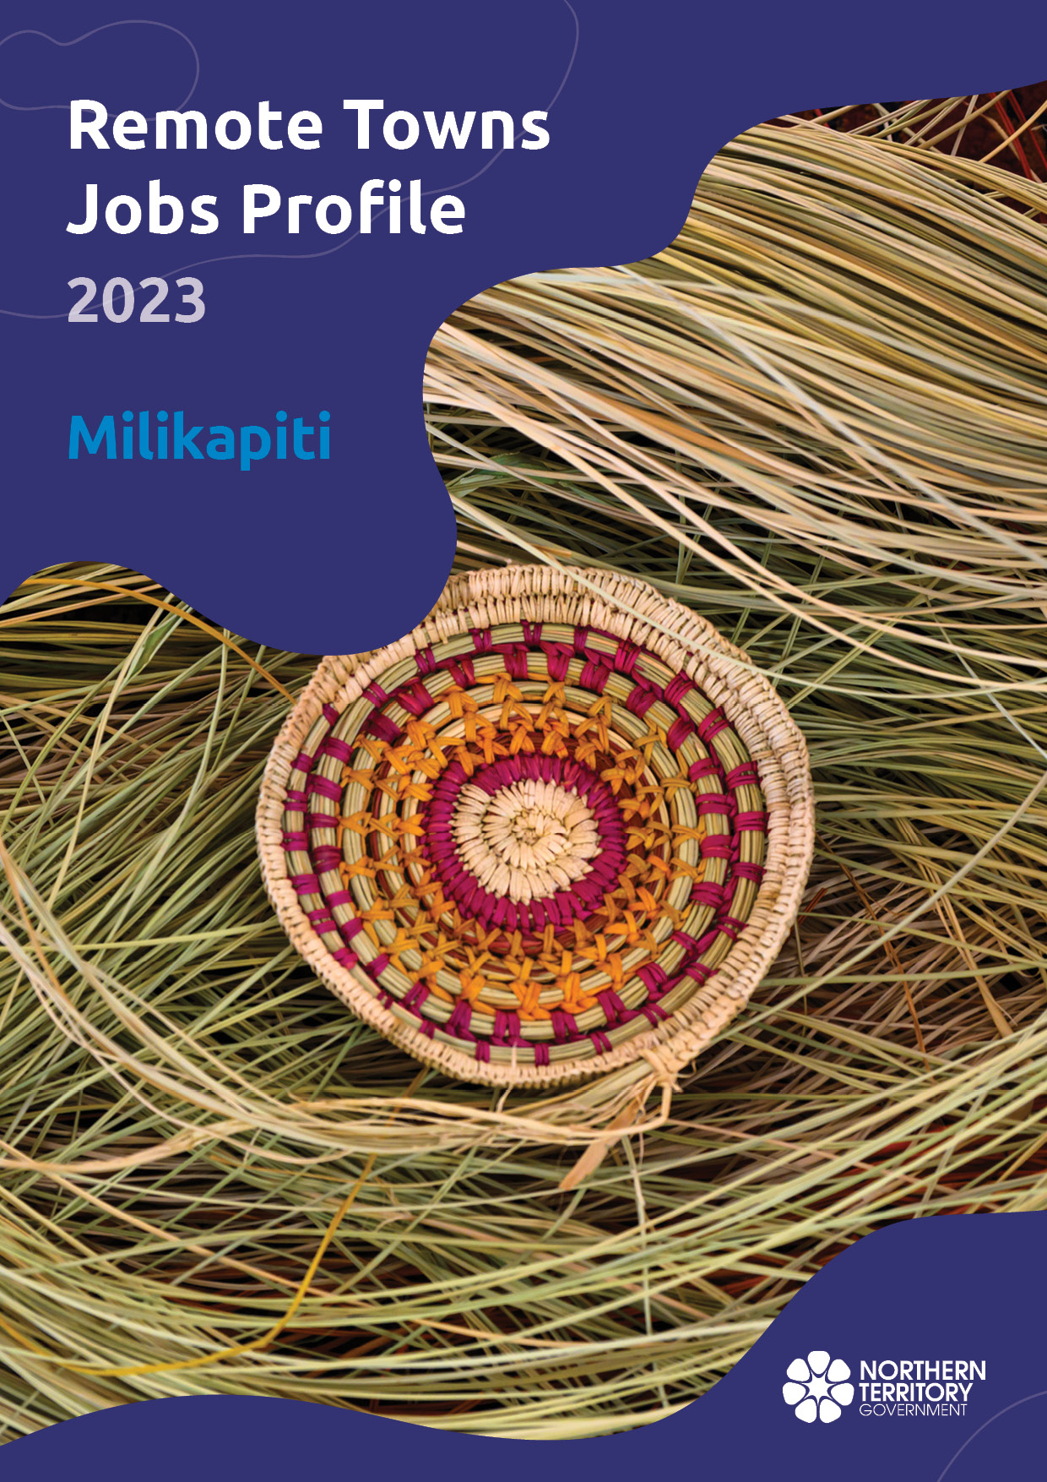?

AP

**© Northern Territory of Australia 2025****referred Reference:** Department of Trade, Business and Asian Relations, 2023

Remote Towns Jobs Profiles, Northern Territory Government, January 2025, Darwin.

**Front cover image:** Weaving materials at Injalak Art Centre, Gunbalanya.

**Disclaimer**

The data in this publication was collected by conducting a survey of businesses located in the 28 remote town boundaries. This body of work was completed in 2023 by the former Northern Territory Department of Industry, Tourism and Trade.

The collection methodology was created in accordance with Australian Bureau of Statistics data quality framework principles. Data in this publication is only reflective of those businesses reported on as operating in the town at the time of data collection (see table at the end of publication for list of businesses reported on). To comply with privacy legislation or where appropriate, some data in this publication may have been adjusted and will not reflect the actual data reported by businesses. As a result of this, combined with certain data not being reported by some businesses, some components may not add to totals. Changes over time may also reflect change in business propensity to report on certain data items rather than actual changes over time. Total figures have generally not been adjusted. Caution is advised when interpreting the comparisons made to the earlier 2011, 2014 and 2017 publications as the businesses identified and reported on and the corresponding jobs may differ between publications. The surveys have not always gathered data on training and jobs in the same years.

**Notes for each table and chart are ordered alphabetically and listed at the end of the publication.**

The Northern Territory of Australia exercised due care and skill to ensure that at the time of publication the information contained in this publication is true and correct. However, it is not intended to be relied on as professional advice or used for commercial purposes. The Territory gives no warranty or assurances as to the accuracy of the information contained in the publication and to the maximum extent permitted by law accepts no direct or indirect liability for reliance on its content.

Any use of this report for commercial purposes is not endorsed by the Department of Trade, Business and Asian Relations.

Contents

Milikapiti 4

Introduction 5

Summary 6

Jobs Overview 7

Jobs filled by Aboriginality 8

Jobs by Sector: Private and Public 10

Job Status: Permanent and Temporary 14

Job Vacancies 16

Jobs by Industry 17

Jobs by Occupation 22

Jobs by Industry by Occupation 25

Jobs by Gender 27

Jobs by Age 30

Vocational Education and Training 34

Population 37

Community Development Program 39

Businesses 40

Notes 41

Abbreviations and Acronyms 42

# Milikapiti

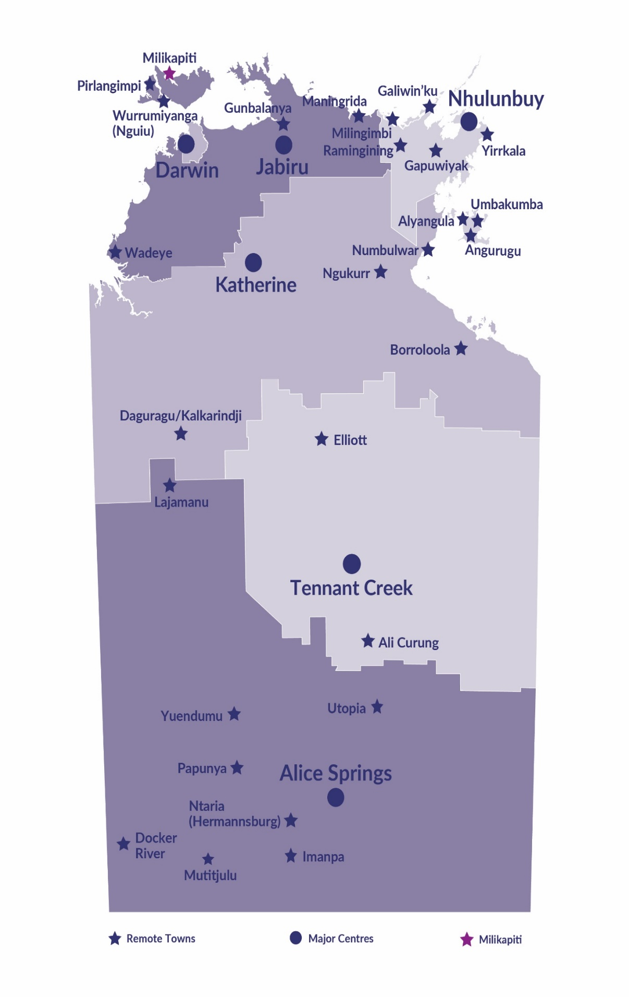Milikapiti is located on Melville Island, which is approximately 100 kilometres north of Darwin, with a population of 418 residents.

*Source: Northern Territory Department of Industry, Tourism and Trade*

# Introduction

This jobs profile provides a snapshot of jobs and the characteristics of job holders in Milikapiti as of September 2023. Trends from the surveys conducted in 2011, 2014, and 2017 are also described. Additionally, it presents data on Community Development Program activity, Population, and Vocational Education and Training.

This job profile is one of 28 profiles developed for remote towns in the Northern Territory. It is anticipated these, and subsequent profiles will contribute to a robust evidence base to inform decision making in and relating to these remote Territory towns.

This profile contains information collected by the Northern Territory Department of Industry, Tourism and Trade from businesses operating within the town and is supplemented by other administrative data sets and information.

Each profile provides up-to-date information that is intended to inform the planning and design of current and future government programs and as an evidence base to inform decision making relating to workforce development, enterprise and job opportunities.

The profile may best be understood as a point-in-time tool. The number of business surveys from which the data was drawn is significantly less than in earlier surveys, and business participation has decreased with each survey. For Milikapiti, 25% fewer businesses than in 2017 are reported here.

The data collection methodology and corresponding questionnaire were created in partnership with the Australian Bureau of Statistics (ABS) and in accordance with ABS data quality framework and survey principles.

The Northern Territory Department of Industry, Tourism and Trades’ Territory Engagement and Delivery, Skills Initiative and VET data teams collaborated with the Northern Institute at Charles Darwin University to facilitate the surveys and reports.

The information collected and reported on represents a significant goodwill investment by those businesses and organisations that participated. Each business is listed at the end of this publication.

# Summary

The 2023 jobs profile was developed based on responses from 9 businesses operating within the Milikapiti town boundary, 3 less than in the 2017 survey. Of these, there were:

* 5 businesses from the Private Sector, with 43 filled jobs or 54% of total filled jobs
* 4 businesses from the Public Sector, with 37 filled jobs or 46% of total filled jobs.

A total of 92 filled and vacant jobs in Milikapiti were reported.[1]

The 2023 profile highlights:

* there were 80 filled jobs of which:
* 58 jobs (73%) were filled by Aboriginal people
* 22 jobs (27%) were filled by non-Aboriginal people
* 39% of employed Aboriginal people are working in the Private Sector
* Aboriginal females made up 74% of total Aboriginal filled jobs
* there were 12 vacant jobs, of which:
* job vacancies as a percentage of jobs was 13%
* job vacancies equate to 1 in 8 jobs
* 10 vacancies were in the Professional and Community and Personal Service Workers and Professionals areas
* Education and Training was the largest industry employer, followed by Accommodation and Food Services with filled jobs of 34 and 17, respectively, in 2023
* Community Services, Health and Education was the largest training activity sector in 2023 with 21 students, followed by Engineering and mining and Building and Construction with 18 and 15 respectively.

The overall population in Milikapiti decreased by 27 people (6.1%) between 2011 and 2021 to 418 people.

In comparison, the overall Northern Territory population increased by 9.7% between 2011 and 2021.

In 2021, the working age population (15 years and over) in Milikapiti was an estimated 315 people compared to 318 in 2011, a decrease by -0.9%.

There were 0.3 jobs in Milikapiti per working age person compared to 0.3 jobs per working age person across the 28 remote towns in the Northern Territory.

# Jobs Overview

Table 1: Count of filled jobs and vacancies, 2017 & 2023 (a)(b)

|  |  |  |  |
| --- | --- | --- | --- |
|  | **2017** | **2023** | **Change 2017-2023** |
| **Total All Jobs** | **126** | **92** | **-34** |
| **Vacancies** | **14** | **12** | **-2** |
| Vacancies as % of Total All Jobs | 11.1% | 13.0% | 1.9 % |
| **Filled Jobs** | **112** | **80** | **-32** |
| Full-time | 63 | 42 | -21 |
| Part-time | 49 | 38 | -11 |

Source: Northern Territory Department of Industry, Tourism and Trade

Chart 1: Count of vacant jobs and filled jobs by full-time/part-time status, 2017 & 2023 (a)(b)

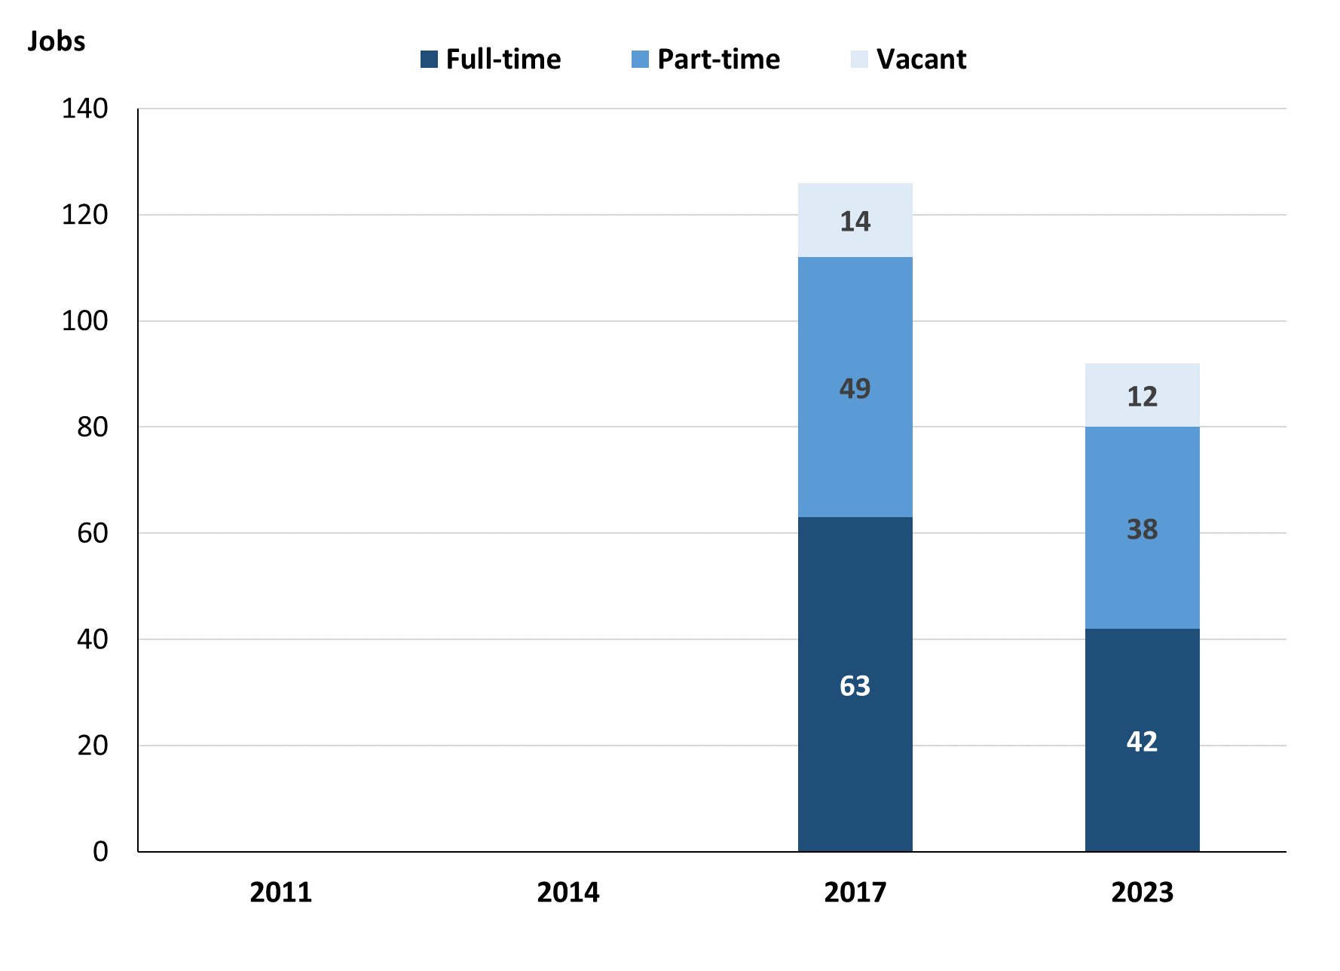

Source: Northern Territory Department of Industry, Tourism and Trade

In 2023 in Milikapiti:

* there was a total of 80 **filled jobs**, a decrease of 32 jobs from 2017
* of the 80 **filled jobs**, there were:
* 42 were **full-time** jobs, a decrease of 21 jobs from 2017
* 38 were **part-time** jobs, a decrease of 11 jobs from 2017
* there were 12 total job **vacancies**, a decrease of 2 vacancies from 2017.

# Jobs filled by Aboriginality

Chart 2: Count of filled jobs by Aboriginality, 2017 & 2023 (a)(c)

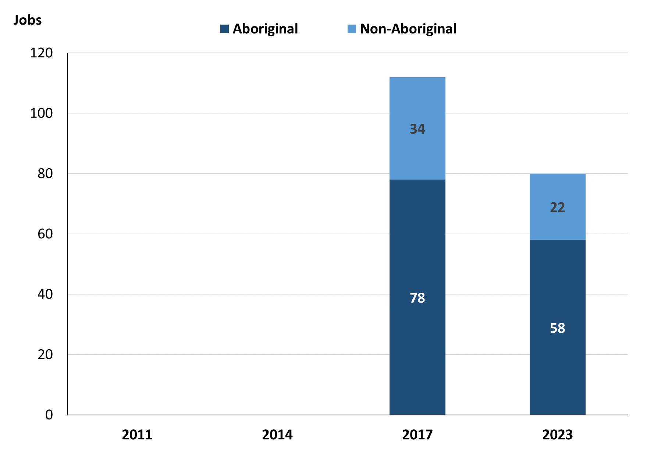

Source: Northern Territory Department of Industry, Tourism and Trade

In 2023 in Milikapiti:

* of the 80 **filled jobs**:
* **Aboriginal** people held 58 jobs, a decrease of 20 jobs from 2017
* **non-Aboriginal** people held 22 jobs, decrease of 12 jobs from 2017
* **Aboriginal** people accounted for 73% of job holders compared to 70% in 2017.

Table 2: Count of filled jobs by full-time/part-time status, 2017 & 2023 (a)(b)(c)

|  |  |  |  |  |  |  |  |  |  |
| --- | --- | --- | --- | --- | --- | --- | --- | --- | --- |
| **Indicator** | **2017** | | | **2023** | | | **Change**  **2017-2023** | | |
| **Aboriginal** | **Non-Aboriginal** | **Total** | **Aboriginal** | **Non-Aboriginal** | **Total** | **Aboriginal** | **Non-Aboriginal** | **Total** |
| Full-time | 31 | 32 | **63** | 23 | 19 | **42** | -8 | -13 | **-21** |
| Part-time | 47 | 2 | **49** | 35 | 3 | **38** | -12 | 1 | **-11** |
| **Total** | **78** | **34** | **112** | **58** | **22** | **80** | **-20** | **-12** | **-32** |

Source: Northern Territory Department of Industry, Tourism and Trade

Chart 3: Count of filled jobs by full-time/part-time status, 2017 & 2023 (a)(b)(c)

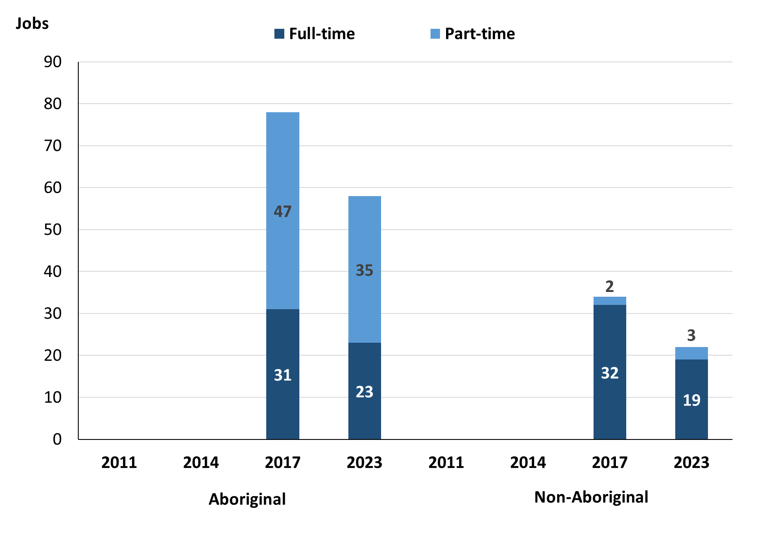

Source: Northern Territory Department of Industry, Tourism and Trade

In 2023 in Milikapiti:

* of the 80 **filled jobs**:
* 23 were **full-time** jobs filled by **Aboriginal** people, a decrease of 8 jobs from 2017
* 35 were **part-time** jobs filled by **Aboriginal** people, a decrease of 12 jobs from 2017
* 19 were **full-time** jobs filled by **non-Aboriginal** people, a decrease of 13 jobs from 2017
* 3 were **part-time** jobs filled by **non-Aboriginal** people, an increase of 1 job from 2017.

# Jobs by Sector: Private and Public

Table 3: Count of filled jobs by sector of business, 2017 & 2023 (a)(c)(d)

|  |  |  |  |  |  |  |  |  |  |  |
| --- | --- | --- | --- | --- | --- | --- | --- | --- | --- | --- |
| **Indicator** | **2017** | | | **2023** | | | **Change**  **2017-2023** | | | |
| **Aboriginal** | **Non-Aboriginal** | **Total** | **Aboriginal** | **Non-Aboriginal** | **Total** | **Aboriginal** | **Non-Aboriginal** | **Total** |
| **Public Sector** | 37 | 14 | **51** | 27 | 10 | **37** | -10 | -4 | **-14** |
| Australian Government | 1 | 0 | **1** | 1 | 0 | **1** | 0 | 0 | **0** |
| Territory Government | 15 | 10 | **25** | 26 | 10 | **36** | 11 | 0 | **11** |
| Local Government | 21 | 4 | **25** | 0 | 0 | **0** | -21 | -4 | **-25** |
| **Private Sector** | 41 | 20 | **61** | 31 | 12 | **43** | -10 | -8 | **-18** |
| **Total** | **78** | **34** | **112** | **58** | **22** | **80** | **-20** | **-12** | **-32** |

Source: Northern Territory Department of Industry, Tourism and Trade

Chart 4: Count of filled jobs by business sector in 2023 (a)(d)

Source: Northern Territory Department of Industry, Tourism and Trade

In 2023 in Milikapiti:

* here were 37 jobs in the **Public Sector**, a decrease of 14 jobs from 2017
* of the 37 jobs in the **Public Sector**:
* 1 job was in the Australian Government, unchanged from 2017
* 36 jobs were in the Territory Government, an increase of 11 jobs from 2017
* none were in the Local Government, a decrease of 25 jobs from 2017
* there were 43 jobs in the **Private Sector**, a decrease of 18 jobs from 2017.

Chart 5: Count of filled jobs by sector of business, 2017 & 2023 (a)(c)(d)

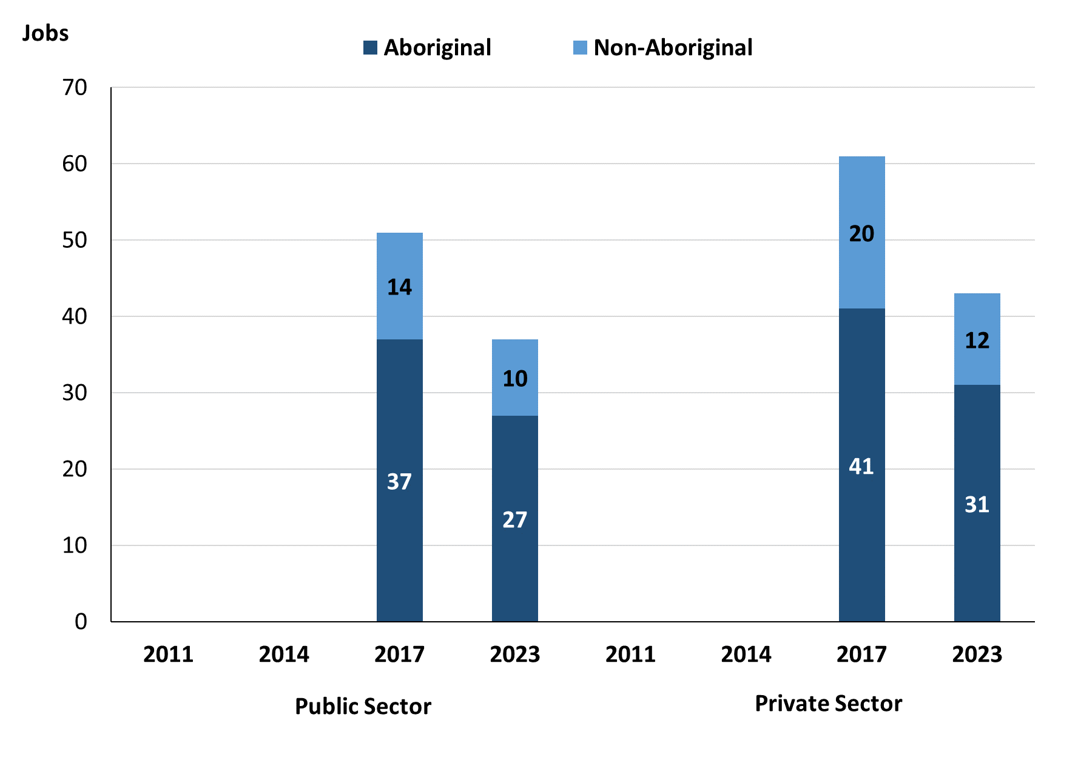

Source: Northern Territory Department of Industry, Tourism and Trade

In 2023 in Milikapiti:

* of the 37 jobs in the **Public Sector**:
* **Aboriginal** people filled 27 jobs, a decrease of 10 jobs from 2017
* **non-Aboriginal** people filled 10 jobs, a decrease of 4 jobs from 2017
* of the 43 jobs in the **Private Sector**:
* **Aboriginal** people filled 31 jobs, a decrease of 10 jobs from 2017
* **non-Aboriginal** people filled 12 jobs, a decrease of 8 jobs from 2017.

Chart 6: Count of filled jobs by sector and full-time/part-time status, 2017 & 2023 (a)(b)(d)

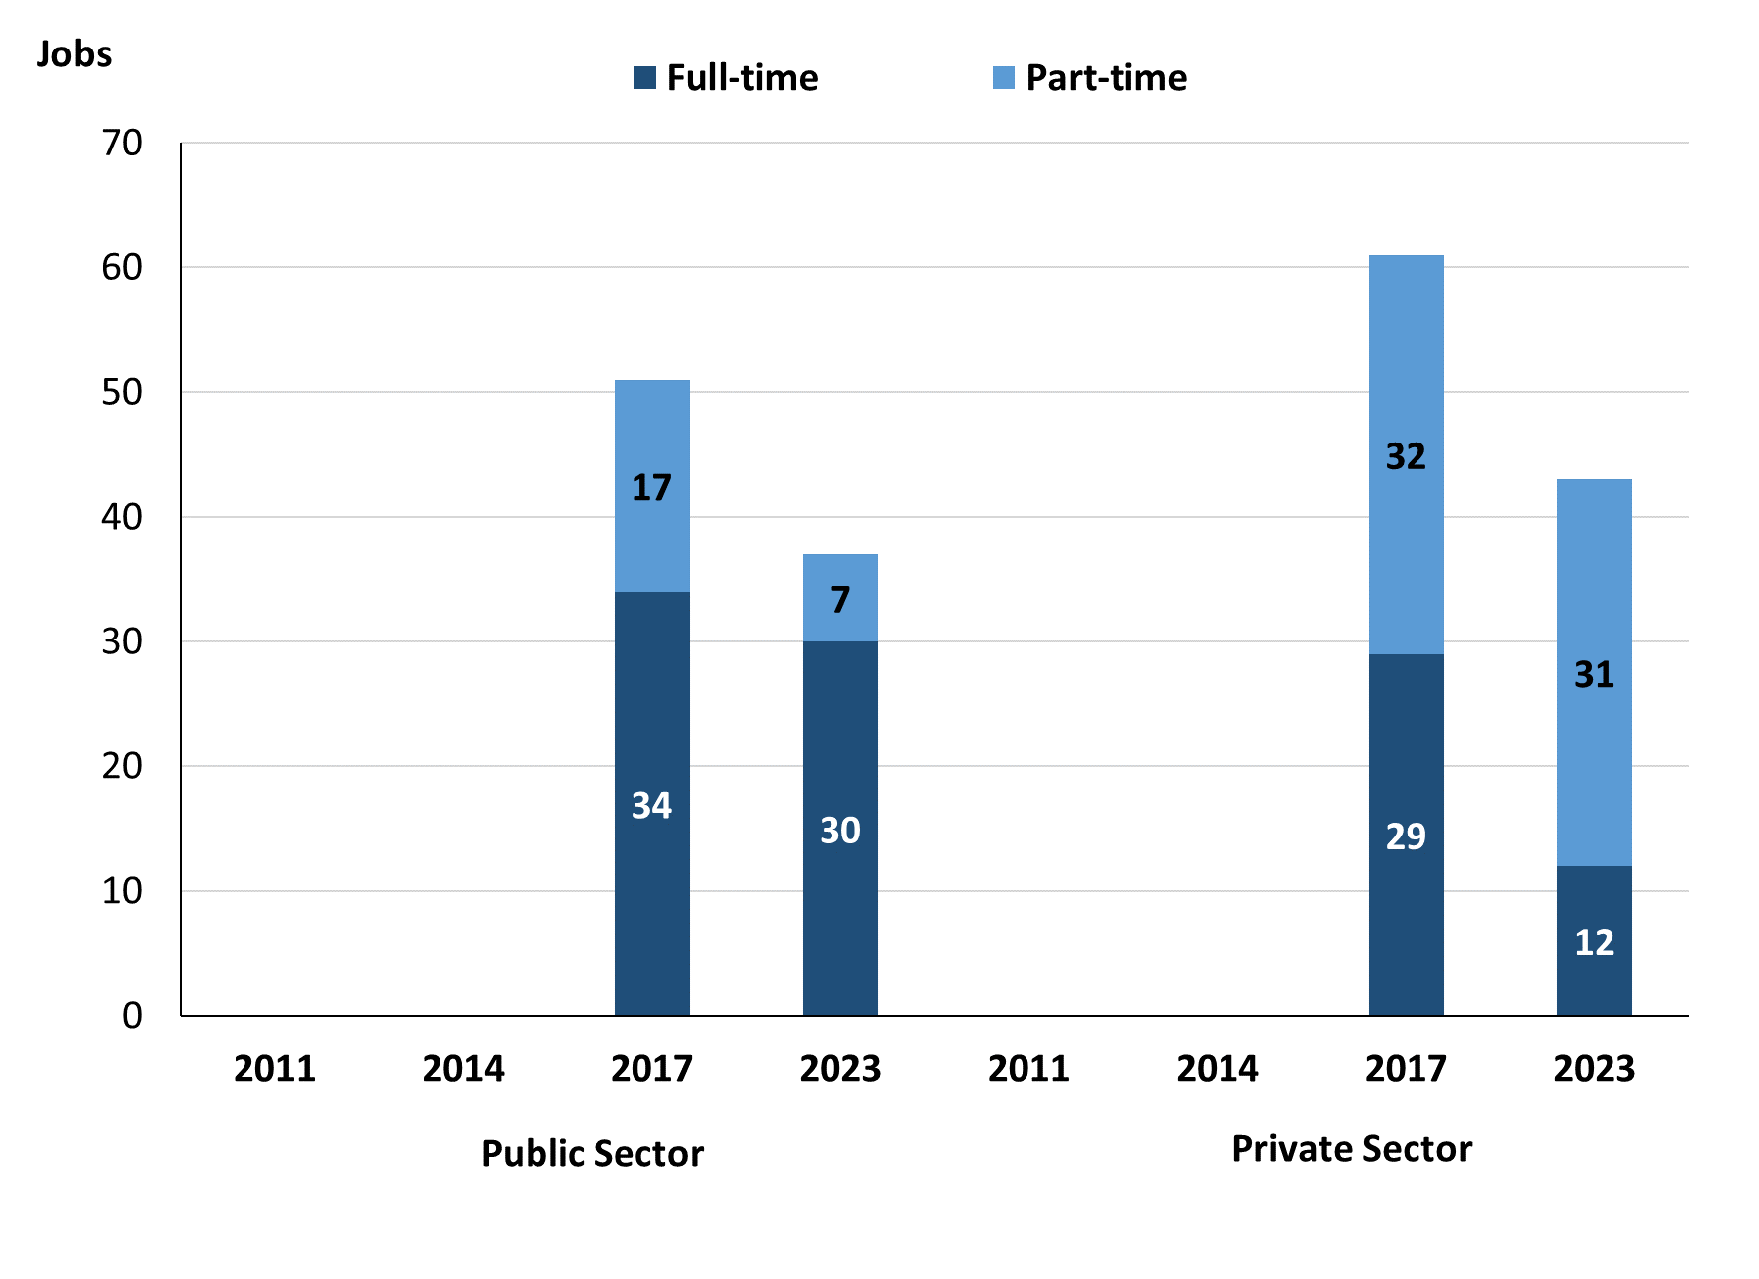

Source: Northern Territory Department of Industry, Tourism and Trade

In 2023 in Milikapiti:

* of the 37 jobs in the **Public Sector**:
* 30 were full-time jobs, a decrease of 4 jobs from 2017
* 7 were part-time jobs, a decrease of 10 jobs from 2017
* of the 43 jobs in the **Private Sector**:
* 12 were full-time jobs, a decrease of 17 jobs from 2017
* 31 were part-time jobs, a decrease of 1 job from 2017.

Table 4: Count of filled jobs by full-time/part-time status by sector, 2017 & 2023 (a)(b)(c)(d)

|  |  |  |  |  |  |  |  |  |  |
| --- | --- | --- | --- | --- | --- | --- | --- | --- | --- |
| **Indicator** | **2017** | | | | | | | | |
| **Aboriginal** | | | **Non-Aboriginal** | | | **Total** | | |
| **Full-time** | **Part-time** | **Total** | **Full-time** | **Part-time** | **Total** | **Full-time** | **Part-time** | **Total** |
| Public Sector | 21 | 16 | **37** | 13 | 1 | **14** | 34 | 17 | **51** |
| Private Sector | 10 | 31 | **41** | 19 | 1 | **20** | 29 | 32 | **61** |
| **Total** | **31** | **47** | **78** | **32** | **2** | **34** | **63** | **49** | **112** |

|  |  |  |  |  |  |  |  |  |  |
| --- | --- | --- | --- | --- | --- | --- | --- | --- | --- |
| **Indicator** | **2023** | | | | | | | | |
| **Aboriginal** | | | **Non-Aboriginal** | | | **Total** | | |
| **Full-time** | **Part-time** | **Total** | **Full-time** | **Part-time** | **Total** | **Full-time** | **Part-time** | **Total** |
| Public Sector | 21 | 6 | **27** | 9 | 1 | **10** | 30 | 7 | **37** |
| Private Sector | 2 | 29 | **31** | 10 | 2 | **12** | 12 | 31 | **43** |
| **Total** | **23** | **35** | **58** | **19** | **3** | **22** | **42** | **38** | **80** |

Source: Northern Territory Department of Industry, Tourism and Trade

In 2023 in Milikapiti there were:

* 27 jobs in the **Public Sector** filled by **Aboriginal** people, a decrease of 10 jobs from 2017, of which:
* 21 were full-time jobs, unchanged from 2017
* 6 were part-time jobs, a decrease of 10 jobs from 2017
* 31 jobs in the **Private Sector** filled by **Aboriginal** people, a decrease of 10 jobs from 2017, of which:
* 2 were full-time jobs, a decrease of 8 jobs from 2017
* 29 were part-time jobs, a decrease of 2 jobs from 2017
* 10 jobs in the **Public Sector** filled by **non-Aboriginal** people, a decrease of 4 jobs from 2017, of which:
* 9 were full-time jobs, a decrease of 4 jobs from 2017
* 1 was a part-time job, unchanged from 2017
* 12 jobs in the **Private Sector** filled by **non-Aboriginal** people, a decrease of 8 jobs from 2017, of which:
* 10 were full-time jobs, a decrease of 9 jobs from 2017
* 2 were part-time jobs, an increase of 1 job from 2017.

# Job Status: Permanent and Temporary

Table 5: Count of filled jobs by employment status, 2017 & 2023 (a)(c)(e)

|  |  |  |  |  |  |  |  |  |  |
| --- | --- | --- | --- | --- | --- | --- | --- | --- | --- |
| **Indicator** | **2017** | | | **2023** | | | **Change**  **2017-2023** | | |
| **Aboriginal** | **Non-Aboriginal** | **Total** | **Aboriginal** | **Non-Aboriginal** | **Total** | **Aboriginal** | **Non-Aboriginal** | **Total** |
| Permanent | 34 | 16 | **50** | 10 | 3 | **13** | -24 | -13 | **-37** |
| Temporary | 44 | 18 | **62** | 48 | 19 | **67** | 4 | 1 | **5** |
| **Total** | **78** | **34** | **112** | **58** | **22** | **80** | **-20** | **-12** | **-32** |

Source: Northern Territory Department of Industry, Tourism and Trade

**Chart 7: Count of filled jobs by employment status, 2017 & 2023 (a)(c)(e)**

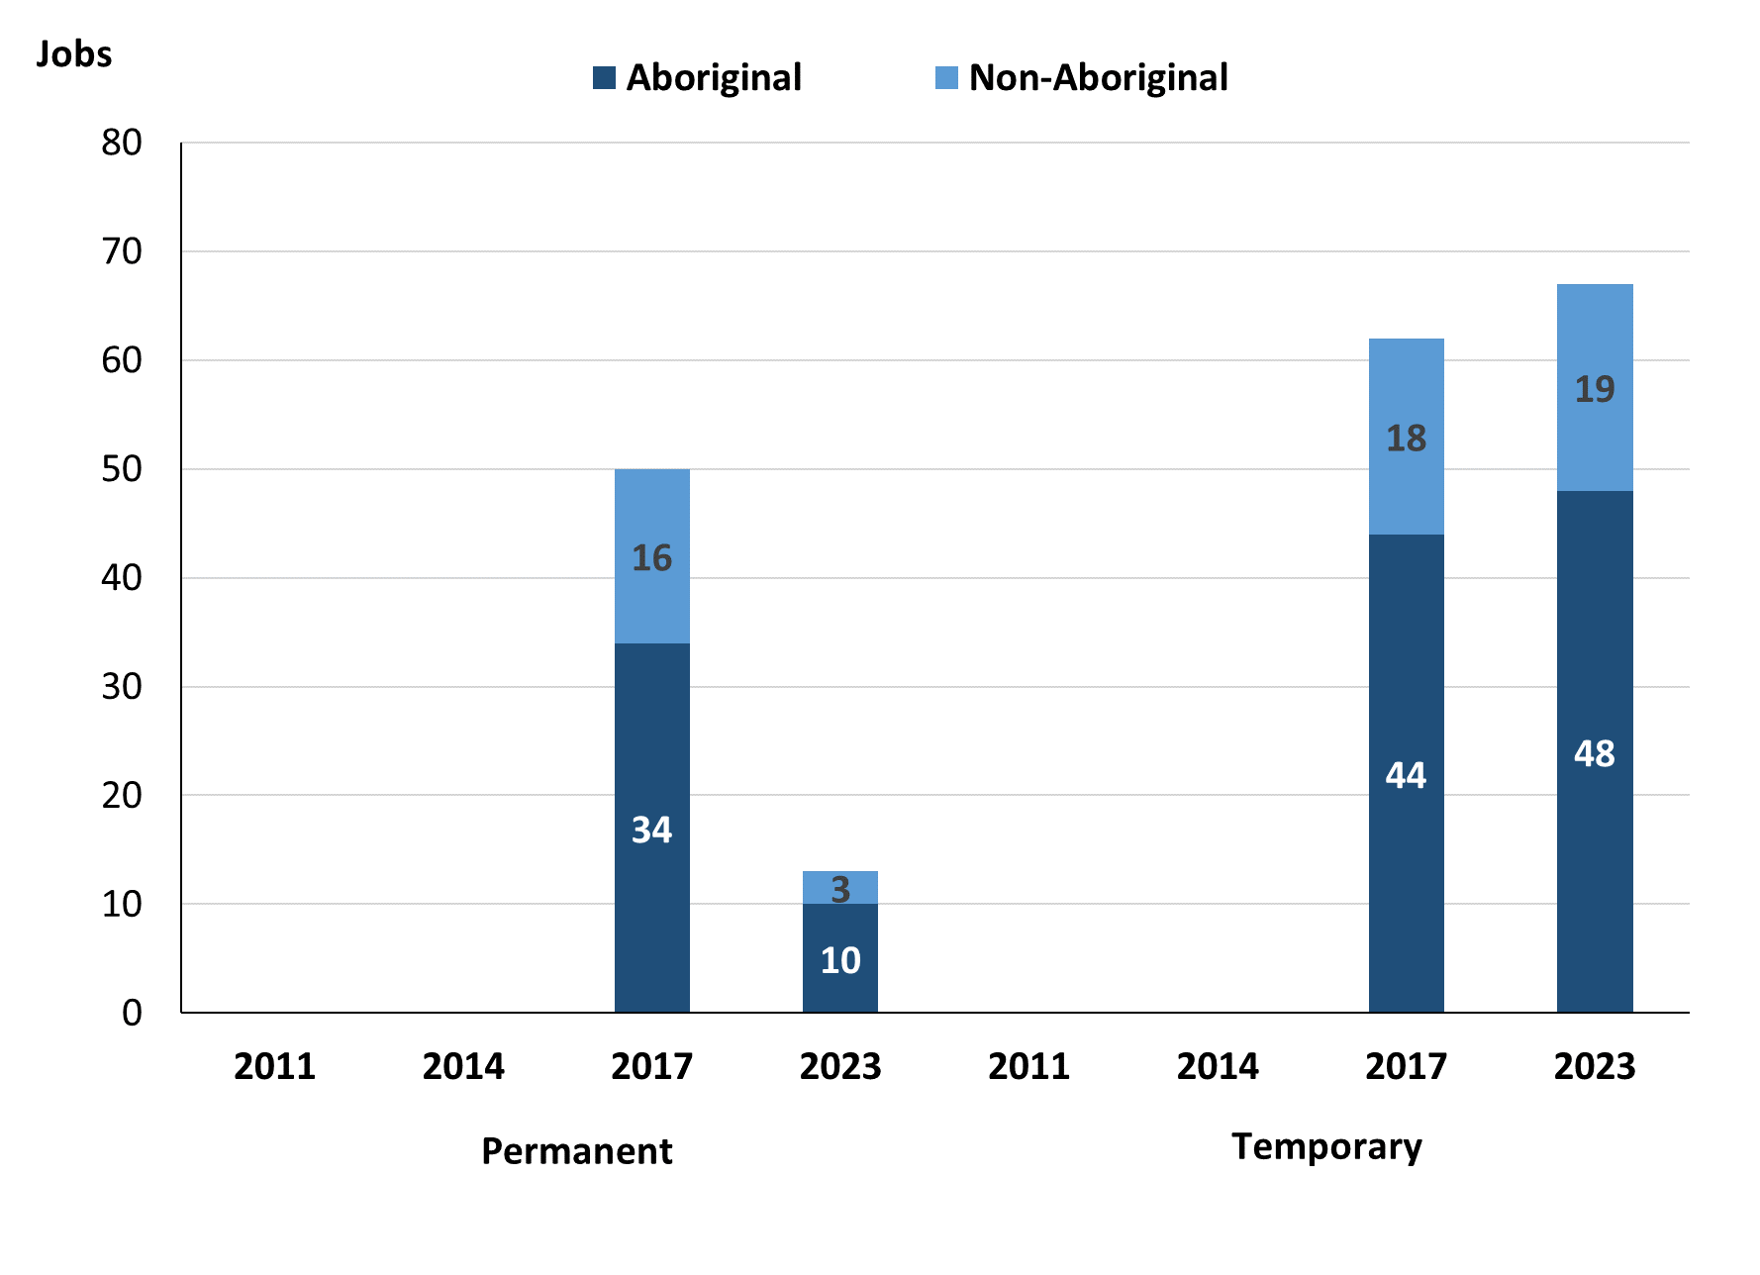

Source: Northern Territory Department of Industry, Tourism and Trade

In 2023 in Milikapiti there were:

* 13 **permanent** jobs, a decrease of 37 jobs from 2017, of which:
* **Aboriginal** people filled 10 jobs, a decrease of 24 jobs from 2017
* **non-Aboriginal** people filled 3 jobs, a decrease of 13 jobs from 2017
* 67 **temporary** jobs, an increase of 5 jobs from 2017, of which:
* **Aboriginal** people filled 48 jobs, an increase of 4 jobs from 2017
* **non-Aboriginal** people filled 19 jobs, an increase of 1 job from 2017.

Table 6: Count of filled jobs by sector and employment status, 2017 & 2023 (a)(c)(d)(e)

|  |  |  |  |  |  |  |  |  |  |
| --- | --- | --- | --- | --- | --- | --- | --- | --- | --- |
| **Indicator** | **2017** | | | | | | | | |
| **Aboriginal** | | | **Non-Aboriginal** | | | **Total** | | |
| **Perm** | **Temp** | **Total** | **Perm** | **Temp** | **Total** | **Perm** | **Temp** | **Total** |
| Public Sector | 28 | 9 | **37** | 6 | 8 | **14** | 34 | 17 | **51** |
| Private Sector | 6 | 35 | **41** | 10 | 10 | **20** | 16 | 45 | **61** |
| **Total** | **34** | **44** | **78** | **16** | **18** | **34** | **50** | **62** | **112** |

|  |  |  |  |  |  |  |  |  |  |
| --- | --- | --- | --- | --- | --- | --- | --- | --- | --- |
| **Indicator** | **2023** | | | | | | | | |
| **Aboriginal** | | | **Non-Aboriginal** | | | **Total** | | |
| **Perm** | **Temp** | **Total** | **Perm** | **Temp** | **Total** | **Perm** | **Temp** | **Total** |
| Public Sector | 9 | 18 | **27** | 2 | 8 | **10** | 11 | 26 | **37** |
| Private Sector | 1 | 30 | **31** | 1 | 11 | **12** | 2 | 41 | **43** |
| **Total** | **10** | **48** | **58** | **3** | **19** | **22** | **13** | **67** | **80** |

Source: Northern Territory Department of Industry, Tourism and Trade

In 2023 in Milikapiti there were:

* 37 jobs in the **Public Sector**, a decrease of 14 jobs from 2017, of which:
* 11 jobs were **permanent,** a decrease of 23 jobs from 2017,
* **Aboriginal** people filled 9 jobs, a decrease of 19 jobs from 2017
* **non-Aboriginal** people filled 2 jobs, a decrease of 4 jobs from 2017
* 26 jobs were **temporary**, an increase of 9 jobs from 2017,
* **Aboriginal** people filled 18 jobs, an increase of 9 jobs from 2017
* **non-Aboriginal** people filled 8 jobs, unchanged from 2017
* 43 jobs in the **Private Sector,** a decrease of 18 jobs from 2017, of which:
* 2 jobs were **permanent,** a decrease of 14 jobs from 2017,
* an **Aboriginal** person filled 1 job, a decrease of 5 jobs from 2017
* a **non-Aboriginal** person filled 1 job, a decrease of 9 jobs from 2017
* 41 jobs were **temporary,** a decrease of 4 jobs from 2017, of which:
* **Aboriginal** people filled 30 jobs, a decrease of 5 jobs from 2017
* **non-Aboriginal** people filled 11 jobs, an increase of 1 job from 2017.

# Job Vacancies

Table 7: Job vacancies, 2017 & 2023

|  |  |  |  |
| --- | --- | --- | --- |
| **Indicator** | **2017** | **2023** | **Change 2017-2023** |
| **Job vacancies** | **14** | **12** | **-2** |

Source: Northern Territory Department of Industry, Tourism and Trade

Table 8: Job vacancies by occupation, 2017 & 2023 (f)(g)

|  |  |  |  |
| --- | --- | --- | --- |
| **Occupation (ANZSCO major group)** | **2017** | **2023** | **Change 2017-2023** |
| Clerical and Administrative Workers | 1 | 1 | 0 |
| Community and Personal Service Workers | 5 | 5 | 0 |
| Labourers | 1 | 0 | -1 |
| Managers | 0 | 0 | 0 |
| Professionals | 6 | 5 | -1 |
| Technicians and Trades Workers | 1 | 1 | 0 |
| **Total** | **14** | **12** | **-2** |

Source: Northern Territory Department of Industry, Tourism and Trade

Table 9: Job vacancies by job title, 2023 profile (f)

|  |  |
| --- | --- |
| **Job Vacancy** | **No.** |
| Classroom Teacher | 5 |
| Food Trade Worker | 1 |
| General Clerk | 1 |
| General Clerk | 1 |
| Police Officer | 2 |
| Teachers’ Aide | 3 |
| **Total** | **12** |

Source: Northern Territory Department of Industry, Tourism and Trade

In 2023 in Milikapiti:

* there were 12 **vacancies** reported, a decrease of 2 vacancies from 2017
* of the 12 reported vacancies, the largest requirements were for:
* 5 Professionals, the majority of which is in the following job:
* Classroom Teacher
* 5 Community and Personal Service Workers, the majority of which is in the following job:
* Police Officer with 2 vacancies
* Teachers’ Aide with 3 vacancies.

# Jobs by Industry

Table 10: Count of filled jobs by industry of business, 2017 & 2023 (a)(h)

|  |  |  |  |  |  |
| --- | --- | --- | --- | --- | --- |
| **Industry (ANZSIC Division)** | **2017** | | **2023** | | **Change 2017-2023** |
| **Total** | **% of Total** | **Total** | **% of Total** | **Total** |
| Accommodation and Food Services | 38 | 33.9% | 17 | 21.3% | -21 |
| Arts and Recreation Services | 8 | 7.1% | 0 | 0.0% | -8 |
| Education and Training | 14 | 12.5% | 34 | 42.5% | 20 |
| Health Care and Social Assistance | 14 | 12.5% | 10 | 12.5% | -4 |
| Public Administration and Safety | 27 | 24.1% | 1 | 1.3% | -26 |
| Retail Trade | 9 | 8.0% | 16 | 20.0% | 7 |
| Transport, Postal and Warehousing | 2 | 1.8% | 1 | 1.3% | -1 |
| Other | 0 | 0.0% | 1 | 1.3% | 1 |
| **Total** | **112** | **100.0%** | **80** | **100.0%** | **-32** |

Source: Northern Territory Department of Industry, Tourism and Trade

In 2023 in Milikapiti:

* the Education and Training industry was the **largest** **industry** **employer**, with 34 filled jobs or 42.5% of filled jobs, an increase of 20 jobs from 2017
* **other** **significant** industry employers were:
* Accommodation and Food Services with 17 jobs (or 21.3% of filled jobs), a decrease of 21 jobs from 2017
* Retail Trade with 16 jobs (or 20.0% of filled jobs), an increase of 7 jobs from 2017
* Health Care and Social Assistance with 10 jobs (or 12.5% of filled jobs), a decrease of 4 jobs from 2017.

Table 11: Count of filled jobs by industry of business, 2017 & 2023 (a)(c)(h)

|  |  |  |  |  |  |  |  |  |  |
| --- | --- | --- | --- | --- | --- | --- | --- | --- | --- |
| **Industry (ANZSIC division)** | **2017** | | | **2023** | | | **Change**  **2017-2023** | | |
| **Aboriginal** | **Non-Aboriginal** | **Total** | **Aboriginal** | **Non-Aboriginal** | **Total** | **Aboriginal** | **Non-Aboriginal** | **Total** |
| Accommodation and Food Services | 23 | 15 | **38** | 12 | 5 | **17** | -11 | -10 | **-21** |
| Arts and Recreation Services | 6 | 2 | **8** | 0 | 0 | **0** | -6 | -2 | **-8** |
| Education and Training | 9 | 5 | **14** | 23 | 11 | **34** | 14 | 6 | **20** |
| Health Care and Social Assistance | 9 | 5 | **14** | 7 | 3 | **10** | -2 | -2 | **-4** |
| Public Administration and Safety | 23 | 4 | **27** | 1 | 0 | **1** | -22 | -4 | **-26** |
| Retail Trade | 7 | 2 | **9** | 14 | 2 | **16** | 7 | 0 | **7** |
| Transport, Postal and Warehousing | 1 | 1 | **2** | 0 | 1 | **1** | -1 | 0 | **-1** |
| Other | 0 | 0 | **0** | 1 | 0 | **1** | 1 | 0 | **1** |
| **Total** | **78** | **34** | **112** | **58** | **22** | **80** | **-20** | **-12** | **-32** |

Source: Northern Territory Department of Industry, Tourism and Trade

**Chart 8: Count of filled jobs by top 5 industries, 2023 (a)(c)(h)**

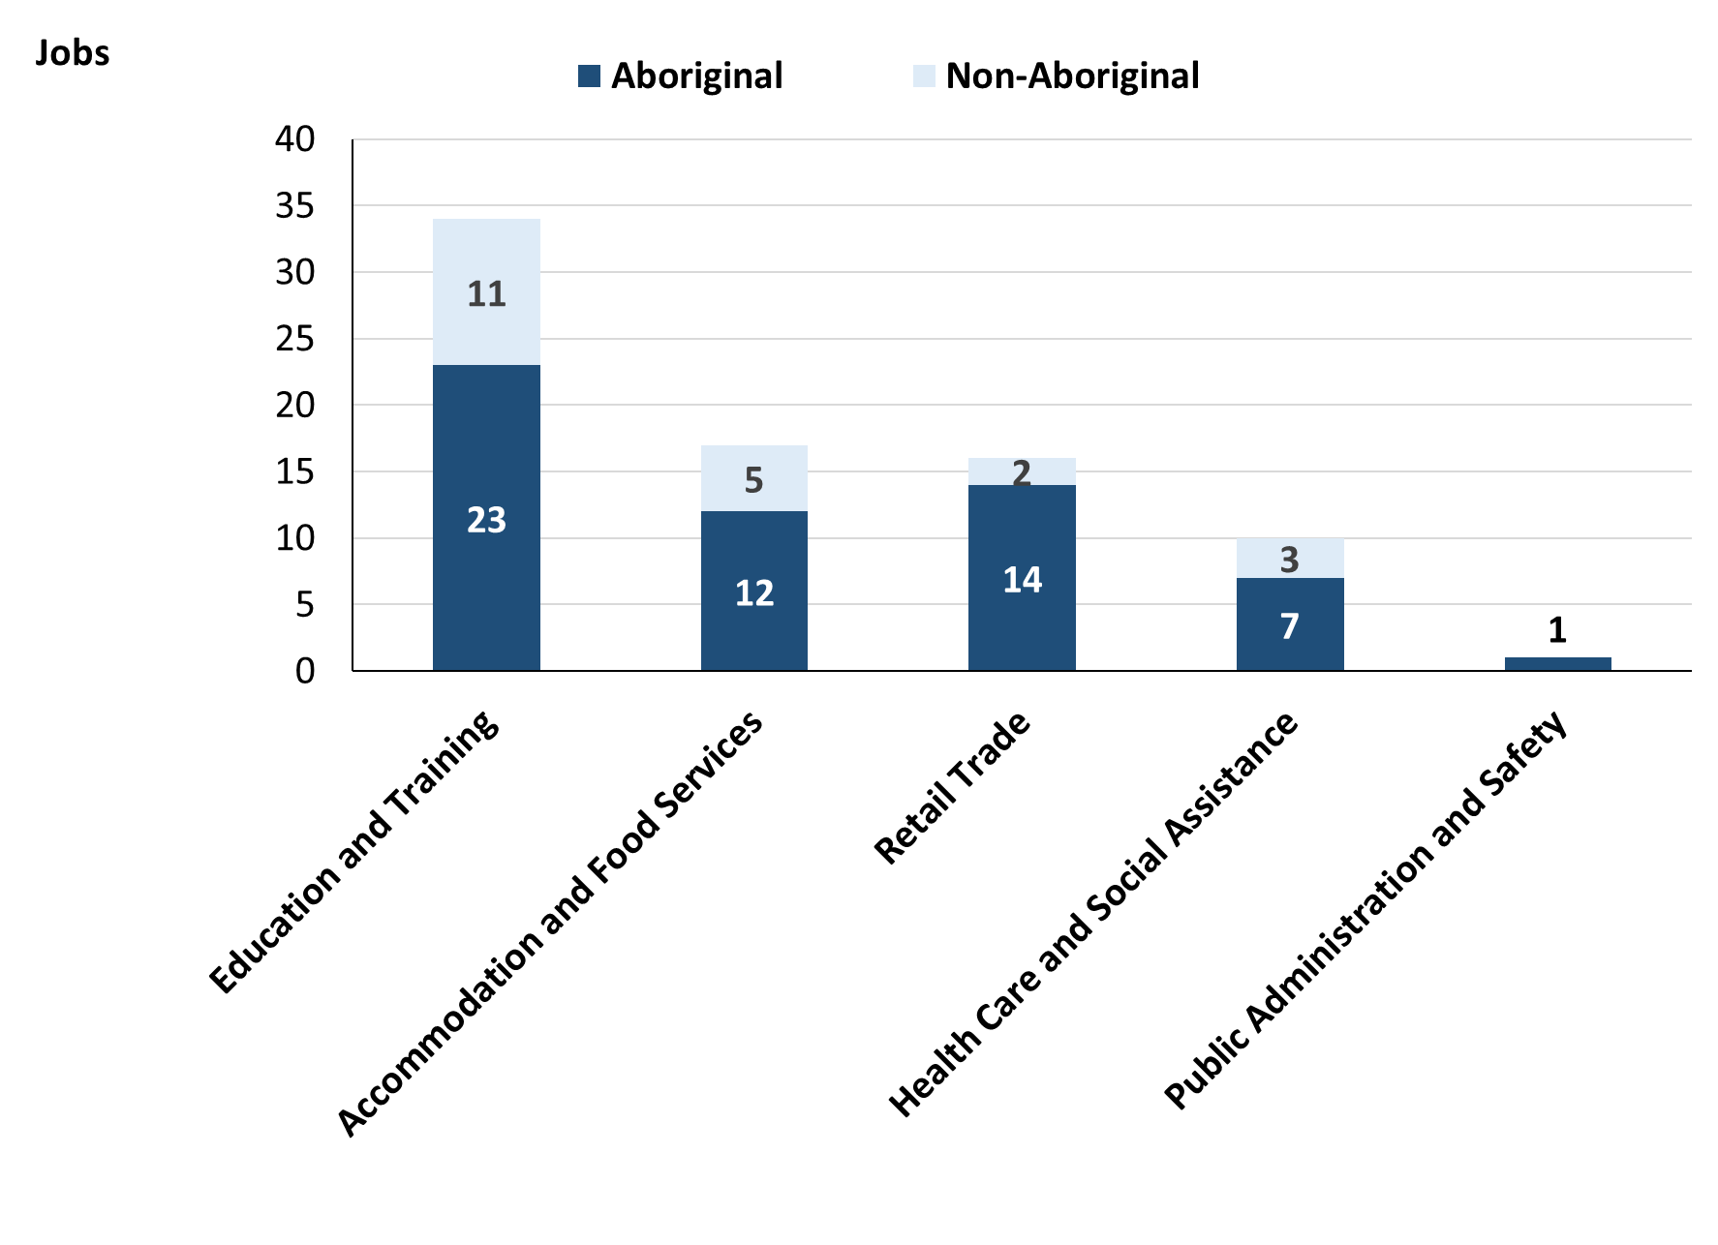

Source: Northern Territory Department of Industry, Tourism and Trade

In 2023 in Milikapiti:

* of the 58 jobs filled by **Aboriginal** people, there were:
* 23 jobs in Education and Training, an increase of 14 jobs from 2017
* 14 jobs in Retail Trade, an increase of 7 jobs from 2017
* 12 jobs in Accommodation and Food Services, a decrease of 11 jobs from 2017
* of the 22 jobs filled by **non-Aboriginal** people, there were:
* 11 jobs in Education and Training, an increase of 6 jobs from 2017
* 5 jobs in Accommodation and Food Services, a decrease of 10 jobs from 2017
* 3 jobs in Health Care and Social Assistance, a decrease of 2 jobs from 2017.

Table 12: Count of filled jobs by industry and employment status, 2017 (a)(c)(e)(h)

|  |  |  |  |  |  |  |  |  |  |  |
| --- | --- | --- | --- | --- | --- | --- | --- | --- | --- | --- |
| **Industry (ANZSIC division)** | **2017** | | | | | | | | | |
| **Aboriginal** | | | **Non-Aboriginal** | | | **Total** | | | |
| **Perm** | **Temp** | **Total** | **Perm** | **Temp** | **Total** | **Perm** | **Temp** | **Total** |
| Accommodation and Food Services | 1 | 22 | **23** | 8 | 7 | **15** | 9 | 29 | **38** |
| Arts and Recreation Services | 0 | 6 | **6** | 2 | 0 | **2** | 2 | 6 | **8** |
| Education and Training | 2 | 7 | **9** | 3 | 2 | **5** | 5 | 9 | **14** |
| Health Care and Social Assistance | 4 | 5 | **9** | 0 | 5 | **5** | 4 | 10 | **14** |
| Public Administration and Safety | 23 | 0 | **23** | 3 | 1 | **4** | 26 | 1 | **27** |
| Retail Trade | 4 | 3 | **7** | 0 | 2 | **2** | 4 | 5 | **9** |
| Transport, Postal and Warehousing | 0 | 1 | **1** | 0 | 1 | **1** | 0 | 2 | **2** |
| **Total** | **34** | **44** | **78** | **16** | **18** | **34** | **50** | **62** | **112** |

Source: Northern Territory Department of Industry, Tourism and Trade

Table 13: Count of filled jobs by industry and employment status, 2023 (a)(c)(e)(h)

|  |  |  |  |  |  |  |  |  |  |  |
| --- | --- | --- | --- | --- | --- | --- | --- | --- | --- | --- |
| **Industry (ANZSIC division)** | **2023** | | | | | | | | | |
| **Aboriginal** | | | **Non-Aboriginal** | | | **Total** | | | |
| **Perm** | **Temp** | **Total** | **Perm** | **Temp** | **Total** | **Perm** | **Temp** | **Total** |
| Accommodation and Food Services | 0 | 12 | **12** | 1 | 4 | **5** | 1 | 16 | **17** |
| Arts and Recreation Services | 0 | 0 | **0** | 0 | 0 | **0** | 0 | 0 | **0** |
| Education and Training | 4 | 19 | **23** | 1 | 10 | **11** | 5 | 29 | **34** |
| Health Care and Social Assistance | 3 | 4 | **7** | 1 | 2 | **3** | 4 | 6 | **10** |
| Public Administration and Safety | 1 | 0 | **1** | 0 | 0 | **0** | 1 | 0 | **1** |
| Retail Trade | 1 | 13 | **14** | 0 | 2 | **2** | 1 | 15 | **16** |
| Transport, Postal and Warehousing | 0 | 0 | **0** | 0 | 1 | **1** | 0 | 1 | **1** |
| Other | 1 | 0 | **1** | 0 | 0 | **0** | 1 | 0 | **1** |
| **Total** | **10** | **48** | **58** | **3** | **19** | **22** | **13** | **67** | **80** |

Source: Northern Territory Department of Industry, Tourism and Trade

In 2023 in Milikapiti:

* of the 13 **permanent** jobs, there were:
* 5 jobs in Education and Training, unchanged from 2017, including:
* **Aboriginal** people filled 4 jobs, an increase of 2 jobs from 2017
* a **non-Aboriginal** people filled 1 job, a decrease of 2 jobs from 2017
* 4 jobs in Health Care and Social Assistance, unchanged from 2017, including:
* **Aboriginal** people filled 3 jobs, a decrease of 1 job from 2017
* a **non-Aboriginal** people filled 1 job, an increase of 1 job from 2017
* 1 job in Public Administration and Safety, a decrease of 25 jobs from 2017, including:
* an **Aboriginal** people filled 1 job, a decrease of 22 jobs from 2017
* **non-Aboriginal** people filled 0 jobs, a decrease of 3 jobs from 2017
* of the 67 **temporary** jobs, there were:
* 29 jobs in Education and Training, an increase from 20 jobs from 2017, including:
* **Aboriginal** people filled 19 jobs, an increase of 12 jobs from 2017
* **non-Aboriginal** people filled 10 jobs, an increase of 8 jobs from 2017
* 16 jobs in Accommodation and Food Services, a decrease of 13 jobs from 2017, including:
* **Aboriginal** people filled 12 jobs, a decrease of 10 jobs from 2017
* **non-Aboriginal** people filled 4 jobs, a decrease of 3 jobs from 2017
* 15 jobs in Retail Trade, an increase of 10 jobs from 2017, including:
* **Aboriginal** people filled 13 jobs, an increase of 10 jobs from 2017
* **non-Aboriginal** people filled 2 jobs, unchanged from 2017.

# Jobs by Occupation

Table 14: Count of filled jobs by occupation, 2017 & 2023 (a)(f)(g)

|  |  |  |  |  |  |
| --- | --- | --- | --- | --- | --- |
| **Occupation (ANZSCO major group)** | **2017** | | **2023** | | **Change 2017-2023** |
| **Total** | **% of Total** | **Total** | **% of Total** | **Total** |
| Clerical and Administrative Workers | 9 | 8.0% | 9 | 11.3% | 0 |
| Community and Personal Service Workers | 35 | 31.3% | 32 | 40.0% | -3 |
| Labourers | 23 | 20.5% | 11 | 13.8% | -12 |
| Machinery Operators and Drivers | 2 | 1.8% | 6 | 7.5% | 4 |
| Managers | 14 | 12.5% | 4 | 5.0% | -10 |
| Professionals | 15 | 13.4% | 11 | 13.8% | -4 |
| Sales Workers | 7 | 6.3% | 5 | 6.3% | -2 |
| Technicians and Trades Workers | 7 | 6.3% | 2 | 2.5% | -5 |
| **Total** | **112** | **100.0%** | **80** | **100.0%** | **-32** |

Source: Northern Territory Department of Industry, Tourism and Trade

Chart 9: Percentage and count of top 6 filled jobs by occupation, 2017 & 2023 (a)(f)(g)

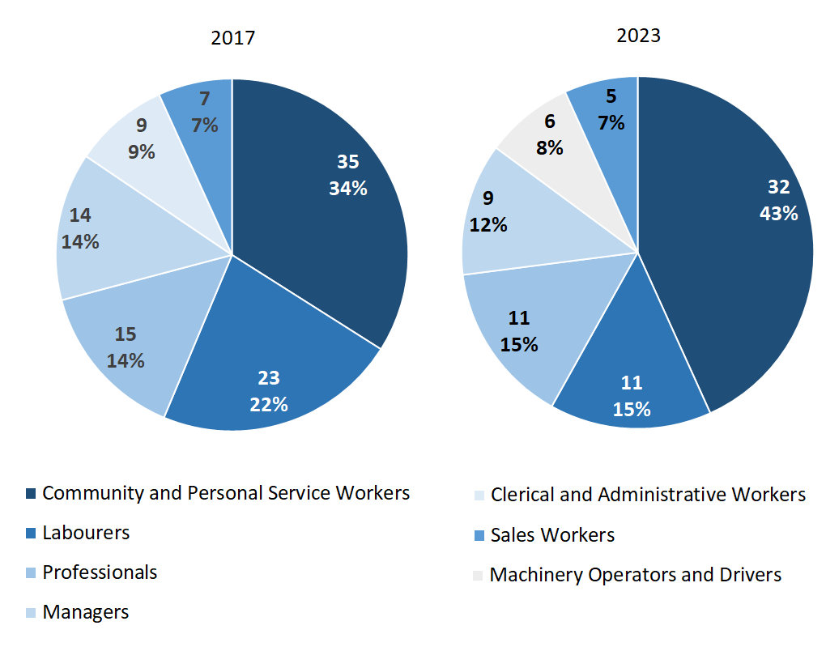

Source: Northern Territory Department of Industry, Tourism and Trade

In 2023 in Milikapiti:

* Community and Personal Service Workers was the **largest** **occupation** **classification** in terms of filled jobs, accounting for 32 jobs (40.0% of total filled jobs), a decrease of 3 jobs from 2017
* **other** **significant** occupation classifications were:
* Labourers accounting for 11 jobs or 13.8% of total jobs, a decrease of 12 jobs from 2017
* Professionals accounting for 11 jobs or 13.8% of total jobs, a decrease of 4 jobs from 2017
* Clerical and Administrative Workers accounting for 9 jobs or 11.3% of total jobs, unchanged from 2017.

**Table 15: Count of filled jobs by ANZSCO occupation, 2017 & 2023 (a)(c)(f)(g)**

|  |  |  |  |  |  |  |  |  |  |  |  |
| --- | --- | --- | --- | --- | --- | --- | --- | --- | --- | --- | --- |
| **Occupation (ANZSCO major group)** | **2017** | | | **2023** | | | | **Change 2017-2023** | | | |
| **Aboriginal** | **Non-Aboriginal** | **Total** | **Aboriginal** | **Non-Aboriginal** | **Total** | **Aboriginal** | | **Non-Aboriginal** | **Total** |
| Clerical and Administrative Workers | 9 | 0 | **9** | 3 | 6 | **9** | -6 | | 6 | **0** |
| Community and Personal Service Workers | 27 | 8 | **35** | 28 | 4 | **32** | 1 | | -4 | **-3** |
| Labourers | 19 | 4 | **23** | 9 | 2 | **11** | -10 | | -2 | **-12** |
| Machinery Operators and Drivers | 1 | 1 | **2** | 5 | 1 | **6** | 4 | | 0 | **4** |
| Managers | 2 | 12 | **14** | 1 | 3 | **4** | -1 | | -9 | **-10** |
| Professionals | 10 | 5 | **15** | 6 | 5 | **11** | -4 | | 0 | **-4** |
| Sales Workers | 7 | 0 | **7** | 5 | 0 | **5** | -2 | | 0 | **-2** |
| Technicians and Trades Workers | 3 | 4 | **7** | 1 | 1 | **2** | -2 | | -3 | **-5** |
| **Total** | **78** | **34** | **112** | **58** | **22** | **80** | **-20** | | **-12** | **-32** |

Source: Northern Territory Department of Industry, Tourism and Trade

In 2023 in Milikapiti:

* of the 58 jobs filled by **Aboriginal** people, there were:
* 28 Community and Personal Service Workers, an increase of 1 job from 2017
* 9 Labourers, a decrease of 10 jobs from 2017
* 6 Professionals, a decrease of 4 jobs from 2017
* 5 Machinery Operators and Drivers, an increase of 4 jobs from 2017
* 5 Sales Workers, a decrease of 2 jobs from 2017
* of the 22 jobs filled by **non-Aboriginal** people, there were:
* 6 Clerical and Administrative Workers, an increase of 6 jobs from 2017
* 5 Professionals, unchanged from 2017
* 4 Community and Personal Service Workers, a decrease of 4 jobs from 2017
* 3 Managers, a decrease of 9 jobs from 2017
* 2 Labourers, a decrease of 2 jobs from 2017.

# Jobs by Industry by Occupation

**Table 16: Count of filled jobs by occupation and by industry, 2017 (a)(f)(g)(h).**

|  |  |  |  |  |  |  |  |  |  |  |  |
| --- | --- | --- | --- | --- | --- | --- | --- | --- | --- | --- | --- |
| **2017** | | | | | | | | | | | |
| **Industry (ANZSIC Division)** | **Occupation (ANZSCO major group)** | | | | | | | | | | |
| **Clerical and Administrative Workers** | **Community and Personal Service Workers** | **Labourers** | **Machinery Operators and Drivers** | **Managers** | **Professionals** | **Sales Workers** | **Technicians and Trades Workers** | **Other Occupations** | **Total** |
| Accommodation and Food Services | 1 | 15 | 9 | 0 | 6 | 2 | 0 | 5 | 0 | **38** |
| Arts and Recreation Services | 0 | 0 | 1 | 0 | 2 | 5 | 0 | 0 | 0 | **8** |
| Education and Training | 1 | 6 | 1 | 0 | 1 | 5 | 0 | 0 | 0 | **14** |
| Health Care and Social Assistance | 2 | 7 | 3 | 0 | 1 | 1 | 0 | 0 | 0 | **14** |
| Public Administration and Safety | 5 | 7 | 9 | 0 | 2 | 2 | 0 | 2 | 0 | **27** |
| Retail Trade | 0 | 0 | 0 | 0 | 2 | 0 | 7 | 0 | 0 | **9** |
| Transport, Postal and Warehousing | 0 | 0 | 0 | 2 | 0 | 0 | 0 | 0 | 0 | **2** |
| **Total** | **9** | **35** | **23** | **2** | **14** | **15** | **7** | **7** | **0** | **112** |

Source: Northern Territory Department of Industry, Tourism and Trade

**Table 17: Count of filled jobs by occupation and by industry, 2023 (a)(f)(g)(h).**

|  |  |  |  |  |  |  |  |  |  |  |  |
| --- | --- | --- | --- | --- | --- | --- | --- | --- | --- | --- | --- |
| **2023** | | | | | | | | | | | |
| **Industry (ANZSIC Division)** | **Occupation (ANZSCO major group)** | | | | | | | | | | |
| **Clerical and Administrative Workers** | **Community and Personal Service Workers** | **Labourers** | **Machinery Operators and Drivers** | **Managers** | **Professionals** | **Sales Workers** | **Technicians and Trades Workers** | **Other Occupations** | **Total** |
| Accommodation and Food Services | 4 | 12 | 0 | 0 | 0 | 0 | 0 | 1 | 0 | **17** |
| Arts and Recreation Services | 0 | 0 | 0 | 0 | 0 | 0 | 0 | 0 | 0 | **0** |
| Education and Training | 4 | 12 | 5 | 2 | 1 | 9 | 0 | 1 | 0 | **34** |
| Health Care and Social Assistance | 1 | 5 | 1 | 1 | 0 | 2 | 0 | 0 | 0 | **10** |
| Public Administration and Safety | 0 | 1 | 0 | 0 | 0 | 0 | 0 | 0 | 0 | **1** |
| Retail Trade | 0 | 1 | 4 | 3 | 3 | 0 | 5 | 0 | 0 | **16** |
| Transport, Postal and Warehousing | 0 | 0 | 1 | 0 | 0 | 0 | 0 | 0 | 0 | **1** |
| Other | 0 | 1 | 0 | 0 | 0 | 0 | 0 | 0 | 0 | **1** |
| **Total** | **9** | **32** | **11** | **6** | **4** | **11** | **5** | **2** | **0** | **80** |

Source: Northern Territory Department of Industry, Tourism and Trade

In 2023 in Milikapiti:

* Community and Personal Service Workers filled the most jobs with 32 jobs (the largest occupation group) and were shared across Accommodation and Food Services with 12 jobs, Education and Training with 12 jobs and Health Care and Social Assistance industries with 5 jobs,
* Education and Training provides the most filled jobs with 34 jobs within an industry group, an increase of 20 filled jobs from 2017
* Public Administration and Safety showed a decrease of 26 filled jobs between 2023 and 2017.

# Jobs by Gender

**Table 18: Count of filled jobs by gender, 2017 & 2023 (a)(c)(i)**

|  |  |  |  |  |  |  |  |  |  |
| --- | --- | --- | --- | --- | --- | --- | --- | --- | --- |
| **Indicator** | **2017** | | | **2023** | | | **2017-2023 Change** | | |
| **Aboriginal** | **Non-Aboriginal** | **Total** | **Aboriginal** | **Non-Aboriginal** | **Total** | **Aboriginal** | **Non-Aboriginal** | **Total** |
| Male | 32 | 22 | **54** | 15 | 9 | **24** | -17 | -13 | **-30** |
| Female | 46 | 12 | **58** | 42 | 13 | **55** | -4 | 1 | **-3** |
| **Total** | **78** | **34** | **112** | **58** | **22** | **80** | **-20** | **-12** | **-32** |

Source: Northern Territory Department of Industry, Tourism and Trade

**Chart 10: Count of filled jobs by gender, 2017 & 2023 (a)(c)(i)**

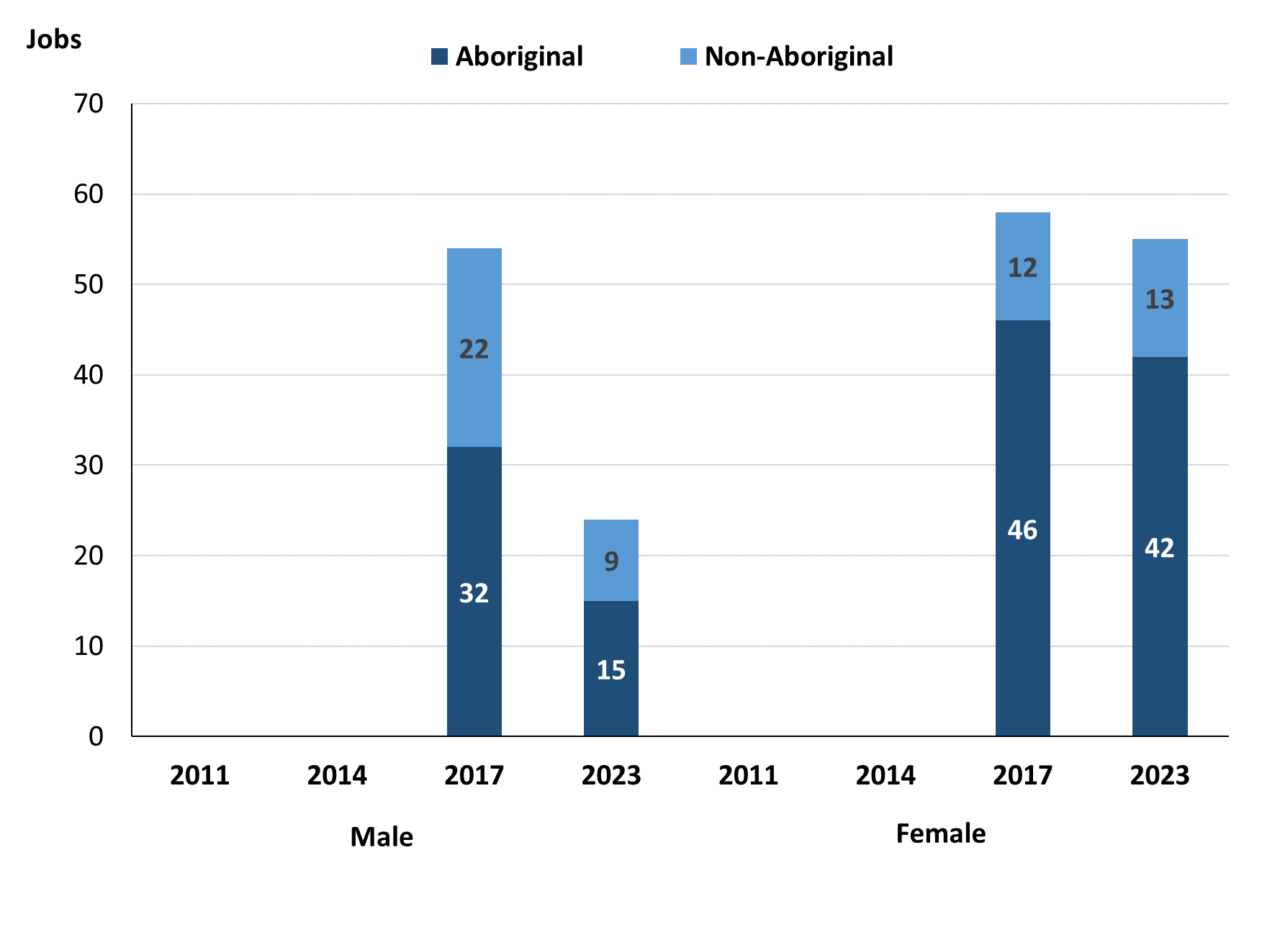

Source: Northern Territory Department of Industry, Tourism and Trade

In 2023 in Milikapiti there were:

* 24 **jobs filled by males**, a decrease of 30 jobs from 2017,of which:
* 15 were **Aboriginal**, a decrease of 17 jobs from 2017
* 9 were **non-Aboriginal**, a decrease of 13 jobs from 2017
* 55 **jobs filled by females**, a decrease of 3 jobs from 2017,of which:
* 42 were **Aboriginal**, a decrease of 4 jobs from 2017
* 13 were **non-Aboriginal**, an increase of 1 job from 2017.

**Table 19: Count of filled jobs by gender, by full-time/part-time** **status, by job permanency and by sector, 2017 (a)(b)(c)(d)(e)(i)**

|  |  |  |  |  |  |  |  |  |  |
| --- | --- | --- | --- | --- | --- | --- | --- | --- | --- |
| **2017** | | | | | | | | | |
| **Indicator** | **Male** | | | **Female** | | | **Total** | | |
| **Aboriginal** | **Non-Aboriginal** | **Total** | **Aboriginal** | **Non-Aboriginal** | **Total** | **Aboriginal** | **Non-Aboriginal** | **Total** |
| Full-time | 16 | 20 | **36** | 15 | 12 | **27** | 31 | 32 | **63** |
| Part-time | 16 | 2 | **18** | 31 | 0 | **31** | 47 | 2 | **49** |
| **Total** | **32** | **22** | **54** | **46** | **12** | **58** | **78** | **34** | **112** |
| Permanent | 16 | 11 | **27** | 18 | 5 | **23** | 34 | 16 | **50** |
| Temporary | 16 | 11 | **27** | 28 | 7 | **35** | 44 | 18 | **62** |
| **Total** | **32** | **22** | **54** | **46** | **12** | **58** | **78** | **34** | **112** |
| Public Sector | 13 | 8 | **21** | 24 | 6 | **30** | 37 | 14 | **51** |
| Private Sector | 19 | 14 | **33** | 22 | 6 | **28** | 41 | 20 | **61** |
| **Total** | **32** | **22** | **54** | **46** | **12** | **58** | **78** | **34** | **112** |

Source: Northern Territory Department of Industry, Tourism and Trade

**Table 20: Count of filled jobs by gender, by full-time/part-time** **status, by job permanency and by sector, 2023 (a)(b)(c)(d)(e)(i)**

|  |  |  |  |  |  |  |  |  |  |
| --- | --- | --- | --- | --- | --- | --- | --- | --- | --- |
| **2023** | | | | | | | | | |
| **Indicator** | **Male** | | | **Female** | | | **Total** | | |
| **Aboriginal** | **Non-Aboriginal** | **Total** | **Aboriginal** | **Non-Aboriginal** | **Total** | **Aboriginal** | **Non-Aboriginal** | **Total** |
| Full-time | 5 | 7 | **12** | 17 | 12 | **29** | 23 | 19 | **42** |
| Part-time | 10 | 2 | **12** | 25 | 1 | **26** | 35 | 3 | **38** |
| **Total** | **15** | **9** | **24** | **42** | **13** | **55** | **58** | **22** | **80** |
| Permanent | 2 | 1 | **3** | 7 | 2 | **9** | 10 | 3 | **13** |
| Temporary | 13 | 8 | **21** | 35 | 11 | **46** | 48 | 19 | **67** |
| **Total** | **15** | **9** | **24** | **42** | **13** | **55** | **58** | **22** | **80** |
| Public Sector | 6 | 2 | **8** | 21 | 8 | **29** | 27 | 10 | **37** |
| Private Sector | 10 | 7 | **17** | 21 | 5 | **26** | 31 | 12 | **43** |
| **Total** | **16** | **9** | **25** | **42** | **13** | **55** | **58** | **22** | **80** |

Source: Northern Territory Department of Industry, Tourism and Trade

In 2023 in Milikapiti:

* of the 24 **jobs** **filled** **by** **males**, there were:
* 15 jobs filled by **Aboriginal** males, a decrease of 17 jobs from 2017, including:
* 5 full-time jobs, a decrease of 11 jobs from 2017
* 10 part-time jobs, a decrease of 6 jobs from 2017
* 2 permanent jobs, a decrease of 14 jobs from 2017
* 13 temporary jobs, a decrease of 3 jobs from 2017
* 6 Public Sector jobs, a decrease of 7 jobs from 2017
* 10 Private Sector jobs, a decrease of 9 jobs from 2017
* 9 jobs filled by **non-Aboriginal** males, a decrease of 13 jobs from 2017, including:
* 7 full-time jobs, a decrease of 13 jobs from 2017
* 2 part-time jobs, unchanged from 2017
* 1 permanent job, a decrease of 10 jobs from 2017
* 8 temporary jobs, a decrease of 3 jobs from 2017
* 2 Public Sector jobs, a decrease of 6 jobs from 2017
* 7 Private Sector jobs, a decrease of 7 jobs from 2017
* of the 55 **jobs** **filled** **by** **females**, there were:
* 42 jobs filled by **Aboriginal** females, a decrease of 4 jobs from 2017, including:
* 17 full-time jobs, an increase of 2 jobs from 2017
* 25 part-time jobs, a decrease of 6 jobs from 2017
* 7 permanent jobs, a decrease of 11 jobs from 2017
* 35 temporary jobs, an increase of 7 jobs from 2017
* 21 Public Sector jobs, a decrease of 3 jobs from 2017
* 21 Private Sector jobs, a decrease of 1 job from 2017
* 13 jobs filled by **non-Aboriginal** females, an increase of 1 job from 2017, including:
* 12 full-time jobs, unchanged from 2017
* 1 part-time job, an increase of 1 job from 2017
* 2 permanent jobs, a decrease of 3 jobs from 2017
* 11 temporary jobs, an increase of 4 jobs from 2017
* 8 Public Sector jobs, an increase of 2 jobs from 2017
* 5 Private Sector jobs, a decrease of 1 job from 2017.

# Jobs by Age

**Table 21: Count of filled jobs by age, 2017 & 2023 (a)(c)(j)**

|  |  |  |  |  |  |  |  |  |  |  |
| --- | --- | --- | --- | --- | --- | --- | --- | --- | --- | --- |
| **Indicator** | **2017** | | | **2023** | | | **Change 2017-2023** | | | |
| **Aboriginal** | **Non-Aboriginal** | **Total** | **Aboriginal** | **Non-Aboriginal** | **Total** | **Aboriginal** | **Non-Aboriginal** | **Total** |
| 15-24 years | 15 | 1 | **16** | 8 | 0 | **8** | -7 | -1 | **-8** |
| 25-44 years | 39 | 15 | **54** | 30 | 9 | **39** | -9 | -6 | **-15** |
| 45+ years | 24 | 18 | **42** | 6 | 13 | **19** | -18 | -5 | **-23** |
| **Total** | **78** | **34** | **112** | **58** | **22** | **80** | **-20** | **-12** | **-32** |

Source: Northern Territory Department of Industry, Tourism and Trade

**Chart 11: Count of filled jobs by age, 2017 & 2023 (a)(c)(j)**

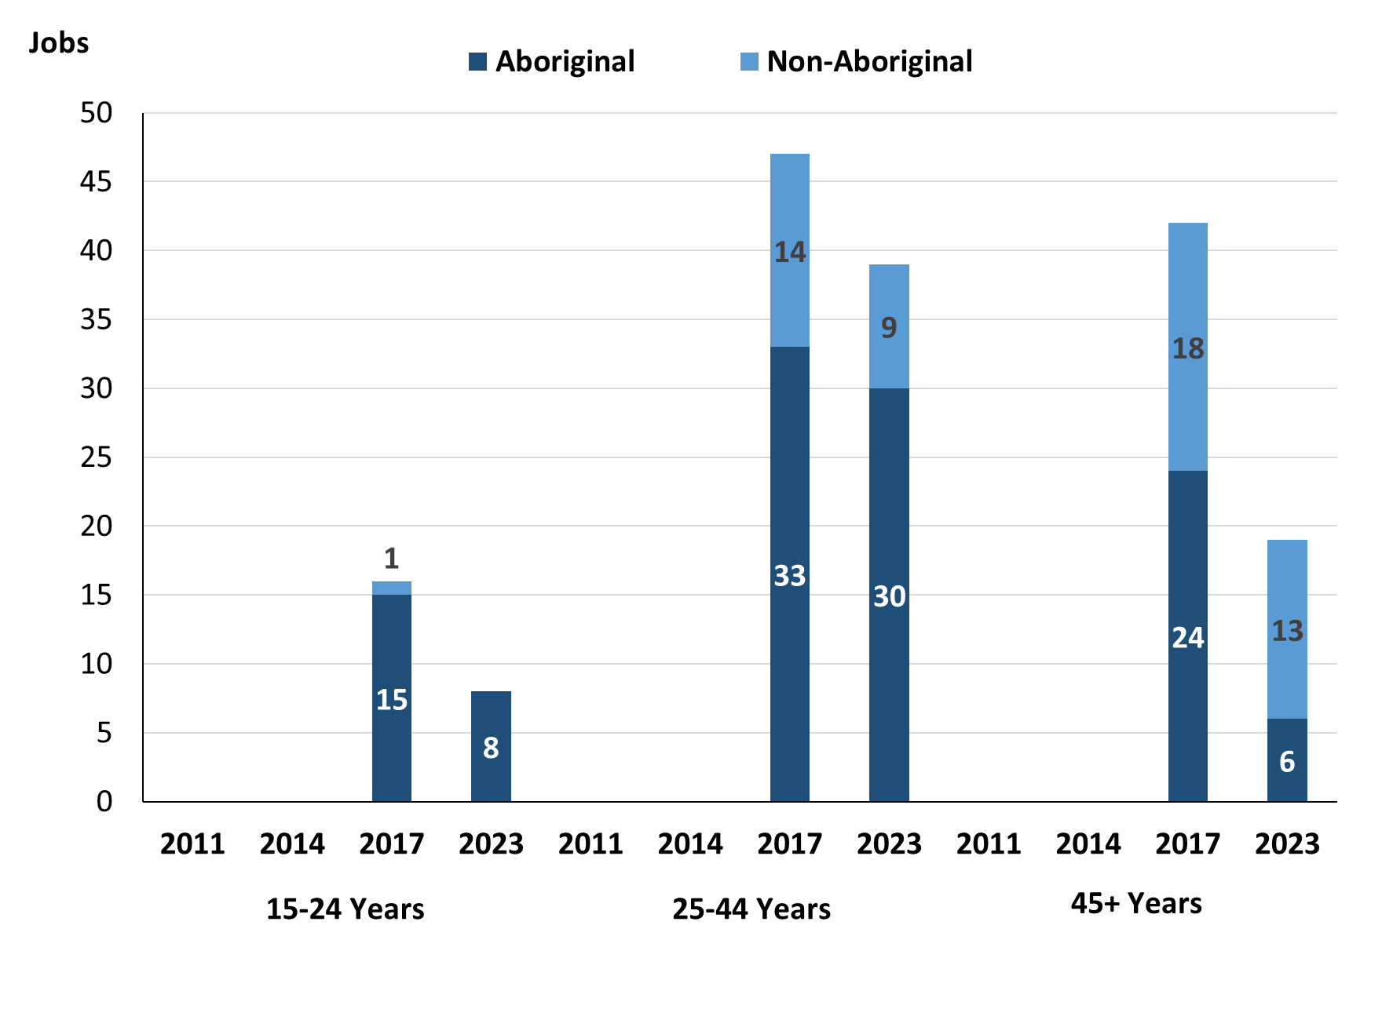

Source: Northern Territory Department of Industry, Tourism and Trade

In 2023 in Milikapiti:

* There were 8 **jobs** **filled** by people aged **15-24 years**, a decrease of 8 jobs from 2017. Of these:
* **Aboriginal** people filled 8 jobs, a decrease of 7 jobs from 2017
* **non-Aboriginal** people filled 0 jobs, a decrease of 1 job from 2017
* There were 39 **jobs** **filled** by people aged **25-44 years**, a decrease of 15 jobs from 2017. Of these:
* **Aboriginal** people filled 30 jobs, a decrease of 9 jobs from 2017
* **non-Aboriginal** people filled 9 jobs, a decrease of 6 jobs from 2017
* There were 19 **jobs** **filled** by people aged **45+ years,** a decrease of 23 jobs from 2017. Of these:
* **Aboriginal** people filled 6 jobs, a decrease of 18 jobs from 2017
* **non-Aboriginal** people filled 13 jobs, a decrease of 5 jobs from 2017.

**Table 22: Count of filled jobs by age, by full-time/part-time status, by job permanency and by sector, July 2017 (a)(b)(c)(d)(e)(i)**

|  |  |  |  |  |  |  |  |  |  |  |  |  |  |
| --- | --- | --- | --- | --- | --- | --- | --- | --- | --- | --- | --- | --- | --- |
| **2017** | | | | | | | | | | | | | |
| **Indicator** | **15-24 years** | | | **25-44 years** | | | **45+ years** | | | **Total** | | | |
| **Aboriginal** | **Non-Aboriginal** | **Total** | **Aboriginal** | **Non-Aboriginal** | **Total** | **Aboriginal** | **Non-Aboriginal** | **Total** | **Aboriginal** | **Non-Aboriginal** | **Total** |
| Full-time | 6 | 1 | **7** | 13 | 14 | **27** | 12 | 17 | **29** | 31 | 32 | **63** |
| Part-time | 9 | 0 | **9** | 26 | 1 | **27** | 12 | 1 | **13** | 47 | 2 | **49** |
| **Total** | **15** | **1** | **16** | **39** | **15** | **54** | **24** | **18** | **42** | **78** | **34** | **112** |
| Permanent | 8 | 0 | **8** | 10 | 11 | **21** | 16 | 5 | **21** | 34 | 16 | **50** |
| Temporary | 7 | 1 | **8** | 29 | 4 | **33** | 8 | 13 | **21** | 44 | 18 | **62** |
| **Total** | **15** | **1** | **16** | **39** | **15** | **54** | **24** | **18** | **42** | **78** | **34** | **112** |
| Public Sector | 9 | 1 | **10** | 16 | 4 | **20** | 12 | 9 | **21** | 37 | 14 | **51** |
| Private Sector | 6 | 0 | **6** | 23 | 11 | **34** | 12 | 9 | **21** | 41 | 20 | **61** |
| **Total** | **15** | **1** | **16** | **39** | **15** | **54** | **24** | **18** | **42** | **78** | **34** | **112** |

Source: Northern Territory Department of Industry, Tourism and Trade

**Table 23: Count of filled jobs by age, by full-time/part-time status, by job permanency and by sector, September 2023 (a)(b)(c)(d)(e)(i)**

|  |  |  |  |  |  |  |  |  |  |  |  |  |  |
| --- | --- | --- | --- | --- | --- | --- | --- | --- | --- | --- | --- | --- | --- |
| **2023** | | | | | | | | | | | | | |
| **Indicator** | **15-24 years** | | | **25-44 years** | | | **45+ years** | | | **Total** | | | |
| **Aboriginal** | **Non-Aboriginal** | **Total** | **Aboriginal** | **Non-Aboriginal** | **Total** | **Aboriginal** | **Non-Aboriginal** | **Total** | **Aboriginal** | **Non-Aboriginal** | **Total** |
| Full-time | 2 | 0 | **2** | 16 | 7 | **23** | 4 | 12 | **16** | 23 | 19 | **42** |
| Part-time | 6 | 0 | **6** | 14 | 2 | **16** | 2 | 1 | **3** | 35 | 3 | **38** |
| **Total** | **8** | **0** | **8** | **30** | **9** | **39** | **6** | **13** | **19** | **58** | **22** | **80** |
| Permanent | 0 | 0 | **0** | 5 | 2 | **7** | 4 | 1 | **5** | 10 | 3 | **13** |
| Temporary | 8 | 0 | **8** | 25 | 7 | **32** | 2 | 12 | **14** | 48 | 19 | **67** |
| **Total** | **8** | **0** | **8** | **30** | **9** | **39** | **6** | **13** | **19** | **58** | **22** | **80** |
| Public Sector | 2 | 0 | **2** | 20 | 3 | **23** | 5 | 7 | **12** | 27 | 10 | **37** |
| Private Sector | 6 | 0 | **6** | 11 | 6 | **17** | 1 | 6 | **7** | 31 | 12 | **43** |
| **Total** | **8** | **0** | **8** | **31** | **9** | **40** | **6** | **13** | **19** | **58** | **22** | **80** |

Source: Northern Territory Department of Industry, Tourism and Trade

In 2023 in Milikapiti:

* of the 8 **jobs** **filled** by people aged **15-24 years**, there were:
* 8 jobs filled by **Aboriginal** people, of which:
* 2 were full-time jobs, a decrease of 4 jobs from 2017
* 6 were part-time jobs, a decrease of 3 jobs from 2017
* none were permanent jobs, a decrease of 8 jobs from 2017
* 8 were temporary jobs, an increase of 1 job from 2017
* 2 were Public Sector jobs, a decrease of 7 jobs from 2017
* 6 were Private Sector jobs, unchanged from 2017
* 0 jobs were filled by **non-Aboriginal** people, of which:
* none were full-time jobs, a decrease of 1 job from 2017
* none were part-time jobs, unchanged from 2017
* none were permanent jobs, unchanged from 2017
* none were temporary jobs, a decrease of 1 job from 2017
* none were Public Sector jobs, a decrease of 1 job from 2017
* none were Private Sector jobs, unchanged from 2017
* of the 39 **jobs** **filled** by people aged **25-44 years**, there were:
* 30 jobs filled by **Aboriginal** people, of which:
* 16 were full-time jobs, an increase of 3 jobs from 2017
* 14 were part-time jobs, a decrease of 12 jobs from 2017
* 5 were permanent jobs, a decrease of 5 jobs from 2017
* 25 were temporary jobs, a decrease of 4 jobs from 2017
* 20 were Public Sector jobs, an increase of 4 jobs from 2017
* 11 were Private Sector jobs, a decrease of 12 jobs from 2017
* 9 jobs filled by **non-Aboriginal** people, of which:
* 7 were full-time jobs, a decrease of 7 jobs from 2017
* 2 were part-time jobs, an increase of 1 job from 2017
* 2 were permanent jobs, a decrease of 9 jobs from 2017
* 7 were temporary jobs, an increase of 3 jobs from 2017
* 3 were Public Sector jobs, a decrease of 1 job from 2017
* 6 were Private Sector jobs, a decrease of 5 jobs from 2017
* of the 19 **jobs** **filled** by people aged **45+ years**, there were:
* 6 jobs filled by **Aboriginal** people, of which:
* 4 were full-time jobs, a decrease of 8 jobs from 2017
* 2 were part-time jobs, a decrease of 10 jobs from 2017
* 4 were permanent jobs, a decrease of 12 jobs from 2017
* 2 were temporary jobs, a decrease of 6 jobs from 2017
* 5 were Public Sector jobs, a decrease of 7 jobs from 2017
* 1 was a Private Sector job, a decrease of 11 jobs from 2017
* 13 jobs filled by **non-Aboriginal** people, of which:
* 12 were full-time jobs, a decrease of 5 jobs from 2017
* 1 was a part-time job, unchanged from 2017
* 1 was a permanent job, a decrease of 4 jobs from 2017
* 12 were temporary jobs, a decrease of 1 job from 2017
* 7 were Public Sector jobs, a decrease of 2 jobs from 2017
* 6 were Private Sector jobs, a decrease of 3 jobs from 2017.

# Vocational Education and Training

Table 24: Northern Territory Vocational Education and Training (VET) students, 2016 & 2023 (k)

|  |  |  |  |  |  |
| --- | --- | --- | --- | --- | --- |
| **VET Funding Group** | **2016** | | **2023** | | **Change** |
| **No.** | **% of Total** | **No.** | **% of Total** | **2016-2023** |
| Automotive | 15 | 23% | 0 | 0% | -15 |
| Building and Construction | 3 | 5% | 15 | 23% | 12 |
| Community Services, Health and Education | 16 | 24% | 21 | 32% | 5 |
| Engineering and Mining | 0 | 0% | 18 | 27% | 18 |
| General Education and Training | 0 | 0% | 5 | 8% | 5 |
| Primary Industry | 27 | 41% | 14 | 21% | -13 |
| Tourism and Hospitality | 5 | 8% | 0 | 0% | -5 |
| **Total** | **66** | **100%** | **66** | **100%** | **0** |

Source: Northern Territory Department of Industry, Tourism and Trade

In Milikapiti in 2023:

* there were 66 **VET students**, unchanged from 2016,
* VET activity with the most students were Community Services, Health and Education with 21 students,
* Engineering and Mining had 18 students,
* Building and Construction had 15 students,
* Engineering and Mining reported the largest increase in students with an increase of 18 students compared to 2016,
* Automotive reported the largest decrease in students with 15 less students over the same period.

Table 25: Northern Territory Vocational Education and Training (VET) unit enrolments, 2016 & 2023 (l)

|  |  |  |  |  |  |
| --- | --- | --- | --- | --- | --- |
| **VET Funding Group** | **2016** | | **2023** | | **Change** |
| **No.** | **% of Total** | **No.** | **% of Total** | **2016-2023** |
| Automotive | 167 | 61% | 0 | 0% | -167 |
| Building and Construction | 0 | 0% | 15 | 17% | 15 |
| Community Services, Health and Education | 14 | 5% | 25 | 29% | 11 |
| Engineering and Mining | 0 | 0% | 28 | 32% | 28 |
| General Education and Training | 0 | 0% | 5 | 6% | 5 |
| Primary Industry | 61 | 22% | 14 | 16% | -47 |
| Tourism and Hospitality | 30 | 11% | 0 | 0% | -30 |
| **Total** | **273** | **100%** | **87** | **100%** | **-186** |

Source: Northern Territory Department of Industry, Tourism and Trade

In Milikapiti in 2023:

* there were 87 **VET unit enrolments**,a decrease of 186-unit enrolments from 2016,
* VET activity with the most student enrolments were Engineering and mining with 28-unit enrolments,
* Community Services, Health and Education had 25-unit enrolments,
* Building and Construction had 15-unit enrolments,
* Engineering and mining reported the largest increase in unit enrolments with an increase of 28-unit enrolments compared to 2016,
* Automotive reported the largest decrease in unit enrolments with 167 less unit enrolments over the same period.

Table 26: Northern Territory Vocational Education and Training (VET) nominal hours, 2016 & 2023 (m)

|  |  |  |  |  |  |
| --- | --- | --- | --- | --- | --- |
| **VET Funding Group** | **2016** | | **2023** | | **Change** |
| **No.** | **% of Total** | **No.** | **% of Total** | **2016-2023** |
| Automotive | 3 095 | 51% | 0 | 0% | -3 095 |
| Building and construction | 0 | 0% | 90 | 3% | 90 |
| Community Services, Health and Education | 300 | 5% | 582 | 17% | 282 |
| Engineering and Mining | 0 | 0% | 1 840 | 54% | 1 840 |
| General Education and Training | 0 | 0% | 75 | 2% | 75 |
| Primary Industry | 2 070 | 34% | 840 | 25% | -1 230 |
| Tourism and Hospitality | 560 | 9% | 0 | 0% | -560 |
| **Total** | **6 025** | **100%** | **3 427** | **100%** | **-2 598** |

Source: Northern Territory Department of Industry, Tourism and Trade

In Milikapiti in 2023:

* there were 3,427 **VET nominal hours** delivered, a decrease of 2,598 nominal hours delivered from 2016,
* VET activity with the most nominal hours delivered were Engineering and Mining with 1,840 nominal hours,
* Primary Industry delivered 840 nominal hours,
* Community Services, Health and Education delivered 582 nominal hours,
* Engineering and mining reported the largest increase in nominal hours delivered with an increase of 1,840 nominal hours compared to 2016,
* Automotive reported the largest decrease in nominal hours delivered with 3,095 less hours over the same period.

Caveat: *Nominal hours are based on the hours funded through Northern Territory Government contracts and fee for service. Students and units include delivery that may have been funded in a previous year. Because of these factors, a direct match cannot be made between hours and student/units.*

**Table 27: Northern Territory Vocational Education and Training (VET) unit completions, 2016 & 2023 (n)**

|  |  |  |  |  |  |
| --- | --- | --- | --- | --- | --- |
| **VET Funding Group** | **2016** | | **2023** | | **Change** |
| **No.** | **% of Total** | **No.** | **% of Total** | **2016-2023** |
| Automotive | 190 | 61% | 0 | 0% | -190 |
| Building and Construction | 9 | 3% | 15 | 19% | 6 |
| Community Services, Health and Education | 19 | 6% | 25 | 32% | 6 |
| Engineering and Mining | 0 | 0% | 18 | 23% | 18 |
| General Education and Training | 0 | 0% | 5 | 6% | 5 |
| Primary Industry | 65 | 21% | 14 | 18% | -51 |
| Tourism and Hospitality | 30 | 10% | 0 | 0% | -30 |
| **Total** | **313** | **100%** | **77** | **100%** | **-236** |

Source: Northern Territory Department of Industry, Tourism and Trade

In Milikapiti in 2023:

* there were 77 **VET unit completions**, a decrease of 236-unit completions from 2016,
* VET activity with the most unit completions were Community Services, Health and Education with 25-unit completions,
* Engineering and mining had 18-unit completions,
* Building and Construction had 15-unit completions,
* Engineering and Mining reported the largest increase in unit completions with 18-unit completions compared to 2016,
* Automotive reported the largest decrease in unit completions with 190 less completions over the same period.

# Population

**Table 28: Population distribution by gender and age (p)(r)**

|  |  |  |  |  |  |  |  |  |  |
| --- | --- | --- | --- | --- | --- | --- | --- | --- | --- |
| **Indicator** | **2011** | | | **2021** | | | **Change (2011-2021)** | | |
| **Male** | **Female** | **Total** | **Male** | **Female** | **Total** | **Male** | **Female** | **Total** |
| **0-4 years** | 27 | 23 | **50** | 17 | 13 | **30** | -10 | -10 | **-20** |
| **5-14 years** | 41 | 41 | **82** | 37 | 29 | **66** | -4 | -12 | **-16** |
| **15-24 years** | 40 | 22 | **62** | 34 | 40 | **74** | -6 | 18 | **12** |
| **25-44 years** | 76 | 67 | **143** | 62 | 64 | **126** | -14 | -3 | **-17** |
| **45-64 years** | 42 | 49 | **91** | 49 | 53 | **102** | 7 | 4 | **11** |
| **65+ years** | 11 | 11 | **22** | 7 | 6 | **13** | -4 | -5 | **-9** |
| **Total** | **228** | **217** | **445** | **202** | **216** | **418** | **-26** | **-1** | **-27** |

*Source: Australian Bureau of Statistics*

In 2021 in Milikapiti:

* there were an estimated 418 people, of which:
* 202 (48.3%) were male
* 216 (51.7%) were female
* between 2011 and 2021, the overall population in Milikapiti decreased by 27 people from 2011, or an average of -0.6% per year compared to -0.5% across the 28 remote towns and 1.0% Territory wide
* the male population decreased by 26 people from 2011
* the female population decreased by 1 person from 2011
* in 2021, the working age population (15 years and over) in Milikapiti was an estimated 315 people (75.4% of the total population) compared with 318 people (71.5% of the total population) in 2011. Of these:
* 74 (17.7%) were between 15 and 24 years of age
* 126 (30.1%) were between 25 and 44 years of age
* 102 (24.4%) were between 45 and 64 years of age
* 13 (3.1%) were over 65 years of age
* of the 315 people of working age:
* 152 (48.3%) were male
* 163 (51.7%) were female.

There were 0.3 jobs in Milikapiti per working age person compared to 0.3 jobs per working age person across the 28 remote towns in the Northern Territory.

**Chart 12: Population comparison (p)(q)**

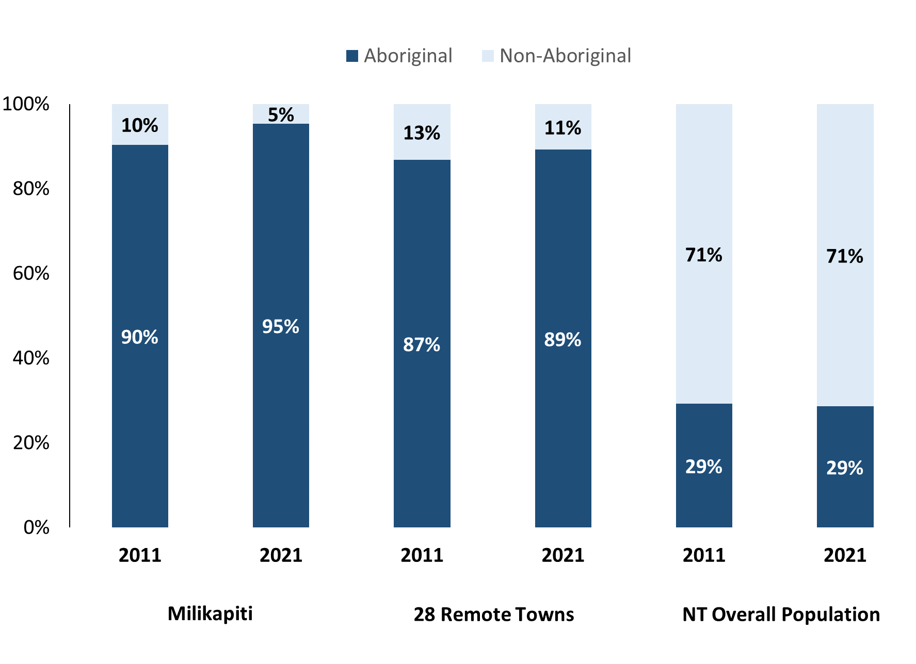

*Source: Australian Bureau of Statistics*

In 2021 in Milikapiti:

* 95.0% of the population in Milikapiti were **Aboriginal**, compared to 90.0% in 2011
* 89.0% of the population across all 28 remote towns were **Aboriginal**
* 29.0% of the NT population were **Aboriginal**.

**Table 29: Unemployment and Aboriginal participation rates (q)**

|  |  |  |  |  |  |  |
| --- | --- | --- | --- | --- | --- | --- |
|  | **Milikapiti** | | | **Northern Territory** | | |
| **Aboriginal** | **Non-Aboriginal** | **Total** | **Aboriginal** | **Non-Aboriginal** | **Total** |
| **Unemployment rate** | 33.7% | 0.0% | 28.7% | 20.8% | 3.2% | 5.6% |
| **Participation rate** | 29.5% | 71.4% | 40.6% | 35.4% | 78.3% | 64.9% |

*Source: Australian Bureau of Statistics*

In 2021 in Milikapiti the:

* **total unemployment rate** was 28.7% compared to 5.6% for the total Northern Territory
* **Aboriginal unemployment rate** was 33.7% compared to 20.8% for the total Northern Territory
* **non-Aboriginal unemployment rate** was 0.0% compared to 3.2% for the total Northern Territory
* **total participation rate** was 40.6% compared to 64.9% for the total Northern Territory
* **Aboriginal participation rate** was 29.5% compared to 35.4% for the total Northern Territory
* **non-Aboriginal participation rate** was 71.4% compared to 78.3% for the total Northern Territory.

# Community Development Program

**Table 30: Community Development Program Aboriginal Job Seekers, 31 December 2023 (o)**

|  |  |  |
| --- | --- | --- |
| **Indicator** | **Aboriginal** | |
| **No.** | **%** |
| **Total Aboriginal Job Seekers** | 152 | N/A |
| **Age (years)** | | |
| 15-24 | 45 | 29.6% |
| 25-44 | 52 | 34.2% |
| 45+ | 55 | 36.2% |
| **Total** | 152 | 100.0% |
| **Gender** | | |
| Male | 78 | 51.3% |
| Female | 74 | 48.7% |
| **Total** | 152 | 100.0% |
| **Employment Outcome – 1 January 2023 to 31 December 2023** | | |
| 13 Weeks | < 20 | N/A |
| 26 Weeks | < 20 | N/A |

*Source: Department of Prime Minister and Cabinet*

**Chart 13: Community Development Program Aboriginal Job Seekers by Gender and Age Group, 31 December 2023 (o)**

*Source: Department of Prime Minister and Cabinet*

As at 31 December 2023, in Milikapiti, there were 152 CDP **Aboriginal** job seekers, of these:

* 78 (51.3%) were male and 74 (48.7%) were female
* 45 (29.6%) were aged 15-24 years, 52 (34.2%) were aged 25-44 years, and 55 (36.2%) were aged 45+ years
* between 1 January 2023 to 31 December 2023, less than 20 had reached the 13 week reporting milestone and less than 20 had reached the 26 week reporting milestone.

# Businesses

**Table 31: Businesses by sector (d)(s)**

|  |  |  |
| --- | --- | --- |
| **Business Name** | **Reported on in 2017** | **Reported on in 2023** |
| **PUBLIC SECTOR** | | |
| **Department of Education** | Yes | **Yes** |
| **Department of Health** | Yes | **Yes** |
| Department of the Prime Minister and Cabinet | Yes | No |
| **National Indigenous Australians Agency** | No | **Yes** |
| **Northern Territory Police, Fire Emergency Services** | No | **Yes** |
| Tiwi Islands Regional Council | Yes | No |
| **PRIVATE SECTOR** | | |
| Catholic Care NT | Yes | No |
| **Hardy Aviation (NT) Pty Limited - Fly Tiwi** | Yes | **Yes** |
| Jilamara Arts and Crafts Association | Yes | No |
| **Milikapiti Community Indigenous Corporation** | Yes | **Yes** |
| **Milikapiti Sports and Social Club** | Yes | **Yes** |
| The Trustee for Tiwi Islands Adventures Charitable Trust | Yes | No |
| **Tiwi Enterprises Pty Ltd** | Yes | **Yes** |
| Tiwi Land Council Inc | Yes | No |
| **Tiwi Training & Employment Pty Ltd** | No | **Yes** |

*Source: Northern Territory Department of Industry, Tourism and Trade*

*Note: Business names captured have been identified by the current 2023 Business ABN name listed.*

In 2023 in Milikapiti:

* there were 9 businesses reported on, of which:
* 4 businesses were from the Public Sector (44%)
* 5 businesses were from the Private Sector (56%).

# Notes

1. These counts represent numbers of filled jobs and not the number of people. As such the totals represent the total number of filled jobs, not the total number of employees. This count is not directly comparable to the total number of employed people as a person may have several jobs or one job may be shared by more than one person.
2. Full-time is defined as a job usually requiring 35 hours or more per week or that required 35 hours or more work during the reference week. Part-time is defined as a job usually requiring less than 35 hours per week or that required less than 35 hours work during the reference week. The reference week refers to the period that respondents were asked to provide information about. In most instances it would be the week prior to the week the questionnaire was completed. Questionnaires were predominantly conducted in June and July.
3. Care needs to be taken when analysing the counts of filled jobs by Aboriginal people. Aboriginality was reported by the business representative completing the questionnaire.
4. Sector was classified using the Standard Economic Sector of Classifications of Australia (SESCA), 2008.
5. Job permanency is classified according to what the business believes the level of job permanency is based on guidelines provided by data collectors. Those guidelines state a permanent job has paid annual and/or sick leave entitlements while a temporary job includes casual and fixed-term contract jobs.
6. Classified according to the Australian and New Zealand Standard Classification of Occupations (ANZSCO), 2006, major occupation level.
7. Other Occupations include jobs where occupation was not stated, not known or inadequately described.
8. Classified using the Australian and New Zealand Standard Industrial Classification (ANZSIC), 2006, division level.
9. Care needs to be taken when analysing the counts of filled jobs by the gender of people in the jobs. The gender of the person employed in a job is reported by the business representative completing the questionnaire.
10. Care needs to be taken when analysing the counts of filled jobs by the age of people in the jobs. The age of the person employed in a job is reported by the business representative completing the questionnaire.
11. Students represent the number of individual clients that enrolled in a Vocational Education and Training unit during the calendar year.
12. Unit enrolments represent the count of individual units that students enrolled in during the calendar year.
13. Nominal hours delivered is the sum of the nominal hours of the units commenced during the calendar year regardless of when the course enrolment commenced.
14. Unit completions are the count of all successfully completed units reported in the calendar year regardless of the year of commencement of the units.
15. The Community Development Program (CDP) supports job seekers in remote Australia to build skills, address barriers and contribute to their communities through a range of flexible activities. Under the CDP, job seekers with activity requirements are expected to do up to 25 hours per week of work-like activities that benefit their community. It should be noted that some CDP participants may be reported on within the profile if they are attached to a filled position with an employer captured in the survey. Due to confidentiality issues, data below 20 people is not published.
16. Population estimates for both 2011 and 2021 are taken from the estimated resident population (ERP) data produced by the Australian Bureau of Statistics (ABS) and based on Australian Statistical Geography Standard (ASGS) Statistical Area Level 1 (SA1) regions. ERP are official estimates of the Australian population, which link people to a place of usual residence with Australia. All ERP data sources, including the Census of Population and Housing (Census), are subject to error (including inaccuracies in collection, recording and processing data) and should be used with caution.
17. Indigenous population proportions, unemployment and workforce participation rates are based on ABS Census counts at ASGS Indigenous Locations (ILOCs) for each remote town.
18. Working-age population includes all residents aged 15 years and over (commonly referred to as the civilian population) and consists of people that are employed, unemployed or not in the labour force.
19. A ‘business’ has been defined as any organisation that has undertaken productive activities in the last year, including companies, non-profit organisations, government departments and enterprises operating within the designated remote geography (town), and has one or more employees in paid employment and an Australian Business Number (ABN).

# Abbreviations and Acronyms

ABN Australian Business Number

ABS Australian Bureau of Statistics

ANZSCO Australian and New Zealand Standard Classification of Occupations

ANZSIC Australian and New Zealand Standard Industrial Classification

ASGS Australian Statistical Geography Standard

CDP Community Development Program

ERP Estimated Resident Population

ILOC Indigenous Locations

nec Bit Elsewhere Classified

No. Number

Perm Permanent

ppt Percentage point

RJCP Remote Jobs and Communities Program

Temp Temporary

SA1 Statistical Area Level 1

VET Vocational Education and Training

1. The number of filled jobs does not represent numbers of people as a person may have several jobs or one job may be shared by more than one person.