Mineral Titles Act
NOTICE OF GRANT OF A MINERAL TITLE
Title Type and Number: | Exploration Licence 33721
Granted: | 15 August 2024, for a period of 6 Years
Area: | 74 Blocks, 234.66 km²
Locality: | JERVOIS RANGE
Name of Holder/s: | 100% SANDFIRE RESOURCES LIMITED* [ACN. 105 154 185]
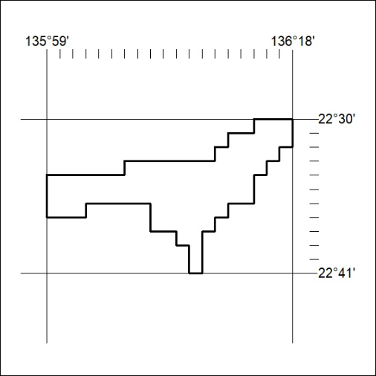
Area granted is indicated above. The titleholder is not permitted to exercise occupational rights on any land that is subject to a development title, or an application for a development title. Any land the subject of a Reserved Land gazettal under the Mineral Titles Act and all land vested in the Commonwealth of Australia is also excluded by description but not excised from the grant area.

250/24

Mineral Titles Act
NOTICE OF GRANT OF A MINERAL TITLE
Title Type and Number: | Exploration Licence 33821
Granted: | 15 August 2024, for a period of 6 Years
Area: | 19 Blocks, 32.00 km²
Locality: | WOOLLA
Name of Holder/s: | 100% WA1 RESOURCES LTD [ACN. 646 878 631]
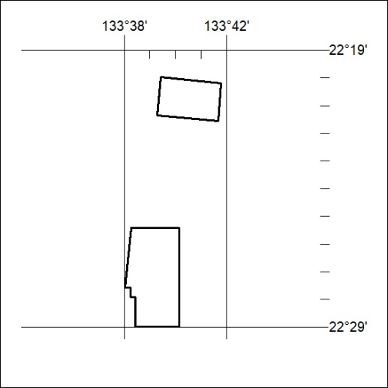
Area granted is indicated above. The titleholder is not permitted to exercise occupational rights on any land that is subject to a development title, or an application for a development title. Any land the subject of a Reserved Land gazettal under the Mineral Titles Act and all land vested in the Commonwealth of Australia is also excluded by description but not excised from the grant area.

251/24
Corrigendum
Notice Number 220/24 appearing in MN93/24 on 1 August 2024 is hereby cancelled and replaced by the following:

Mineral Titles Act 2010
NOTICE OF LAND CEASING TO BE A MINERAL TITLE AREA
Title Type and Number: | Exploration Licence 31799
Area Ceased on: | 31 July 2024
Area: | 53 Blocks, 170.98 km²
Locality: | BREADEN
Name of Applicant(s)/Holder(s): | 100% NORTHERN STAR (TANAMI) PTY LTD [ACN. 603 860 831]
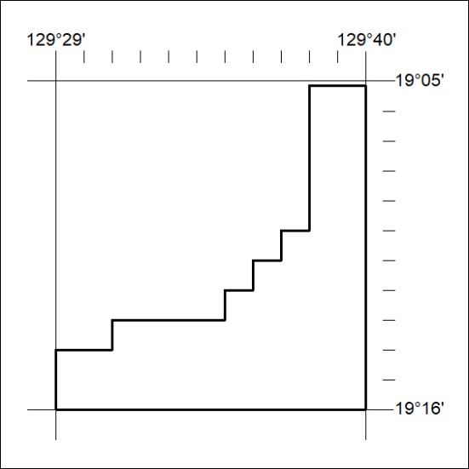

252/24

