Mineral Titles Act 2010
NOTICE OF LAND CEASING TO BE A MINERAL TITLE AREA
Title Type and Number: | Mineral Lease (Central) 96
Area ceased on: | 31 May 2024
Locality: | FLYNN
Name of Applicants(s)Holder(s): | 60% CUFE TENNANT CREEK PTY LTD [ACN. 655 367 105], 40% GECKO MINING COMPANY PTY LTD* [ACN. 169 920 745]
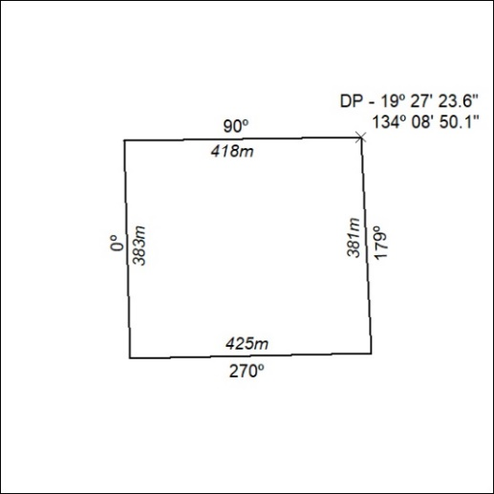
(Area now amalgamated into Mineral Lease 33869 under s102)

232/24

Mineral Titles Act 2010
NOTICE OF LAND CEASING TO BE A MINERAL TITLE AREA
Title Type and Number: | Mineral Lease (Central) 97
Area ceased on: | 31 May 2024
Locality: | FLYNN
Name of Applicants(s)Holder(s): | 60% CUFE TENNANT CREEK PTY LTD [ACN. 655 367 105], 40% GECKO MINING COMPANY PTY LTD* [ACN. 169 920 745]
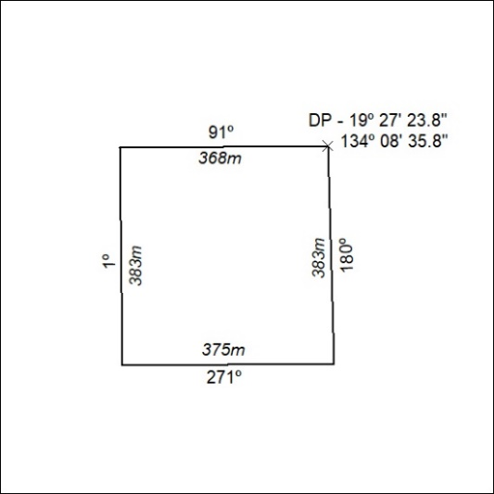
(Area now amalgamated into Mineral Lease 33869 under s102)

233/24

Mineral Titles Act 2010
NOTICE OF LAND CEASING TO BE A MINERAL TITLE AREA
Title Type and Number: | Mineral Lease (Northern) 878
Area ceased on: | 31 May 2024
Locality: | BATCHELOR
Name of Applicants(s)Holder(s): | 100% NT MINING OPERATIONS PTY LTD* [ACN. 136 525 990]
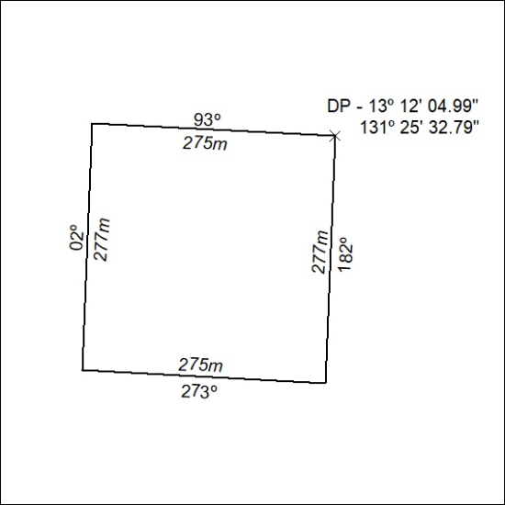
(Area now amalgamated into Mineral Lease 33870 under s102)

234/24

Mineral Titles Act 2010
NOTICE OF LAND CEASING TO BE A MINERAL TITLE AREA
Title Type and Number: | Mineral Lease (Northern) 879
Area ceased on: | 31 May 2024
Locality: | BATCHELOR
Name of Applicants(s)Holder(s): | 100% NT MINING OPERATIONS PTY LTD* [ACN. 136 525 990]
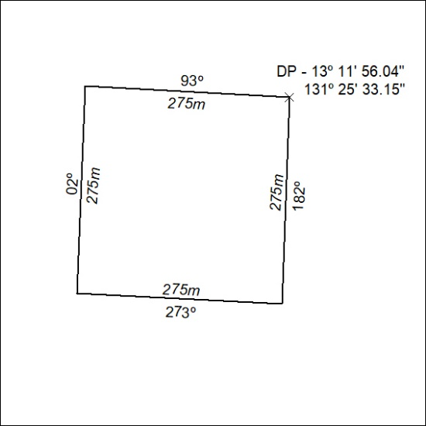
(Area now amalgamated into Mineral Lease 33870 under s102)

235/24

