Mineral Titles Act 2010
NOTICE OF LAND CEASING TO BE A MINERAL TITLE AREA
Title Type and Number: | Exploration Licence 32544
Area Ceased on: | 30 May 2024
Area: | 250 Blocks, 809.24 km²
Locality: | GALLIPOLI
Name of Applicant(s)/Holder(s): | 100% TECK AUSTRALIA PTY LTD [ACN. 091 271 911]
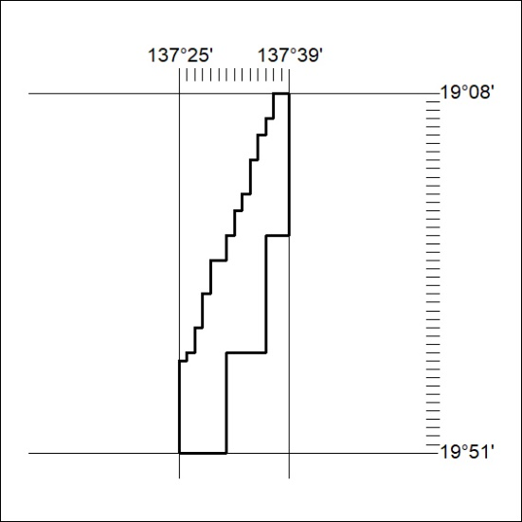

209/24

Mineral Titles Act 2010
NOTICE OF LAND CEASING TO BE A MINERAL TITLE AREA
Title Type and Number: | Exploration Licence 32545
Area Ceased on: | 30 May 2024
Area: | 124 Blocks, 402.38 km²
Locality: | LULU
Name of Applicant(s)/Holder(s): | 100% TECK AUSTRALIA PTY LTD [ACN. 091 271 911]
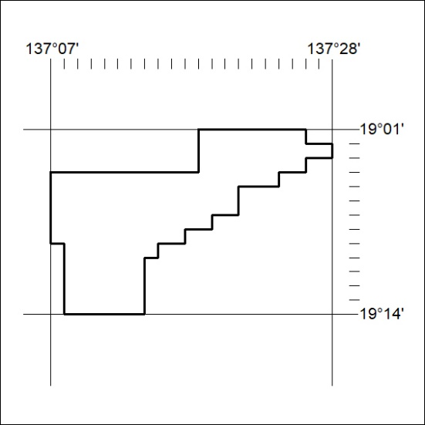

210/24

Mineral Titles Act 2010
NOTICE OF LAND CEASING TO BE A MINERAL TITLE AREA
Title Type and Number: | Exploration Licence 32547
Area Ceased on: | 30 May 2024
Area: | 235 Blocks, 758.04 km²
Locality: | AVON
Name of Applicant(s)/Holder(s): | 100% TECK AUSTRALIA PTY LTD [ACN. 091 271 911]
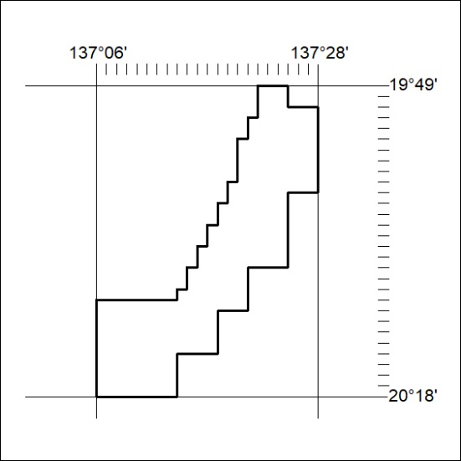

211/24

Mineral Titles Act 2010
NOTICE OF LAND CEASING TO BE A MINERAL TITLE AREA
Title Type and Number: | Exploration Licence 32548
Area Ceased on: | 30 May 2024
Area: | 180 Blocks, 583.50 km²
Locality: | LULU
Name of Applicant(s)/Holder(s): | 100% TECK AUSTRALIA PTY LTD [ACN. 091 271 911]
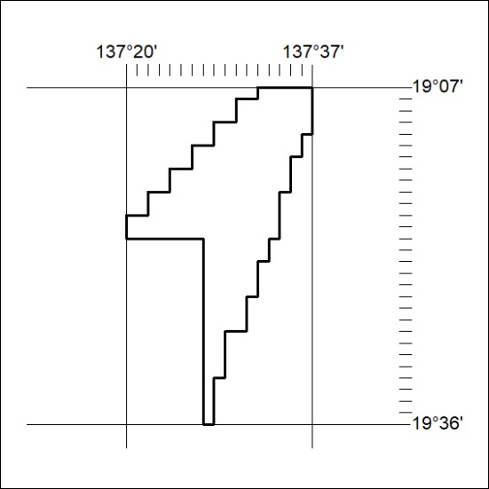

212/24

Mineral Titles Act 2010
NOTICE OF LAND CEASING TO BE A MINERAL TITLE AREA
Title Type and Number: | Exploration Licence 32549
Area Ceased on: | 30 May 2024
Area: | 180 Blocks, 577.40 km²
Locality: | LULU
Name of Applicant(s)/Holder(s): | 100% TECK AUSTRALIA PTY LTD [ACN. 091 271 911]
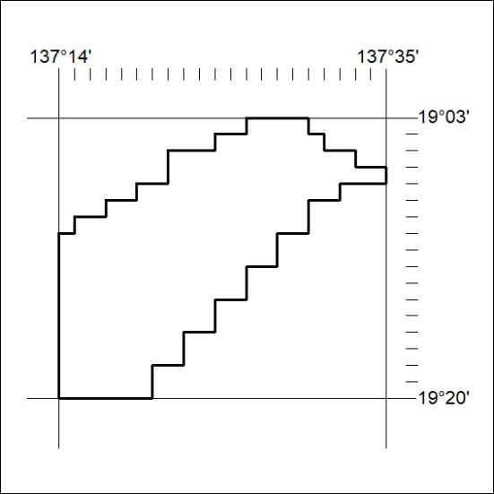

213/24

Mineral Titles Act 2010
NOTICE OF LAND CEASING TO BE A MINERAL TITLE AREA
Title Type and Number: | Exploration Licence 32731
Area Ceased on: | 30 May 2024
Area: | 198 Blocks, 612.69 km²
Locality: | AVON
Name of Applicant(s)/Holder(s): | 100% TECK AUSTRALIA PTY LTD [ACN. 091 271 911]
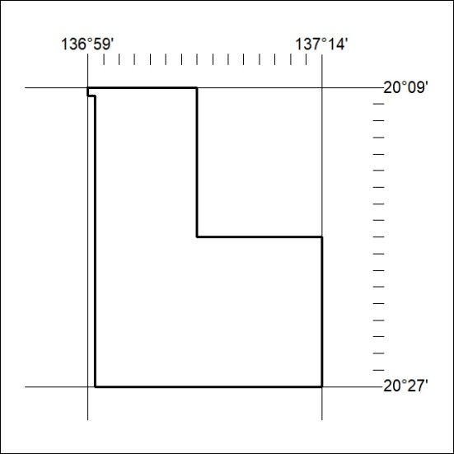

214/24

Mineral Titles Act 2010
NOTICE OF LAND CEASING TO BE A MINERAL TITLE AREA
Title Type and Number: | Exploration Licence 32732
Area Ceased on: | 30 May 2024
Area: | 198 Blocks, 637.49 km²
Locality: | AVON
Name of Applicant(s)/Holder(s): | 100% TECK AUSTRALIA PTY LTD [ACN. 091 271 911]
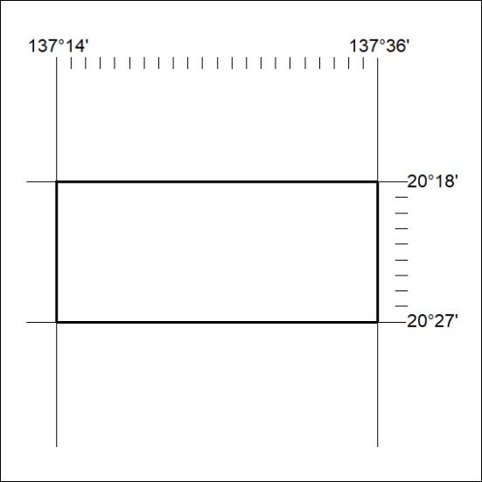

215/24

Mineral Titles Act 2010
NOTICE OF LAND CEASING TO BE A MINERAL TITLE AREA
Title Type and Number: | Exploration Licence 32733
Area Ceased on: | 30 May 2024
Area: | 220 Blocks, 709.27 km²
Locality: | AVON
Name of Applicant(s)/Holder(s): | 100% TECK AUSTRALIA PTY LTD [ACN. 091 271 911]
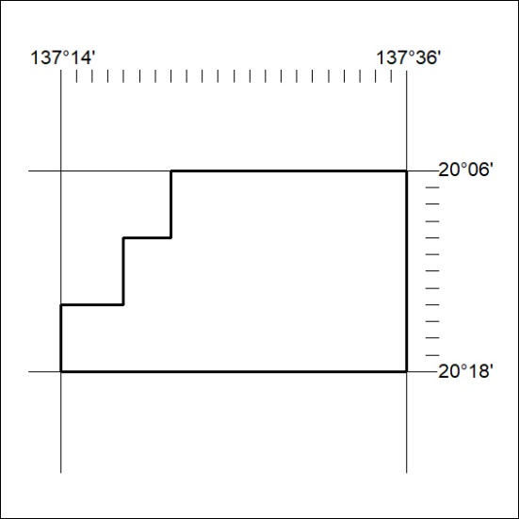

216/24

Mineral Titles Act 2010
NOTICE OF LAND CEASING TO BE A MINERAL TITLE AREA
Title Type and Number: | Exploration Licence 32922
Area Ceased on: | 30 May 2024
Area: | 190 Blocks, 591.84 km²
Locality: | RANKEN
Name of Applicant(s)/Holder(s): | 100% TECK AUSTRALIA PTY LTD [ACN. 091 271 911]
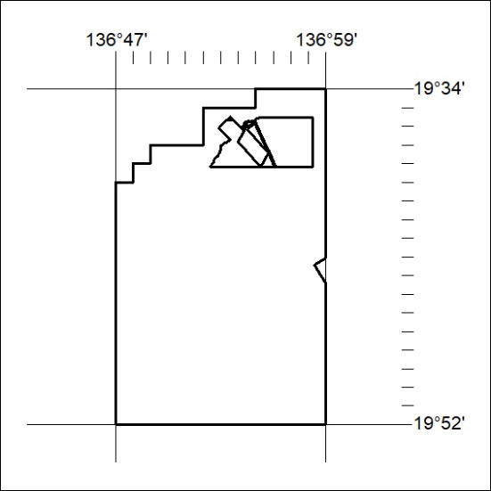

217/24

