Mineral Titles Act 2010
NOTICE OF LAND CEASING TO BE A MINERAL TITLE AREA
Title Type and Number: | Mineral Lease (Northern) 794
Area ceased on: | 08 May 2024
Area: | 6.00 Hectare
Locality: | PINE CREEK
Name of Applicants(s)Holder(s): | 100% PNX METALS LIMITED* [ACN. 127 446 271]
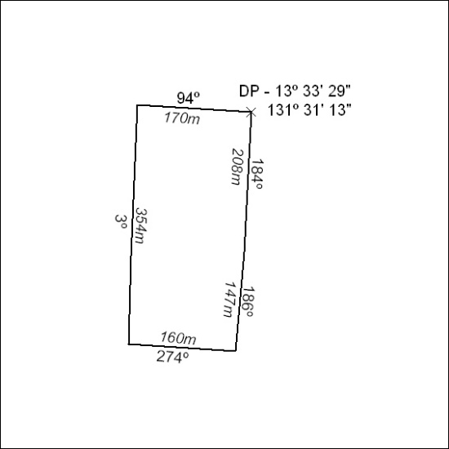
(Area now amalgamated into Mineral Lease 33743 under s102)

183/24

Mineral Titles Act 2010
NOTICE OF LAND CEASING TO BE A MINERAL TITLE AREA
Title Type and Number: | Mineral Lease (Northern) 795
Area ceased on: | 08 May 2024
Area: | 8.00 Hectare
Locality: | PINE CREEK
Name of Applicants(s)Holder(s): | 100% PNX METALS LIMITED* [ACN. 127 446 271]
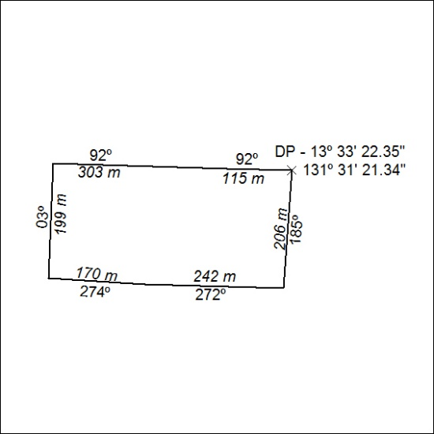
(Area now amalgamated into Mineral Lease 33743 under s102)

184/24

Mineral Titles Act 2010
NOTICE OF LAND CEASING TO BE A MINERAL TITLE APPLICATION AREA
Title Type and Number: | Mineral Lease 33495
Area ceased on: | 08 May 2024
Area: | 39.00 Hectare
Locality: | PINE CREEK
Name of Applicants(s)Holder(s): | 100% ROCKWASH PTY LTD [ACN. 611 356 837]
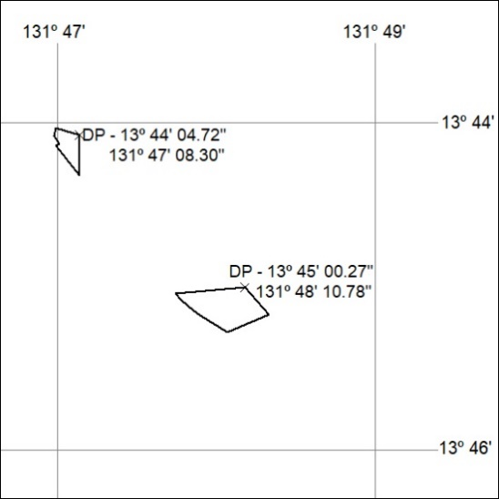

185/24

Mineral Titles Act 2010
NOTICE OF LAND CEASING TO BE A MINERAL TITLE APPLICATION AREA
Title Type and Number: | Mineral Lease 33496
Area ceased on: | 08 May 2024
Area: | 10.00 Hectare
Locality: | PINE CREEK
Name of Applicants(s)Holder(s): | 100% ROCKWASH PTY LTD [ACN. 611 356 837]
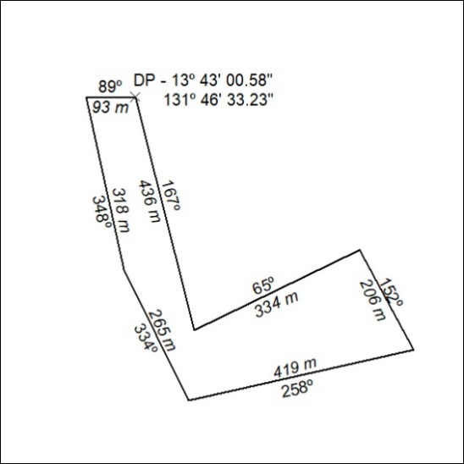

186/24

Mineral Titles Act
NOTICE OF GRANT OF A MINERAL TITLE
Title Type and Number: | Exploration Licence 33595
Granted: | 07 May 2024, for a period of 6 Years
Area: | 80 Blocks, 253.11 km²
Locality: | ALCOOTA
Name of Holder/s: | 100% PURE EXPLORATION PTY LTD [ACN. 669 443 636]
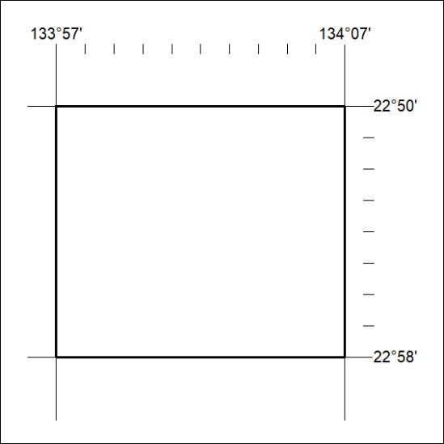
Area granted is indicated above. The titleholder is not permitted to exercise occupational rights on any land that is subject to a development title, or an application for a development title. Any land the subject of a Reserved Land gazettal under the Mineral Titles Act and all land vested in the Commonwealth of Australia is also excluded by description but not excised from the grant area.

187/24

