Mineral Titles Act
NOTICE OF GRANT OF A MINERAL TITLE
Title Type and Number: | Exploration Licence 33584
Granted: | 02 April 2024, for a period of 6 Years
Area: | 10 Blocks, 31.79 km²
Locality: | DOREEN
Name of Holder/s: | 100% GSW RESOURCES PTY LTD [ACN. 653 791 130]
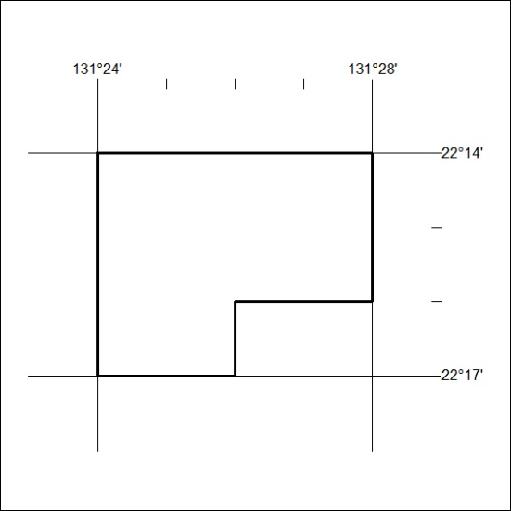
Area granted is indicated above. The titleholder is not permitted to exercise occupational rights on any land that is subject to a development title, or an application for a development title. Any land the subject of a Reserved Land gazettal under the Mineral Titles Act and all land vested in the Commonwealth of Australia is also excluded by description but not excised from the grant area.

87/24

Mineral Titles Act 2010
NOTICE OF LAND CEASING TO BE A MINERAL TITLE AREA
Title Type and Number: | Exploration Licence 32433
Area Ceased on: | 04 April 2024
Area: | 246 Blocks, 810.36 km²
Locality: | MIDDLE CREEK
Name of Applicant(s)/Holder(s): | 100% ENIGMA MINING LIMITED [ACN. 009 225 558]
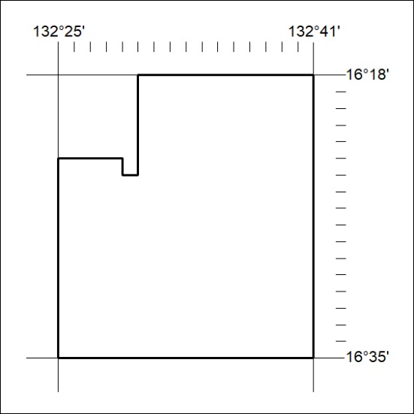

88/24
Mineral Titles Act 2010
NOTICE OF LAND CEASING TO BE A MINERAL TITLE AREA
Title Type and Number: | Exploration Licence 32434
Area Ceased on: | 04 April 2024
Area: | 238 Blocks, 783.99 km²
Locality: | MIDDLE CREEK
Name of Applicant(s)/Holder(s): | 100% ENIGMA MINING LIMITED [ACN. 009 225 558]

89/24

Mineral Titles Act 2010
NOTICE OF LAND CEASING TO BE A MINERAL TITLE APPLICATION AREA
Title Type and Number: | Exploration Licence 33560
Area Ceased on: | 04 April 2024
Area: | 72 Blocks, 232.93 km²
Locality: | BUCK
Name of Applicant(s)/Holder(s): | 100% RAREX LIMITED [ACN. 105 578 756]
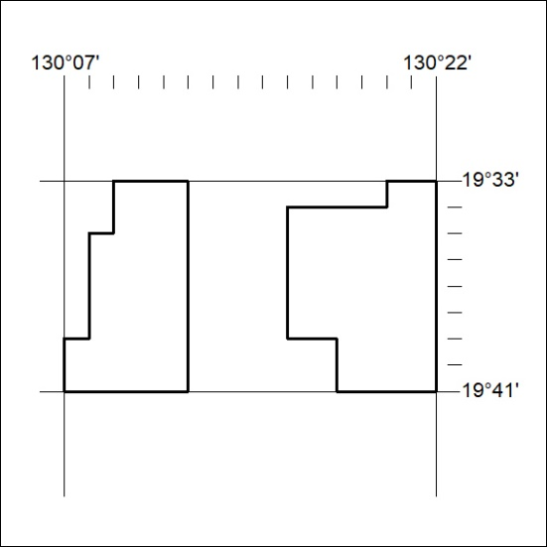

90/24
Mineral Titles Act 2010
NOTICE OF LAND CEASING TO BE A MINERAL TITLE APPLICATION AREA
Title Type and Number: | Exploration Licence 33712
Area Ceased on: | 04 April 2024
Area: | 61 Blocks, 197.31 km²
Locality: | BUCK
Name of Applicant(s)/Holder(s): | 100% RAREX LIMITED [ACN. 105 578 756]
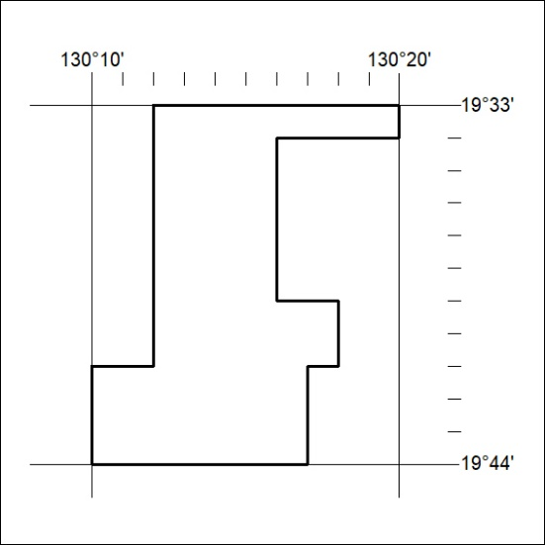

91/24

