Mineral Titles Act 2010
NOTICE OF LAND CEASING TO BE A MINERAL TITLE AREA
Title Type and Number: | Extractive Mineral Exploration Licence 32655
Area Ceased on: | 23 December 2023
Area: | 4 Blocks, 13.13 km²
Locality: | NEWCASTLE WATERS
Name of Applicant(s)/Holder(s): | 100% TERRITORY SANDS PTY LTD [ACN. 632 797 972]
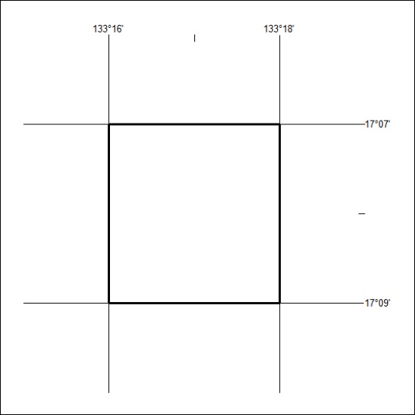

01/24

Mineral Titles Act 2010
NOTICE OF LAND CEASING TO BE A MINERAL TITLE AREA
Title Type and Number: | Extractive Mineral Exploration Licence 32661
Area Ceased on: | 23 December 2023
Area: | 4 Blocks, 13.13 km²
Locality: | NEWCASTLE WATERS
Name of Applicant(s)/Holder(s): | 100% TERRITORY SANDS PTY LTD [ACN. 632 797 972]
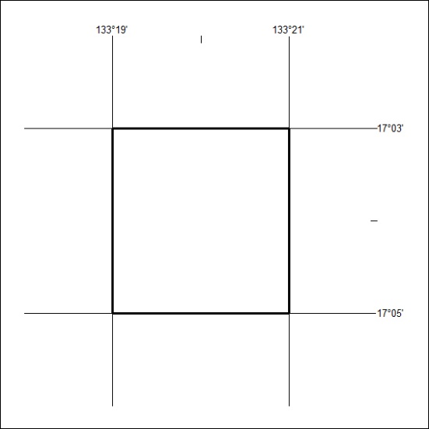

02/24

Mineral Titles Act 2010
NOTICE OF LAND CEASING TO BE A MINERAL TITLE AREA
Title Type and Number: | Extractive Mineral Lease 31404
Area ceased on: | 05 January 2024
Area: | 7.00 Hectare
Locality: | MARY RIVER
Name of Applicants(s)Holder(s): | 100% DARWIN CHRISTIAN MINISTRIES INC
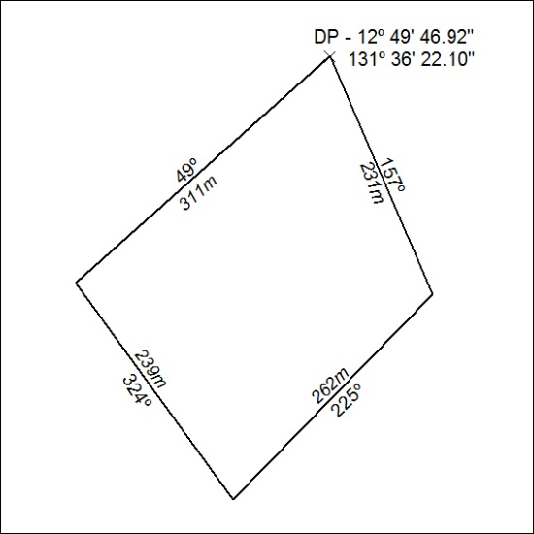

03/24

Mineral Titles Act 2010
NOTICE OF LAND CEASING TO BE A MINERAL TITLE AREA
Title Type and Number: | Mineral Lease (Central) 508
Area ceased on: | 31 December 2023
Area: | 5.00 Hectare
Locality: | TENNANT CREEK
Name of Applicants(s)Holder(s): | 16.67% CARTER Gowan Russell, 16.67% CARTER John Kirwin, 16.67% CARTER Pamela Ann, 16.67% CARTER Suzanne Lee, 16.66% COOK Alexander Kym, 16.66% COOK Jennifer Erica
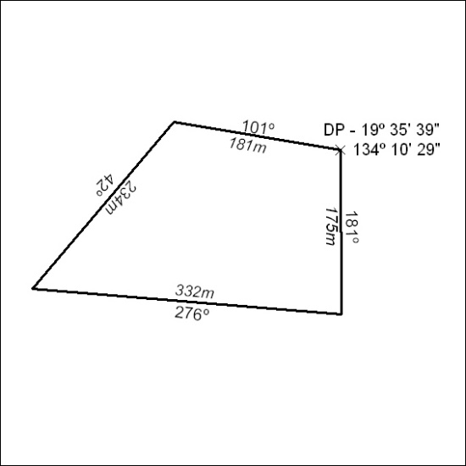
04/24

