Mineral Titles Act 2010
NOTICE OF LAND CEASING TO BE A MINERAL TITLE AREA
Title Type and Number: | Exploration Licence 32301
Area Ceased on: | 05 September 2023
Area: | 230 Blocks, 740.70 km²
Locality: | PLAYFORD
Name of Applicant(s)/Holder(s): | 100% BARKLY OPERATIONS PTY LTD [ACN. 641 856 706]
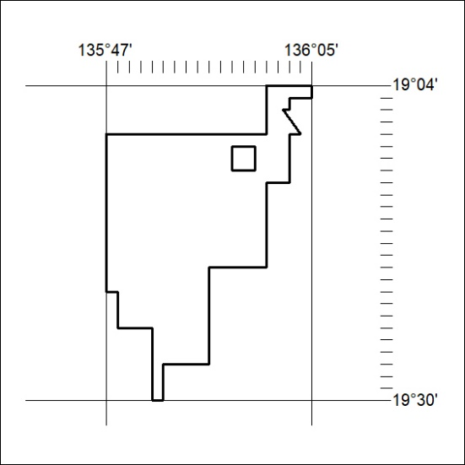
(Area now amalgamated into Exploration Licence 33590 under s102 – EL moratorium period does not apply)

362/23

Mineral Titles Act 2010
NOTICE OF LAND CEASING TO BE A MINERAL TITLE AREA
Title Type and Number: | Exploration Licence 32307
Area Ceased on: | 05 September 2023
Area: | 4 Blocks, 12.98 km²
Locality: | ALROY
Name of Applicant(s)/Holder(s): | 100% BARKLY OPERATIONS PTY LTD [ACN. 641 856 706]
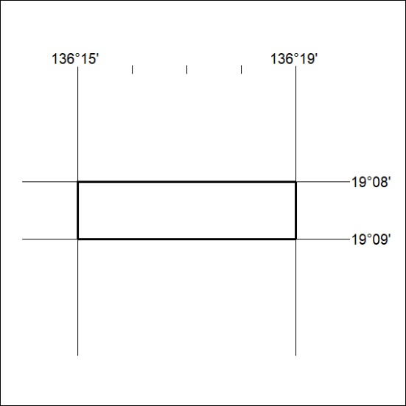
(Area now amalgamated into Exploration Licence 33589 under s102 – EL moratorium period does not apply)

363/23
Mineral Titles Act 2010
NOTICE OF LAND CEASING TO BE A MINERAL TITLE AREA
Title Type and Number: | Exploration Licence 32308
Area Ceased on: | 05 September 2023
Area: | 212 Blocks, 685.55 km²
Locality: | ALROY
Name of Applicant(s)/Holder(s): | 100% BARKLY OPERATIONS PTY LTD [ACN. 641 856 706]
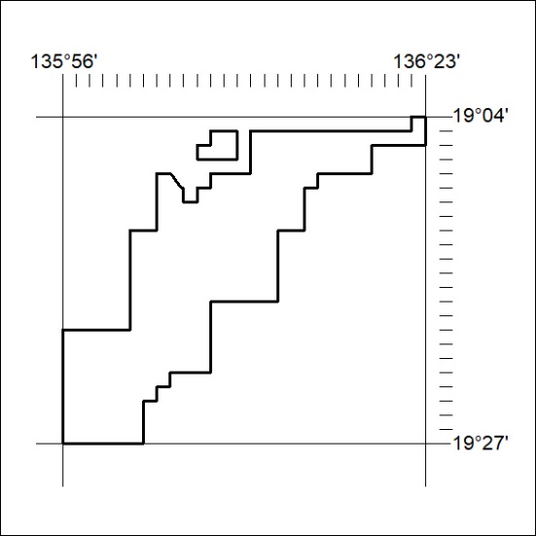
(Area now amalgamated into Exploration Licence 33589 under s102 – EL moratorium period does not apply)

364/23

Mineral Titles Act 2010
NOTICE OF LAND CEASING TO BE A MINERAL TITLE AREA
Title Type and Number: | Exploration Licence 32309
Area Ceased on: | 05 September 2023
Area: | 106 Blocks, 343.47 km²
Locality: | ALROY
Name of Applicant(s)/Holder(s): | 100% BARKLY OPERATIONS PTY LTD [ACN. 641 856 706]
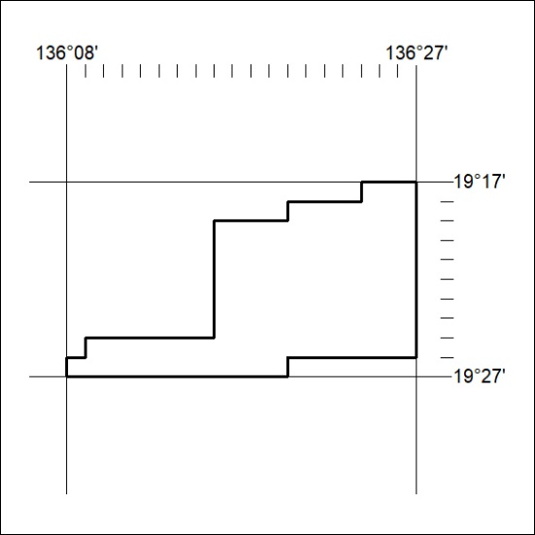
(Area now amalgamated into Exploration Licence 33588 under s102 – EL moratorium period does not apply)

365/23
Mineral Titles Act 2010
NOTICE OF LAND CEASING TO BE A MINERAL TITLE AREA
Title Type and Number: | Exploration Licence 32816
Area Ceased on: | 05 September 2023
Area: | 4 Blocks, 12.98 km²
Locality: | PLAYFORD
Name of Applicant(s)/Holder(s): | 100% BARKLY OPERATIONS PTY LTD [ACN. 641 856 706]
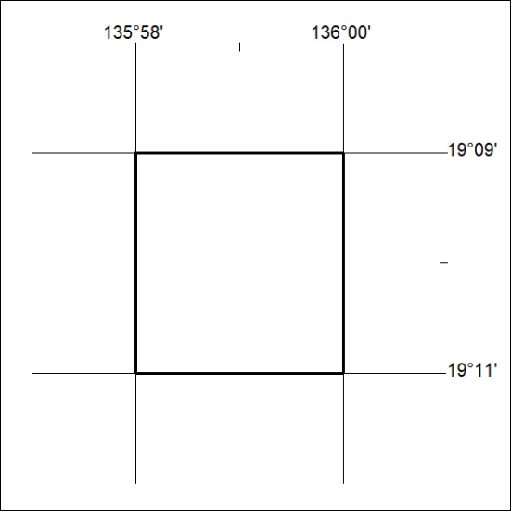
(Area now amalgamated into Exploration Licence 33590 under s102 – EL moratorium period does not apply)

366/23

Mineral Titles Act 2010
NOTICE OF LAND CEASING TO BE A MINERAL TITLE AREA
Title Type and Number: | Exploration Licence 33507
Area Ceased on: | 05 September 2023
Area: | 43 Blocks, 139.27 km²
Locality: | ALROY
Name of Applicant(s)/Holder(s): | 100% BARKLY OPERATIONS PTY LTD [ACN. 641 856 706]
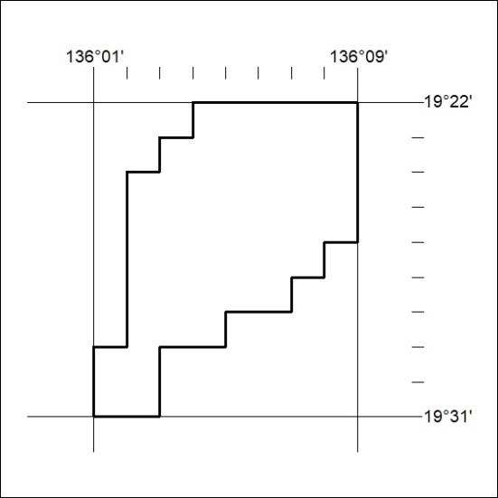
(Area now amalgamated into Exploration Licence 33588 under s102 – EL moratorium period does not apply)

367/23
Mineral Titles Act 2010
NOTICE OF LAND CEASING TO BE A MINERAL TITLE APPLICATION AREA
Title Type and Number: | Exploration Licence 33552
Area Ceased on: | 07 September 2023
Area: | 118 Blocks, 374.03 km²
Locality: | NICKER
Name of Applicant(s)/Holder(s): | 100% NT1 PTY LTD [ACN. 664 042 746]
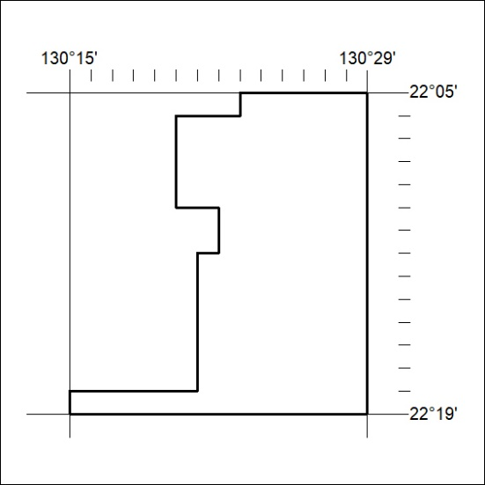

368/23

Mineral Titles Act 2010
NOTICE OF LAND CEASING TO BE A MINERAL TITLE APPLICATION AREA
Title Type and Number: | Exploration Licence 33553
Area Ceased on: | 07 September 2023
Area: | 92 Blocks, 292.64 km²
Locality: | NICKER
Name of Applicant(s)/Holder(s): | 100% NT1 PTY LTD [ACN. 664 042 746]
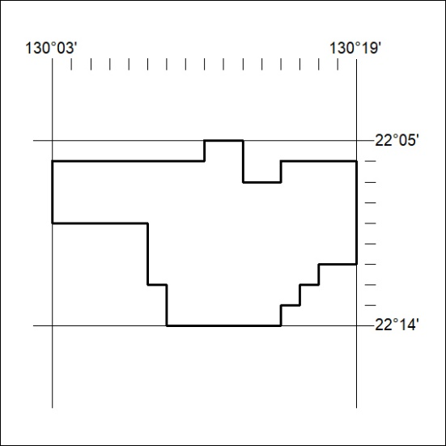

369/23

