Mineral Titles Act 2010
NOTICE OF LAND CEASING TO BE A MINERAL TITLE AREA
Title Type and Number: | Exploration Licence 32283
Area Ceased on: | 23 February 2023
Area: | 128 Blocks, 402.26 km²
Locality: | FAVENC
Name of Applicant(s)/Holder(s): | 100% KNOX RESOURCES PTY LTD* [ACN. 623 480 286]
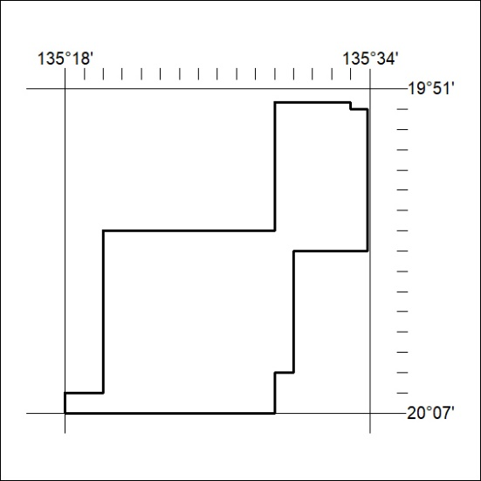
(Area now amalgamated into Exploration Licence 33376 under s102 – EL moratorium period does not apply)

047/23

Mineral Titles Act 2010
NOTICE OF LAND CEASING TO BE A MINERAL TITLE AREA
Title Type and Number: | Exploration Licence 32964
Area Ceased on: | 23 February 2023
Area: | 1 Block, 1.01 km²
Locality: | DALMORE
Name of Applicant(s)/Holder(s): | 100% KNOX RESOURCES PTY LTD* [ACN. 623 480 286]
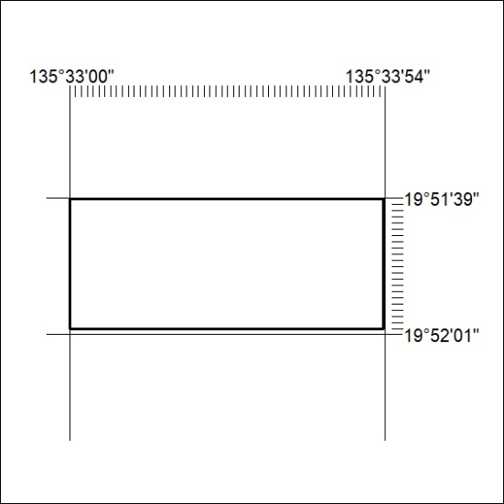
(Area now amalgamated into Exploration Licence 33376 under s102 – EL moratorium period does not apply)

048/23

Mineral Titles Act
NOTICE OF GRANT OF A MINERAL TITLE
Title Type and Number: | Exploration Licence 33262
Granted: | 22 February 2023, for a period of 6 Years
Area: | 242 Blocks, 769.68 km²
Locality: | MACDONALD DOWNS
Name of Holder/s: | 100% SANDFIRE RESOURCES LIMITED* [ACN. 105 154 185]
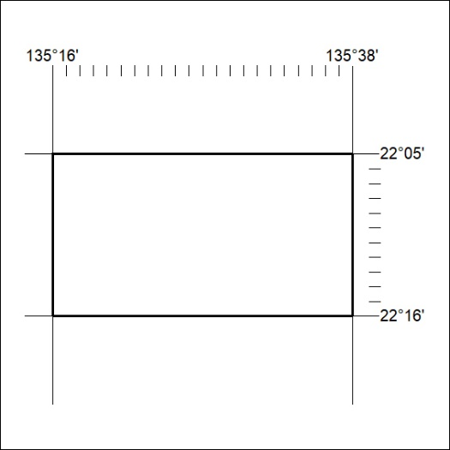
Area granted is indicated above. The titleholder is not permitted to exercise occupational rights on any land that is subject to a development title, or an application for a development title. Any land the subject of a Reserved Land gazettal under the Mineral Titles Act and all land vested in the Commonwealth of Australia is also excluded by description but not excised from the grant area.

049/23

Mineral Titles Act
NOTICE OF GRANT OF A MINERAL TITLE
Title Type and Number: | Exploration Licence 33263
Granted: | 22 February 2023, for a period of 6 Years
Area: | 242 Blocks, 769.68 km²
Locality: | ARAPUNGA
Name of Holder/s: | 100% SANDFIRE RESOURCES LIMITED* [ACN. 105 154 185]
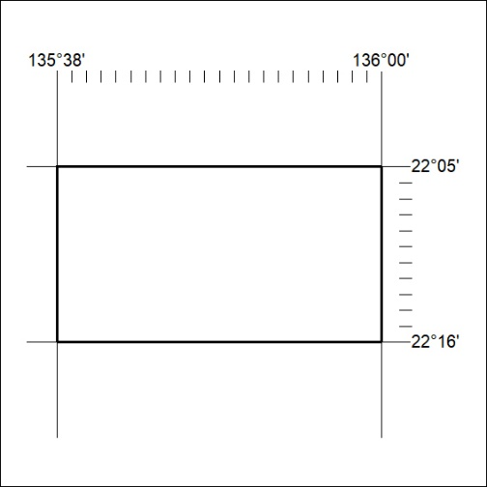
Area granted is indicated above. The titleholder is not permitted to exercise occupational rights on any land that is subject to a development title, or an application for a development title. Any land the subject of a Reserved Land gazettal under the Mineral Titles Act and all land vested in the Commonwealth of Australia is also excluded by description but not excised from the grant area.

050/23

Mineral Titles Act
NOTICE OF GRANT OF A MINERAL TITLE
Title Type and Number: | Exploration Licence 33264
Granted: | 22 February 2023, for a period of 6 Years
Area: | 231 Blocks, 734.70 km²
Locality: | LUCY
Name of Holder/s: | 100% SANDFIRE RESOURCES LIMITED* [ACN. 105 154 185]
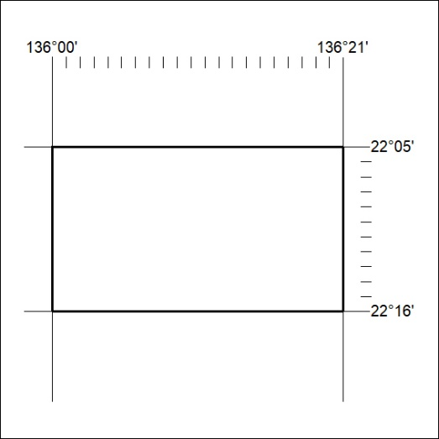
Area granted is indicated above. The titleholder is not permitted to exercise occupational rights on any land that is subject to a development title, or an application for a development title. Any land the subject of a Reserved Land gazettal under the Mineral Titles Act and all land vested in the Commonwealth of Australia is also excluded by description but not excised from the grant area.

051/23

Mineral Titles Act
NOTICE OF GRANT OF A MINERAL TITLE
Title Type and Number: | Exploration Licence 33265
Granted: | 22 February 2023, for a period of 6 Years
Area: | 206 Blocks, 655.12 km²
Locality: | LUCY
Name of Holder/s: | 100% SANDFIRE RESOURCES LIMITED* [ACN. 105 154 185]
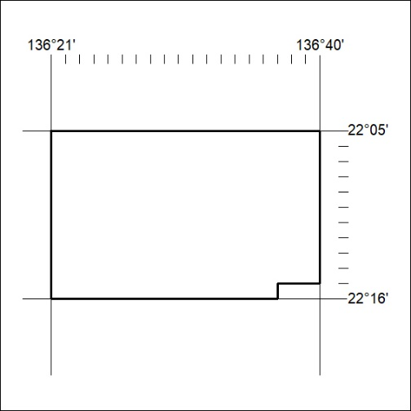
Area granted is indicated above. The titleholder is not permitted to exercise occupational rights on any land that is subject to a development title, or an application for a development title. Any land the subject of a Reserved Land gazettal under the Mineral Titles Act and all land vested in the Commonwealth of Australia is also excluded by description but not excised from the grant area.

052/23

Mineral Titles Act
NOTICE OF GRANT OF A MINERAL TITLE
Title Type and Number: | Exploration Licence 33266
Granted: | 22 February 2023, for a period of 6 Years
Area: | 181 Blocks, 559.00 km²
Locality: | MACDONALD DOWNS
Name of Holder/s: | 100% SANDFIRE RESOURCES LIMITED* [ACN. 105 154 185]
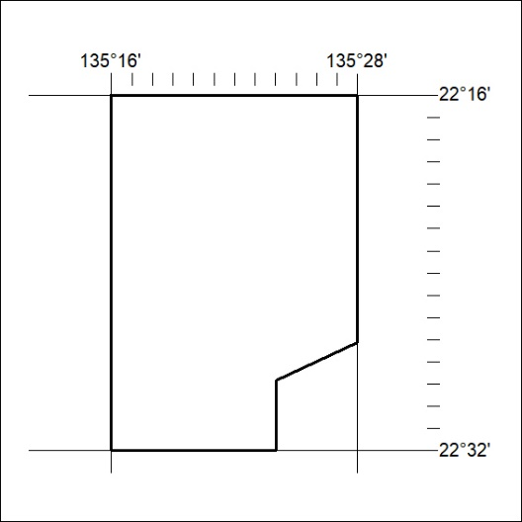
Area granted is indicated above. The titleholder is not permitted to exercise occupational rights on any land that is subject to a development title, or an application for a development title. Any land the subject of a Reserved Land gazettal under the Mineral Titles Act and all land vested in the Commonwealth of Australia is also excluded by description but not excised from the grant area.

053/23

Mineral Titles Act
NOTICE OF GRANT OF A MINERAL TITLE
Title Type and Number: | Exploration Licence 33267
Granted: | 22 February 2023, for a period of 6 Years
Area: | 230 Blocks, 714.80 km²
Locality: | ARAPUNGA
Name of Holder/s: | 100% SANDFIRE RESOURCES LIMITED* [ACN. 105 154 185]
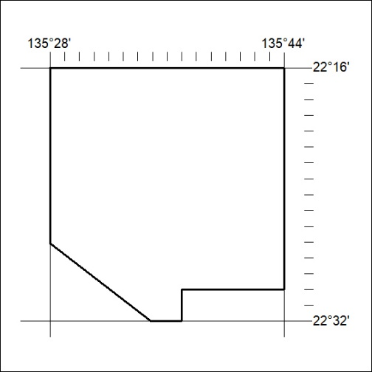
Area granted is indicated above. The titleholder is not permitted to exercise occupational rights on any land that is subject to a development title, or an application for a development title. Any land the subject of a Reserved Land gazettal under the Mineral Titles Act and all land vested in the Commonwealth of Australia is also excluded by description but not excised from the grant area.

054/23

Mineral Titles Act
NOTICE OF GRANT OF A MINERAL TITLE
Title Type and Number: | Exploration Licence 33268
Granted: | 22 February 2023, for a period of 6 Years
Area: | 240 Blocks, 762.26 km²
Locality: | ARAPUNGA
Name of Holder/s: | 100% SANDFIRE RESOURCES LIMITED* [ACN. 105 154 185]
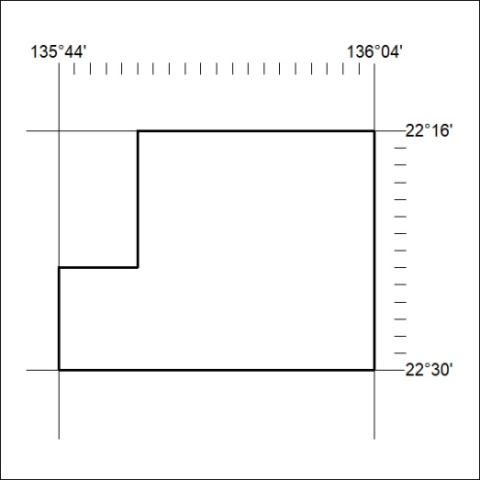
Area granted is indicated above. The titleholder is not permitted to exercise occupational rights on any land that is subject to a development title, or an application for a development title. Any land the subject of a Reserved Land gazettal under the Mineral Titles Act and all land vested in the Commonwealth of Australia is also excluded by description but not excised from the grant area.

055/23

Mineral Titles Act
NOTICE OF GRANT OF A MINERAL TITLE
Title Type and Number: | Exploration Licence 33269
Granted: | 22 February 2023, for a period of 6 Years
Area: | 238 Blocks, 755.83 km²
Locality: | LUCY
Name of Holder/s: | 100% SANDFIRE RESOURCES LIMITED* [ACN. 105 154 185]
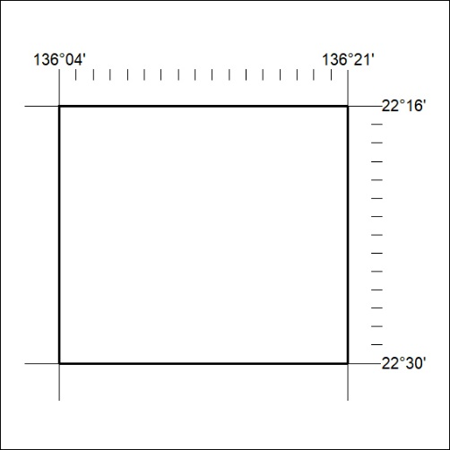
Area granted is indicated above. The titleholder is not permitted to exercise occupational rights on any land that is subject to a development title, or an application for a development title. Any land the subject of a Reserved Land gazettal under the Mineral Titles Act and all land vested in the Commonwealth of Australia is also excluded by description but not excised from the grant area.

056/23

Mineral Titles Act
NOTICE OF GRANT OF A MINERAL TITLE
Title Type and Number: | Exploration Licence 33270
Granted: | 22 February 2023, for a period of 6 Years
Area: | 224 Blocks, 711.37 km²
Locality: | LUCY
Name of Holder/s: | 100% SANDFIRE RESOURCES LIMITED* [ACN. 105 154 185]
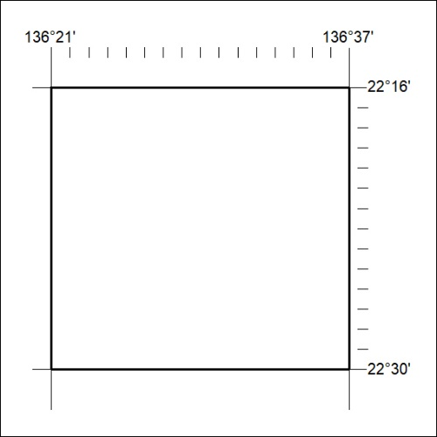
Area granted is indicated above. The titleholder is not permitted to exercise occupational rights on any land that is subject to a development title, or an application for a development title. Any land the subject of a Reserved Land gazettal under the Mineral Titles Act and all land vested in the Commonwealth of Australia is also excluded by description but not excised from the grant area.

057/23

Mineral Titles Act
NOTICE OF GRANT OF A MINERAL TITLE
Title Type and Number: | Exploration Licence 33271
Granted: | 22 February 2023, for a period of 6 Years
Area: | 171 Blocks, 510.85 km²
Locality: | JINKA
Name of Holder/s: | 100% SANDFIRE RESOURCES LIMITED* [ACN. 105 154 185]
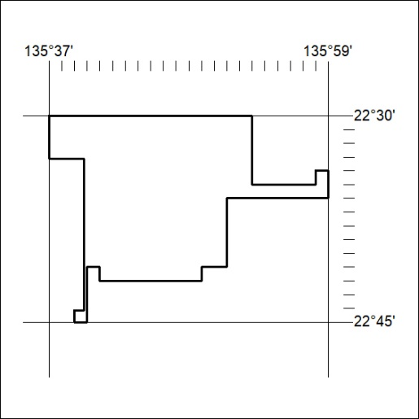
Area granted is indicated above. The titleholder is not permitted to exercise occupational rights on any land that is subject to a development title, or an application for a development title. Any land the subject of a Reserved Land gazettal under the Mineral Titles Act and all land vested in the Commonwealth of Australia is also excluded by description but not excised from the grant area.

058/23

Mineral Titles Act
NOTICE OF GRANT OF A MINERAL TITLE
Title Type and Number: | Exploration Licence 33272
Granted: | 22 February 2023, for a period of 6 Years
Area: | 117 Blocks, 369.29 km²
Locality: | JERVOIS RANGE
Name of Holder/s: | 100% SANDFIRE RESOURCES LIMITED* [ACN. 105 154 185]
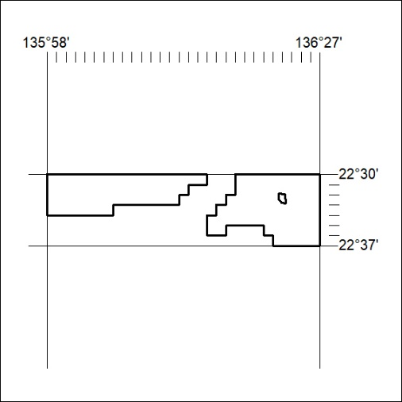
Area granted is indicated above. The titleholder is not permitted to exercise occupational rights on any land that is subject to a development title, or an application for a development title. Any land the subject of a Reserved Land gazettal under the Mineral Titles Act and all land vested in the Commonwealth of Australia is also excluded by description but not excised from the grant area.

059/23

Mineral Titles Act
NOTICE OF GRANT OF A MINERAL TITLE
Title Type and Number: | Exploration Licence 33275
Granted: | 22 February 2023, for a period of 6 Years
Area: | 52 Blocks, 164.80 km²
Locality: | JERVOIS RANGE
Name of Holder/s: | 100% SANDFIRE RESOURCES LIMITED* [ACN. 105 154 185]
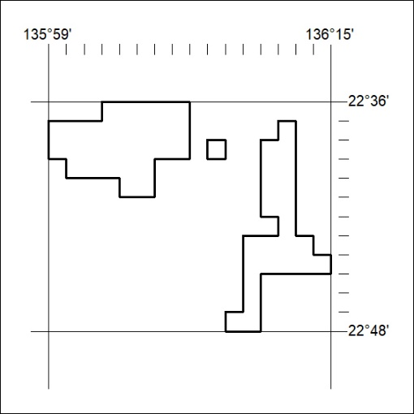
Area granted is indicated above. The titleholder is not permitted to exercise occupational rights on any land that is subject to a development title, or an application for a development title. Any land the subject of a Reserved Land gazettal under the Mineral Titles Act and all land vested in the Commonwealth of Australia is also excluded by description but not excised from the grant area.

060/23

