Mineral Titles Act 2010
NOTICE OF LAND CEASING TO BE A MINERAL TITLE AREA
Title Type and Number: | Extractive Mineral Lease 28404
Area ceased on: | 06 January 2023
Area: | 66.00 Hectare
Locality: | NOONAMAH
Name of Applicants(s)Holder(s): | 100% ACACIA QUARRY HOLDINGS PTY LTD* [ACN. 139 700 520]
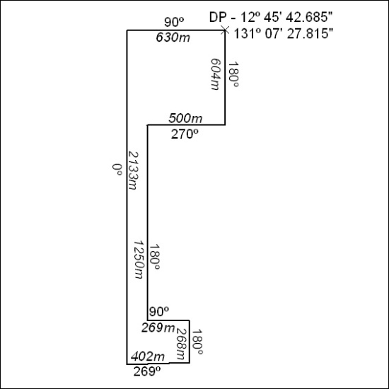

012/23

