  - Biosecurity

Foot-and-mouth disease
Foot-and-mouth disease (FMD) is caused by a virus that can infect cloven hoofed (two-toed) animals including cattle, buffalo, pigs, goat, sheep and deer. An incursion of FMD in Australia would be devastating for all livestock industries and impact other sectors such as tourism.

How could FMD enter Australia and how does it spread?
- FMD is one of the most contagious animal diseases. Infected animals excrete the virus in fluid from ruptured blisters, exhaled air and body fluids.
- The virus is spread between animals by direct contact with an infected animal or via contaminated equipment or clothing. It can also be spread in the air through expelled air from an infected animal. Pigs are known to produce a lot of the virus when infected and are a high risk spreading FMD to other animals.
- FMD virus can survive in meat and dairy products. The most likely way FMD could enter Australia is via the illegal importation of contaminated products from overseas.

What can you do
- Never feed pigs any kitchen scraps. These could have products contaminated with the virus.
- Keep pigs out of dumps.
- Never bring any meat or animal products back into Australia if you’ve been travelling overseas.
- If you have been hiking, or visiting farms or rural areas overseas you must declare this on entry.

If you have any young animals that die suddenly or you suspect one of your animals may have blisters (formed or ruptured), call the Emergency Animal Disease (EAD) Hotline immediately 1800 675 888.

What to look for
In all species, high death rates in young animals is common.
Cattle and buffalo  - lethargic and reluctant to walk  - increased drooling  - blisters or ruptured blisters in the mouth and on the tongue, teats of females, between the toes and around the top of the hoof.  - rapid weight loss. | 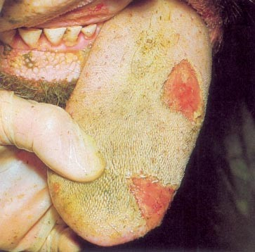
Pigs  - lameness caused by blisters  - blanched (white) looking skin around the hoof  - pigs may appear to want to crawl instead of walk due to painful hooves  - blisters on snouts  - in severe cases the hoof may appear to be detaching from the toes. | 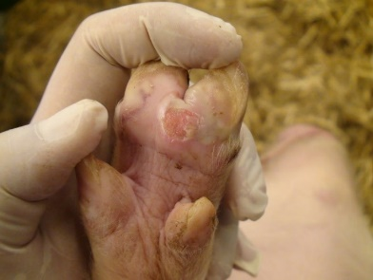
Sheep and goats  - FMD in sheep and goats have very mild and easily missed clinical signs  - fever and lameness in one or more legs  - blisters may form in the mouth but are not as noticeable in comparison to cattle. | 