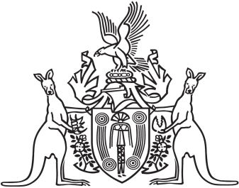
Northern Territory of Australia

Government Gazette
ISSN-0157-833X
No. S111 20 December 2018
Northern Territory of Australia
Licensing (Director-General) Act 2014
Appointment of Acting Director-General of Licensing
I, Natasha Kate Fyles, Attorney-General and Minister for Justice:
(a) under section 5(2) of the Licensing (Director-General) Act 2014 and with reference to section 44(1) of the Interpretation Act, terminate the appointment of Cynthia-Lee Bravos as the Director-General of Licensing with effect on and from 1 January 2019; and
(b) under section 5(2) of the Act and with reference to section 44A of the Interpretation Act, appoint Sally Grace Ozolins to act in the office of Director-General of Licensing for 6 months on and from 1 January 2019 during a vacancy in the office.
Dated 19 December 2018
N. K. Fyles
Attorney-General and Minister for Justice

