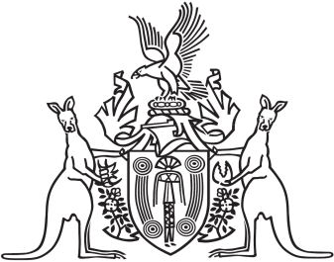
Northern Territory of Australia

Government Gazette
ISSN-0157-833X
No. S43 22 June 2018
Northern Territory of Australia
Public Sector Employment and Management Act
Appointment of Chief Executive Officer
I, Michael Patrick Francis Gunner, Chief Minister, under section 19A(1)
of the Public Sector Employment and Management Act, appoint
Simonne Peta Shepherd to be the Chief Executive Officer of the Department of Tourism and Culture on and from 25 June 2018.
Dated 18 June 2018
M. P. F. Gunner
Chief Minister
Northern Territory of Australia

Tourism NT Act
Appointment of Chief Executive Officer
I, Michael Patrick Francis Gunner, Chief Minister, under section 12(1) of the Tourism NT Act, appoint Simonne Peta Shepherd to be the Chief Executive Officer of Tourism NT on and from 25 June 2018.
Dated 21 June 2018
M. P. F. Gunner
Chief Minister

