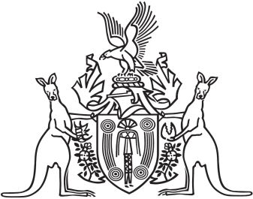
Northern Territory of Australia

Government Gazette
ISSN-0157-833X
No. S28 3 May 2018
Northern Territory of Australia

Assembly Members and Statutory Officers (Remuneration and Other Entitlements) Amendment Act 2017
Commencement Notice

I, Vicki Susan O'Halloran, Administrator of the Northern Territory of Australia, under section 2 of the Assembly Members and Statutory Officers (Remuneration and Other Entitlements) Amendment Act 2017 (No. 20 of 2017), fix 3 May 2018 as the day on which the Act commences.
Dated 3 May 2018
V. S. O'Halloran
Administrator

