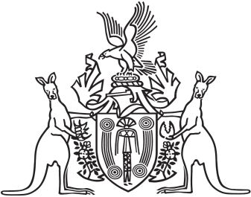
Northern Territory of Australia

Government Gazette
ISSN-0157-833X
No. S34 26 June 2017
Northern Territory of Australia

Pastoral Land Act
Declaration of Rate of Rent
I, Lauren Jane Moss, Minister for Environment and Natural Resources, under section 55(2) of the Pastoral Land Act, declare 0.616% of the unimproved value of pastoral land, using 2015 valuations as determined under the Valuation of Land Act, to be the rent payable for pastoral leases in all Districts for the financial year commencing on 1 July 2017.
Dated 19 June 2017
L. J. Moss
Minister for Environment and Natural Resources

