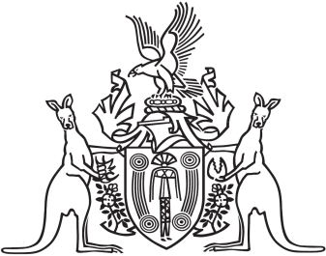

Northern Territory of Australia

Government Gazette

ISSN-0157-833X

No. S13 27 March 2017

Notice of intention to transfer property of an association