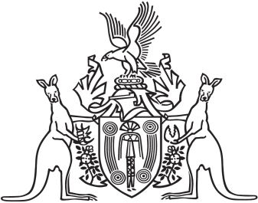
Northern Territory of Australia

Government Gazette
ISSN-0157-833X
No. S55 28 June 2016
Northern Territory of Australia

Northern Territory Civil and Administrative Tribunal Act
Appointment of Ordinary Member of Tribunal
I, John Laurence Hardy, Administrator of the Northern Territory of Australia, acting with the advice of the Executive Council, under section 16(1) of the Northern Territory Civil and Administrative Tribunal Act and with reference to section 16(2)(b) of the Act, appoint John Wilfred Death to be an ordinary member of the Northern Territory Civil and Administrative Tribunal on and from the date on which this instrument is published in the Gazette.
Dated 28 June 2016
J. L. Hardy
Administrator
By His Honour's Command
P. D. Styles
Minister for Business
acting for
Attorney-General and Minister for Justice

