Mining Management Plan
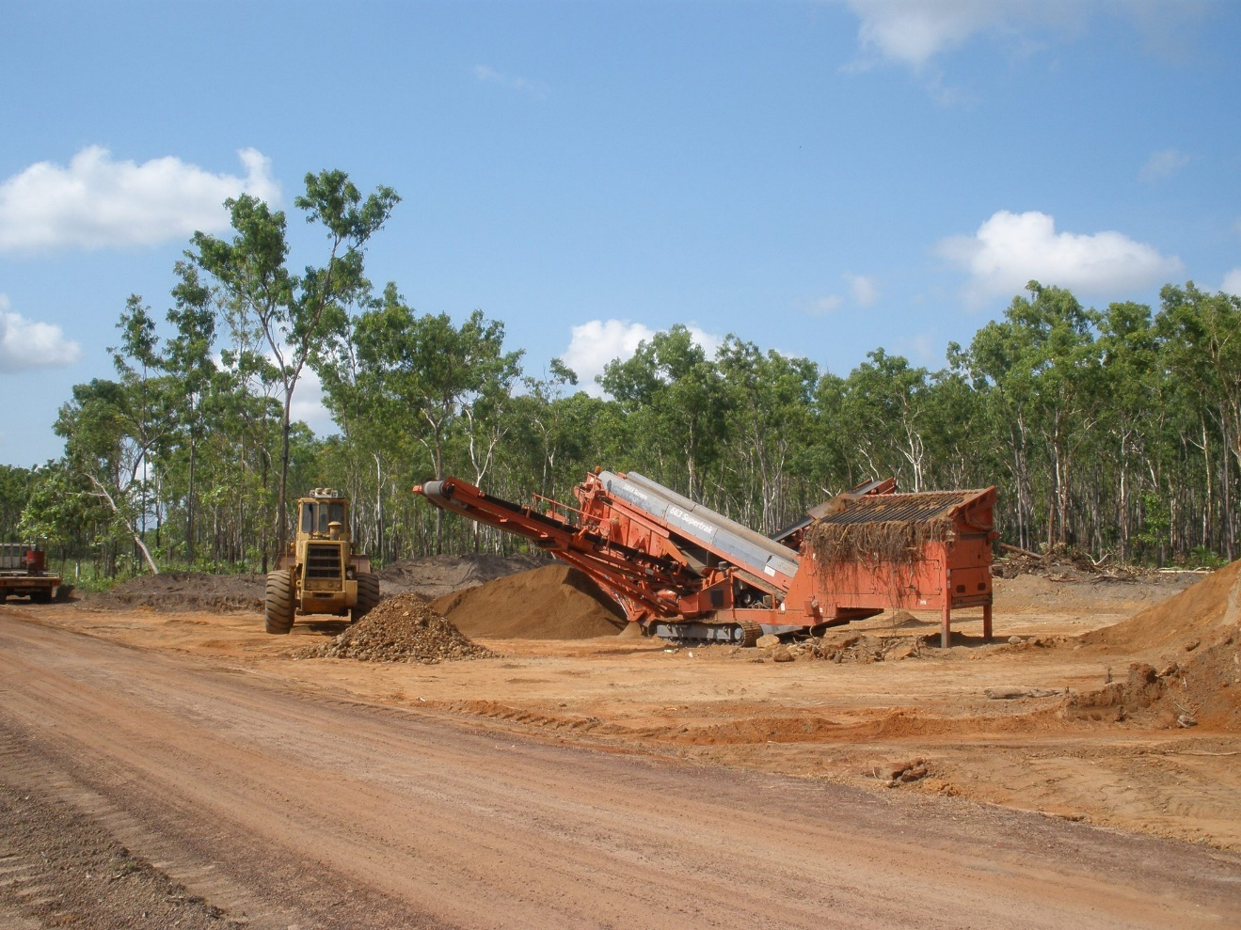
  - Project Name:
Operator Name:
Authorisation: XXXX-XX
Date:

Photo for illustration purposes only. Remove or replace with a site specific photo upon submission of MMP.
NOTE 1: this template has been designed to guide you through the MMP Process. Itallic text is provided for guidance and should be edited/deleted according to your specific project, circumstances and environmental commitments.
NOTE 2: Do you need to submit an MMP? Review your approved Mining Management Plan (MMP). If there are no changes, an annual MMP is not required. Rather, notify the department, via email, that there are no changes.

Term | Definition
Closure | Closure is achieved when it has been demonstrated that rehabilitation is successful and closure criteria have been achieved.On completion of the rehabilitation of a mining site to the satisfaction of the Minister, the operator for the site may apply to the Minister for a certificate of closure.
Closure criteria | The standard or level of performance, as specified in the mining management plan for the mining site, which demonstrates successful closure of the site. Criteria should be specific, measurable, achievable, relevant and time-based.  The agreed next-land use will inform the closure criteria. Usually closure aims to return disturbed land to a safe, stable and non-polluting state.  Closure is achieved when it has been demonstrated that the closure criteria have been met.
DITT | Department of Industry, Tourism and Trade.
Disturbance  footprint | The area or extent of un-rehabilitated land within the title area that has been altered by operations and which has not yet been successfully rehabilitated.  The disturbance footprint will vary with time.
Environmental Management System (EMS) | The environmental protection management system for a mining site, established, implemented and maintained under Section 16 (2)(c) of the MMA. It is the system that enables an organisation to achieve its environmental goals through consistent review, evaluation, and improvement of its environmental performance.
End of mine life | The date at which mining activities are proposed to cease.
Extractive Operation | A pit or excavation made in land below the natural surface for the purpose of extracting sand, rock, soil or gravel. Can also include removal of stockpiled material.
Rehabilitation | The process of restoring the site after completion of extraction. It broadly involves landform design, contouring, surface water management and revegetation.  It can also include the physical works on sites, such decommissioning, decontamination and demolition of infrastructure; bulk earthworks for contouring and spreading of topsoil/growth medium.  Regular monitoring for weeds, erosion, revegetation growth etc. is required and where monitoring identifies issues, further rehabilitation works may be required e.g. repairing washouts, ripping, mulching.
Significant Impact Assessment | An assessment, which considers the impacts of your proposed activities on identified sensitive species and habitats. This assessment is to be conducted by a suitably qualified person.
Suitably Qualified Person | Typically persons undertaking studies for environmental assessment have a tertiary qualification in environmental science, or multiple years of relevant work experience equivalent to such a qualification (e.g familiarity with regional ecosystems and biota; erosion and sediment control management and systems).

Acronyms | Full form
AAPA | Aboriginal Areas Protection Authority
ABN and ACN | Australian Business Number and Australian Company Number
ASIC-ABR | Australian Securities and Investments Commission – Australian Business Register
DEPWS | Department of Environment, Parks and Water Security
DITT/  The Department | Department of Industry, Tourism and Trade
EMEL | Extractive Mineral Exploration Lease
EML | Extractive Mineral Lease
EMP | Extractive Mineral Permit
EMS | Environmental Management System
EP | Environment Protection Act 2019
EPBC | Environment Protection and Biodiversity Conservation Act 1999
ML | Mineral Lease
MMA | Mining Management Act 2019
MMP | Mining Management Plan
MTA | Mineral Titles Act 2010
NT | Northern Territory
SOBS | Site of Botanical Significance
SOCS | Site of Conservation Significance
STRIKE | Spatial Territory Resource Information Kit for Exploration

Contents
Mining Management Plans 5
MMP Amendments 5
Section 1 Project Details 6
1.1. Mining Interest and Ownership 7
1.2. Organisational Structure 7
Section 2 Legislation 7
Section 3 Existing Disturbance 8
Section 4 Environmental considerations 9
4.1 Identification of Environmental Risk 9
Section 5 Assessment of the Environmental Risk 10
Section 6 Activities Proposed 12
6.1 Site Map 13
Section 7 Environmental Management System 14
Section 8 Rehabilitation 18
Section 9 Closure Planning 21
Section 10 Security Costings 23
Section 11 Required Attachments 23
USEFUL RESOURCES: 24

Mining Management Plans
A Mining Management Plan (MMP) is required to meet Section 40 of the Mining Management Act 2001 (the MMA).
This Extractive MMP template has been developed to provide an easy to use consistent document to record MMP requirements and to help streamline the assessment. The MMP must be appropriate to the operation and it can be any length of time suitable to the operation i.e. could be a life of mine plan or, if long-term planning is not possible, it can be for a shorter term.
The purpose of the MMP is to:
- define the management of the mining operation
- identify the key environmental risks associated with the operation
- demonstrate that you have addressed the risks
- meet the requirements of the MMA.
While the MMP is a regulatory requirement, it is also the Authorised Operator’s key guiding document in relation to the approved disturbance on the extractives site and the management of the activity to limit impacts on the natural and surrounding environment of the mine site. This template is not prescriptive, if required edit the template to ensure all relevant information is provided for assessment of your specific project.

MMP Amendments
Do you need to submit an Amended MMP?
As per Section 41 of the MMA and your Authorisation, at a minimum, you must review your MMP annually (or earlier if planning new works) and determine if it is still appropriate to your operation. Where amendment is not required, please advise the department on or before the anniversary of the authorisation, by email to mineralinfo.ITT@nt.gov.au
Where an amendment is required, submit an updated MMP for assessment/approval prior to undertaking new works.
Under Section 41(3) of the MMA, an amended MMP must clearly identify amendments made. Table 1 provides a summary of amendments/changes made from the previous MMP.
Table 1: Amendments
Section | Amendment
*Add additional rows as needed

Section 1 Project Details
Table 2: Project Details
Project Name
Provide new or existing project name
Authorisation Number
Insert existing authorisation number where applicable
Operator Name
Use ASIC-ABR registered name (if a company), or the official name of the applicant if an individual.
ABN or ACN
Proposed Schedule
Detail the timeframe for the works outlined in this MMP.
Propose a timeframe e.g. 2022 – 2024 or alternatively, state if this is a life of mine plan.
Location and Access Details
Include a brief description of the location, access details, and distance to nearest town or community.
Target Commodity Details
i.e. sand, gravel, rock etc.
Mining Activities
Provide a summary of proposed activities.
Agreed/Proposed end land use.
Provide a summary of the intended end land use, including evidence from the underlying land holder, if this has been agreed with them.

Mining Interest and Ownership
Table 3 lists the mining interests (titles), the title holder name/s, the title expiry date and the underlying land tenure e.g. crown land, freehold, pastoralist or Aboriginal land trust.
Table 3: Mining Interests
Title Number | Title Holder | Expiry Date | Land Tenure

Organisational Structure
Table 4 indicate who is responsible for the day to day management of the site.
Table 4: Environmental Management Structure
Position Title | Name | Responsibilities
Delete or add rows for various position titles as required.

Section 2 Legislation
Although the department does not administer the following legislation, the Operator needs to be aware of their obligations under other legislation,
Obligations under other legislation apply and may include:
Mineral Titles Act 2010
Mining Management Regulations 2001
Work Health and Safety (National Uniform Legislation) Act 2011
Work Health and Safety (National Uniform Legislation) Regulations 2011
Workers Rehabilitation and Compensation and Legislation Amendment Bill 2015
Bushfires Management Act 2016
Weeds Management Act 2001
Heritage Act 2011
Northern Territory Aboriginal Sacred Sites Act 1989
Northern Territory Civil and Administrative Tribunal (Conferral of Jurisdiction For Native Title Matters) Act 2014
Environmental Protection Act 2019
Water Act 1992
Waste Management and Pollution Control Act 1998
Territory Parks and Wildlife Conservation Act 1976
Plant Health Act / Regulations 2008
Environment Protection and Biodiversity Conservation Act (Commonwealth) 1999

Section 3 Existing Disturbance
For existing Authorisations only.
Address for each title (EML or EMP).
Table 5: Existing Disturbances
Mining Interests (i.e. titles) | Title Number | Title Number | Title Number | Title Number
Total area of Existing pits
(ha)
Existing Haul Roads/Tracks
(ha)
Lay down
(ha)
Temporary infrastructure area
e.g. office, ablutions, screening etc.
(ha)
Total area of sediment ponds
(ha)
Other
Total area of disturbance
(ha)
*Add columns as required

Section 4 Environmental considerations

4.1 Identification of Environmental Risk
In preparing your MMP it is important to identify the environmental risks associated with the proposed mining activities. In simple terms, follow the process outlined in Figure 1 when developing your MMP.
In addition, ensure you check the “Offer of Grant letter” from Titles Division, as this may contain comments from other Government departments and the Mining Operations Division that will help guide you in identifying and addressing potential risk.
Provide a brief summary discussion of the process you followed in developing your MMP. Refer to the identified risks (Section 5) and management of these risks through your environmental management system (Section 7).

Figure 1 details the approach undertaken when developing this MMP.

Figure 1: Guide to developing an MMP
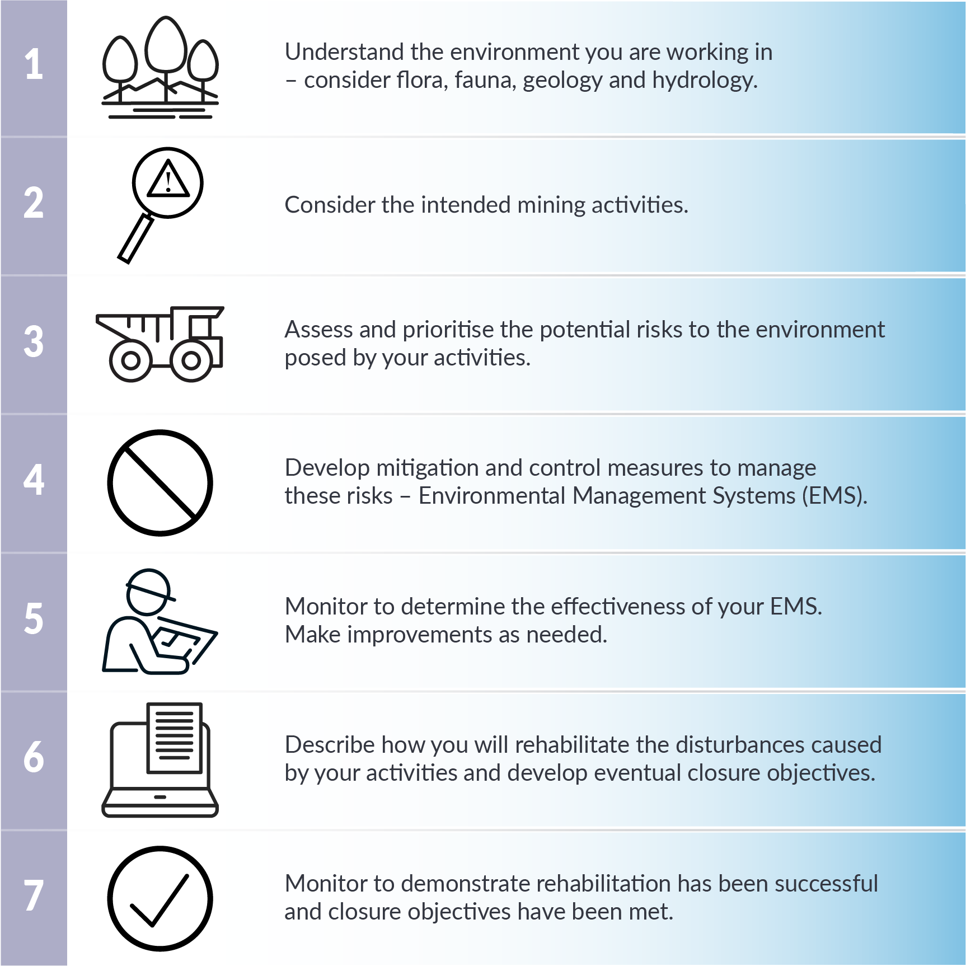

Diagram for illustration purposes only. Can be removed or replaced upon submission of MMP.

Section 5 Assessment of the Environmental Risk
The purpose of this assessment is to ensure Operators complete a project risk assessment of potential environmental impacts and are aware of other legislative obligations from various Agencies.
Assess the risks to determine the level of assessment required including, identifying if the project requires assessment under the Water Act 1992, Environment Protection Act 2019 or the Environment Protection and Biodiversity Conservation Act 1999.
The department recommends risk assessments are undertaken by suitably qualified persons. It is essential that persons undertaking ecological studies/specialised surveys for environmental assessment have the appropriate skills, knowledge and experience to ensure that reported outcomes are adequate, accurate and robust. This would include the capability to:
Interpret local data in a regional context, including through access to relevant, current spatial environmental datasets hosted by government agencies
Clearly report on methods, results, interpretation and relevance to environmental risks and their management and mitigation.
Where required, attach supporting information, such as search outcomes or management plans as an appendix. These may include but are not limited to:
- Risk likelihood analysis
- Survey results
- Biodiversity Management Plan
- Weed Management Plan
- Consultation outcomes with other relevant departments.
If you have any queries please contact a Mining Officer prior to submitting the MMP.

Table 6: Risk Assessment undertaken for this project.
ASSESSMENT ASPECT | YES or NO | ACTIONS REQUIRED  (if answered YES) | APPENDED INFORMATION  (e.g. evidence of consultation with DEPWS and/or management plan where required)
Step 1:  Are there any threatened flora and fauna species or habitats of significance that may occur in the proposed work area? |  | Threatened Species. A suitably qualified person must assess the likelihood of threatened species occurring within the title area. If the likelihood is high, the Operator must either:  • Undertake field studies,  • A “Significant Impact Assessment” or;  • Avoid sensitive areas. | e.g. Consulted Flora and Fauna Division (DEPWS), see appendix.  e.g. Consulted EPBC Protected Matters Search Tool, see appendix.  e.g. Developed Biodiversity Management Plan, see appendix.
Step 2:  Are there any known declared weeds within the proposed work area? |  | The Weeds Management Act 2001 applies to all mining related activities. Seek advice from DEPWS – Weeds Management to ensure management measures are appropriate for the level of activity proposed | e.g. Weed Management Plan, see appendix.
Step 3:  Will you be using water from bores or other sources for the operation? |  | Water related matters on mineral titles are no longer exempt from the Water Act 1992. Please consult with DEPWS and/or familiarise yourself with the Water Act 1992 to ensure compliance.
Table 7. Environmental assessment and cultural considerations
ASSESSMENT ASPECT | YES or NO | MANAGEMENT REQUIREMENTS
Step 4:  Is your project likely to have a significant impact on the environment? |  | Refer to the NTEPA guidance in relation to the Environment Protection Act 2019.  https://ntepa.nt.gov.au/__data/assets/pdf_file/0009/805167/referring-proposed-action-to-ntepa-guideline.pdf
Step 5:  Are there Aboriginal sacred sites in the Project area? |  | Sacred Sites are protected under the NT Aboriginal Sacred Sites Act 1989 and administered by the Aboriginal Areas Protection Authority (AAPA). Seek advice from AAPA in relation to sacred site protection.
Step 6:  Are there archaeological and heritage sites in the Project area? |  | Heritage and archaeology sites are protected in the NT.  NT Heritage Branch of the Department Environment, Parks and Water Resources (DEPWS) administers the Heritage Act 2011. Seek advice from DEPWS in relation to protection of heritage and archaeological sites.

Section 6 Activities Proposed
Provide details only for the proposed works, for the duration of this MMP.
Address for each title (EML or EMP)
Table 8: Proposed Disturbance
Mining Interests (i.e. titles) | Title Number | Title Number | Title Number | Title Number
Total area of pits
(ha)
Haul Roads/Tracks
(ha)
Lay down area
(ha)
Temporary infrastructure disturbance (footprint) area
e.g. office, ablutions, screening etc.
(ha)
Total area of sediment ponds
(ha)
Other
Total area to be cleared/disturbed (ha)
*add or delete columns as required.

Site Map
Include a site map/s detailing existing and proposed pits, lay down areas, access tracks.
Ensure the map includes:
- north arrow
- legend
- scale
- existing disturbances
- proposed disturbances
- title boundaries and numbers;
- buffers and avoidance areas
- rehabilitated areas; and
- date.
Where disturbances are located on multiple titles, include a map for each title, or as appropriate to effectively demonstrate all working areas.
In addition to maps, the department requires current and proposed disturbance areas be provided in an appropriate spatial dataset (i.e. gpx, kmz or kml files, MapInfo tab files, ARC GIS files, or QGIS files).
Figure 2: Site Map
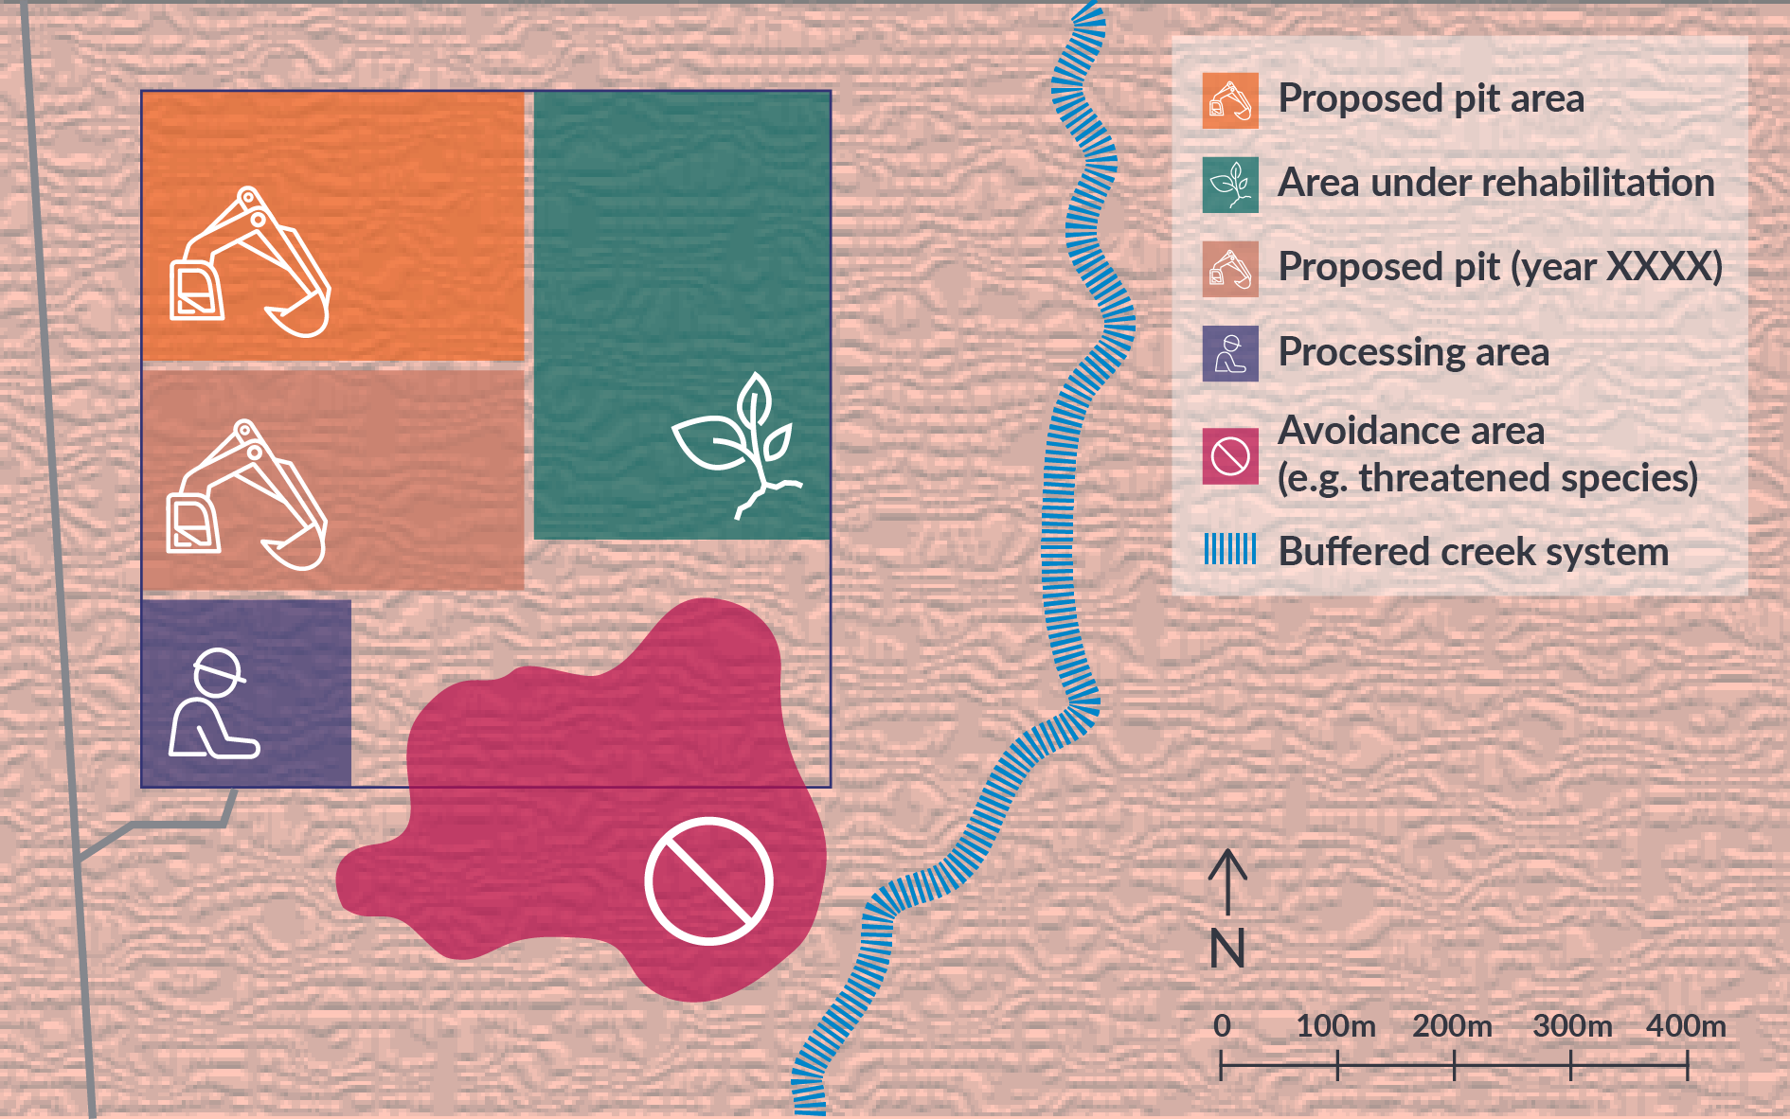
Conceptual diagram for illustration purposes only. Replace with site specific maps.

Section 7 Environmental Management System
Section 16 of the MMA requires an operator to establish and maintain an environmental protection management system that is appropriate to the proposed mining activities and will, as far as practicable, protect the environment. The Environmental Management System (EMS) fulfils this requirement. The EMS should describe management of the potential environmental risks you identified in the Section 4, Figure 1 process.

To be effective the EMS will include:
- monitoring to measure the effectiveness of the management actions
- set appropriate ‘trigger’ values (the point at which action will be taken)
- corrective actions that will be undertaken should a trigger value be breached or where a management system is deemed to be not be as effective as planned.
To assist you with identifying your mitigation methods and/or management plans specific to your mining activities briefly detail the objectives, monitoring and rehabilitation actions that will be undertaken. See examples in table below.
Prior to, and during the life of the project, it is recommended the Operator establish photo monitoring points or obtain drone imager. This will assist with tracking change over time, and demonstrate successful rehabilitation and eventual closure.
Consider all the suggestions provided in Table 9 and edit according to your project and what you will actually implement on site.

Table 9: Environmental Management System that will be implemented at this project - Edit and add to this table as required to suit your specific project

Mitigation/Controls  Briefly describe the management and mitigation you will apply to reduce the risk | Objectives  State your aims, where possible make it measurable | Monitoring  How will you monitor your performance against your Objectives? | Trigger  At what point will you identify a problem with your management method? | Action  List the actions you will take to rectify, so that your objective can be met.
Weed management  For example:  Annual weed management program implemented.  Manager to ensure annual control programs implemented prior to weeds seeding.  Weed identification and management included in staff training/induction.  Regular assessment of rehabilitation areas. | No weed spread within or off the site.  Management of weeds and 50% reduction in density present on site.  Manage emerging weeds during rehabilitation process and monitor for 12 months. | Baseline weed density/species distribution established.  Weeds mapped annually by GPS/Orthomosaic.  Photo monitoring points established i.e. every 3 months.  Monthly checks during rehabilitation. | Weed density increased, new species observed.  Increase in weed density through data validation.  Complaints from nearby residents or road users. | Annual weed survey.  Weed spraying prior to seeding or during rehabilitation process.  Fire prevention.
Erosion and Sediment Control  Erosion and sediment control plan implemented.  Sediment traps checked/maintained. | No sediment leaving titles.  Receiving waters (creeks/streams) have no increased sediment load. | Weekly visual monitoring of erosion controls and sediment traps during the wet season.  Monitoring points established and samples taken. | Failure of erosion control.  Sediment traps nearing capacity/failing.  Sediments observed leaving title.  Sediments detected in waterways. | Immediately remediate and/or improve erosion controls.  Document actions and outcomes in logbook.
Biodiversity Management  Disturbances rehabilitated in a timely manner (within 3 months of works completed) | Re spread top soil and felled vegetation.  Revegetation occurring within 12 months. | Photo monitoring points established. | Failure of broadleaved species emerging from disturbance area. | Rip and contour bare areas.
Waste Management | All waste disposed of appropriately i.e. waste disposal facility. | Ensure all personnel are aware of requirement for disposal of waste e.g. tool box meetings. | Wastes not removed.  Contamination evident. | Take waste to a waste disposal facility appropriate to the type of waste.
Dust Management | Minimal dust generated from site activities.  All roads and tracks watered during dry periods.  Install dust monitoring devices (dependant on activity type). | Note weather conditions.  Logging daily visual dust site observations.  Readings recorded and downloaded. | Dust plumes generated from roads and tracks, disturbance areas.  Complaints from neighbouring land holders.  Visible dust on buildings, vegetation. | Water roads and tracks, disturbance areas during dry months.  Ensure regular schedule is maintained.
Hydrocarbon/Hazardous Material Management
Water Management
If required, where groundwater is intercepted
Other? …Add as appropriate to your operation

Section 8 Rehabilitation
Rehabilitation should be undertaken progressively and will help you work towards eventual closure of the site, as required under the MMA. The next land use dictates closure requirements and therefore dictates the progressive rehabilitation you will need to undertake. Consultation with the underlying land owner or lessee should be undertaken to determine the next land use. These should then be demonstrated and detailed in the MMP.
Where consultation is not possible or has not occurred, it will be assumed the next land use will be the same as prior to mining and therefore by checking the boxes in the below table, you are agreeing to implement the following minimum rehabilitation standards. Where boxes have been left unchecked, justification is required.
Rehabilitation of an area includes, as a minimum: ripping, contouring and respreading of overburden or vegetative material over the site. The site must be demonstrably safe, stable, non-polluting and made suitable for vegetation establishment. Rehabilitation is required to be undertaken progressively, i.e. where an area has been mined, it should be rehabilitated in a timely manner or when conditions are optimal, rather than waiting until the end of mine life. Refer to Figure 3: Progressive Rehabilitation Model.
The advantages of progressive rehabilitation are:
- better, more viable seed recruitment leading to improved seedling establishment
- fewer weeds
- machinery is often available on site as these works can be undertaken in conjunction with mining new areas
- cost effective.
- partial security releases, or the ‘rolling over’ of security to enable the mining of new areas.
The department will consider the partial refund of security, where progressive rehabilitation is demonstrated. Progressive rehabilitation relates to discrete areas, in that before refund of security is considered, each area must be demonstrated to have been fully and successfully rehabilitated.
To demonstrate rehabilitation, the Operator must submit a Rehabilitation Report that details the works undertaken and includes photographs, an updated security calculation and updated site map, spatial data and ideally orthomosaic imagery with all disturbances, and rehabilitation areas shown. The rehabilitation can relate to all or part of a title. Contact the department for guidance in developing a Rehabilitation Report.
Reduced ‘rehabilitation rent’ is available under the Mineral Titles Act 2010 where all or part of an EMP is no longer intended for use for extraction of material and rehabilitation works are being conducted. Contact Mineral Titles for further advice mineral.titles@nt.gov.au
Figure 3: Progressive Rehabilitation Model
Conceptual diagram for illustration purposes only. Can be removed or replaced upon submission of MMP.

Table 10: Progressive Rehabilitation Activities that will be undertaken at this project - Edit and add to this table as required to suit your specific project
Rehabilitation Activity Checklist  Activities apply to an agreed end land use, or an absence of an agreed end land use. | Yes or No  Where ‘no’ provide justification | Relevant Appendix
Next land use decision consultation/agreement made. |  | e.g. copies of correspondence with landowner
Progressive rehabilitation implemented. |  | e.g. Photographs/ drone imagery provided in Appendices
Pit walls made safe, bunded or ripped along contours prior to oncoming rain season (consider long term stability). |  | e.g. Photographs
Mined areas made suitable for vegetation establishment prior to oncoming rain season e.g. Contoured, overburden (Topsoil) and felled vegetation spread back over mined areas. |  | e.g. Photographs
Tracks and compacted areas no longer required are ripped and access blocked e.g. by felled timber, bund or temporary gate. |  | e.g. Photographs
Erosion controls implemented. Sediments contained within site |  | e.g. Photographs
Monitor for weedy grasses and manage where required |  | e.g. Photographs
Other?…add site specific actions

Section 9 Closure Planning
Section 40 of the MMA requires a MMP to include a plan for closure and to detail related closure activities that will be undertaken. Closure is at the end of the Project life, when mining is ceased and no further mining is planned. A key component of Closure Planning is the development of closure criteria, against which achievements can be measured. To identify closure criteria, key themes should be developed which will consider previously defined "next land use” and may include landform, vegetation, sediment management, removal of infrastructure. Examples are provided below, populate and edit according to your project.
Closure planning will dictate the progressive rehabilitation that you undertake on site (Table 10). Progressive rehabilitation will help you achieve closure and release of all security in a timely manner.

Table 11: Closure Criteria – Edit and add to this table as required to suit your specific project
Key Themes | Objectives  List the objectives for each | Rehabilitation Monitoring  Detail monitoring activities where relevant | Monitoring Frequency  Detail how often monitoring will be undertaken
Landform  Consider next land use, the surrounding landform and topography. | Pits contoured to minimise erosion and reflect surrounding landforms. | Photograph points established and photographs taken at appropriate times.  Photographs should be taken;  - prior to rehabilitation  - during rehabilitation after wet season; or  - after a significant growth event.
Vegetation  Examples:  - Sandsheet heath  - Mulga woodland  - Eucalypt woodland  - Remediated landform with no vegetation – safe, stable and non-polluting | e.g. 80% vegetation coverage with native fire tolerant broadleaved vegetation by year 2. | Photographic points established and photographs taken at appropriate times.
Reducing Access | Rip all tracks and haul roads. Re spread topsoil and felled timber. | Monitor up to 6 months post mining for ESCP issues. Photo monitoring for emergent vegetation. Weed Monitoring and control.

Section 10 Security Costings
Rehabilitation and post rehabilitation monitoring and repair costings must be determined using the departmental Security Calculation Tool, available from the departmental website. Costings should be based upon existing and proposed disturbance and account for rehabilitation, where it has been conducted and accepted.
Where agreement with the department has been previously reached, staged security payments that correlate with a staged work program should be provided.
Ensure that a security calculation is submitted with the MMP to limit delays in assessment times.
A security calculation is provided in Appendix…

Section 11 Required Attachments
Use this checklist to ensure you have provided all necessary attachments
Table 12: Required Attachments
Provided  Y/N | Document
 | Application for Authorisation or variation of Authorisation
 | Nomination of Operator Form, where required
 | Security Calculation Spreadsheet
 | KML/shape files/track logs of all existing and proposed disturbances e.g. pits, laydown areas, tracks, rehabilitated areas.
 | Map(s) of the work area(s):
 | Relevant appendices as referred to in MMP

USEFUL RESOURCES:
The following resources will be useful in your environmental risk assessment and MMP development:
DITT - https://nt.gov.au/industry/mining-and-petroleum/mining-activities/mining-forms-and-guidelines
STRIKE - http://strike.nt.gov.au/ (for location of SOCS, SOBS, threatened species)
NR MAPS – http://nrmaps.nt.gov.au/
Department of Environment, Parks and Water Security - https://depws.nt.gov.au/
AAPA - Aboriginal Areas Protection Authority - http://www.aapant.org.au/
NT Heritage Register - https://nt.gov.au/property/land/heritage-register-search-for-places-or-objects
EPBC Protected Matters Search Tool - http://www.environment.gov.au/epbc/protected-matters-search-tool
Aerial imagery (Google Earth, NR Maps, Bing)
Extractive Industry Association of NT Code of Conduct https://extractindustrynt.com/
Land Clearing Guidelines - https://nt.gov.au/__data/assets/pdf_file/0007/236815/land-clearing-guidelines.pdf
Aerial imagery (Google Earth, NR Maps, Bing)
Extractive Industry Association of NT Code of Conduct https://extractindustrynt.com/

