1.0 Introduction
Explorers are required under the Mining Management Act to rehabilitate areas impacted by their exploration activities and to minimise environmental impacts resulting from these activities.
The main goal in environmental management of exploration activities is to minimise or prevent unnecessary impacts and rehabilitate sites where disturbance cannot be avoided. Well designed and executed construction, maintenance and rehabilitation works can avoid creating future environmental impacts and additional costs.
Tracks and gridlines are to be cleared with a minimum of disturbance to the environment and be rehabilitated in such a way as to reinstate the natural land surface, promote rapid revegetation and prevent the initiation of soil erosion.
On major projects with longer timeframes, tracks and gridlines are required to be appropriately designed, constructed and routinely maintained to prevent degradation during the life of the project.

2.0 Requirements

2.1 Track Construction and Maintenance
When designing and constructing tracks, adverse environmental impacts can be minimised by implementing simple best practice measures, such as:
- Locating tracks to minimise impact upon, or avoid if possible:
  - environmentally sensitive areas, heritage areas and culturally sensitive sites
  - soils with high erosion risk, steep slopes and long slope lengths
  - creek crossings, floodplains and broad drainage lines; and
  - areas already degraded by soil erosion, over-grazing, fire or weeds
- Minimising vegetation clearing by choosing routes that avoid densely vegetated areas and the clearing of large mature trees.
- Minimising soil disturbance by using a stick rake or the ‘blade up’ method and wherever possible driving vehicles across unprepared terrain.
- Keeping the width of tracks to the minimum required to safely meet the needs of the largest vehicle.
- Minimising disruption to natural drainage lines by crossing creeks at right angles and maintaining the natural level of the creek bed at crossings.
- Minimise the concentration and channelling of natural surface water flows by avoiding the formation of windrows at the sides of tracks.
- Carefully planning and constructing tracks on sloping ground as they are susceptible to erosion. Minimise the risk of soil erosion by implementing erosion control techniques, such as using switch-backs (changes in direction), and erosion control structures such as diversion banks or whoa-boys (Figure 1), placed at suitable intervals.
- Maintaining tracks that are frequently used over long periods. Minimise impacts by routinely inspecting and maintaining tracks to prevent small problems turning into large ones. Regular remedial works addressing issues such as deep rutting, formation of bulldust, and soil erosion should help reduce repair time and costs at the end of a project.
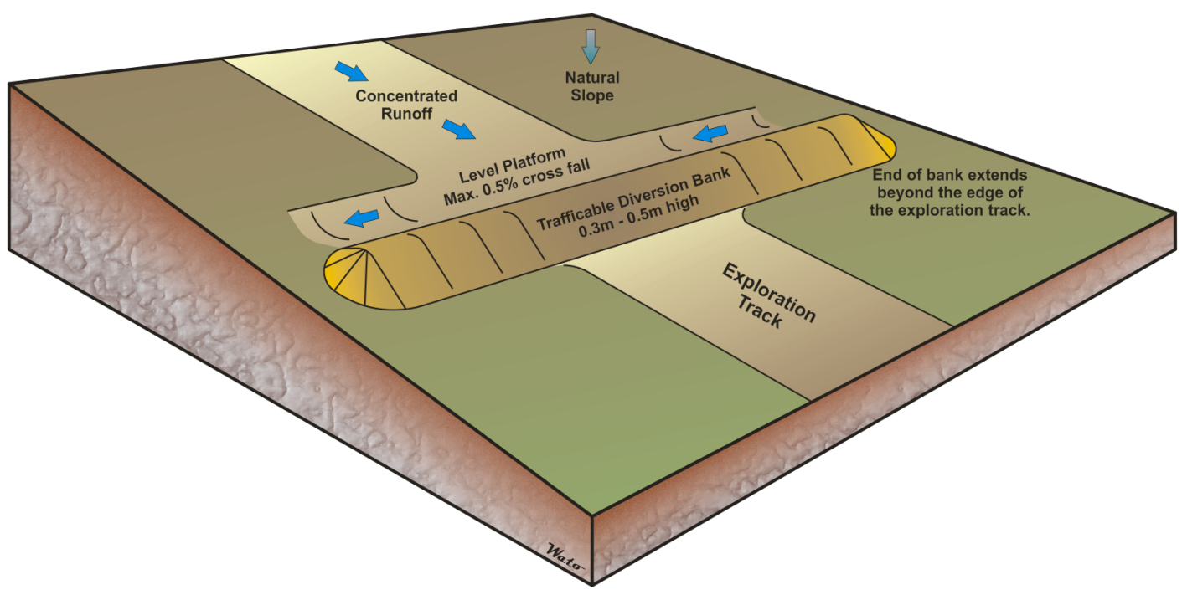
Figure 1: Diversion bank (Whoa-boy) diverting concentrated water off a track or gridline. The bank allows the natural cross flow of water from upslope to down slope and minimises the potential for soil erosion.

2.2 Track Rehabilitation
Rehabilitation of tracks is required on all exploration licences. Rehabilitation success can be significantly improved by implementing measures such as:
- Rehabilitating tracks progressively or as soon as possible after they are no longer required. This will minimise the risk of erosion and promote revegetation.
- Grading any windrows and associated vegetation back onto access tracks.
- Removing any obstructions from creek beds, and in-filling ruts or any areas of soil erosion.
- Deep ripping tracks that have become compacted or deeply rutted and where the topsoil is significantly disturbed. Ripping across the slope, or cross-ripping, is recommended. Avoid ripping directly down-slope.
- Installing erosion control structures, such as whoa-boys, on tracks that are deeply rutted or eroded. This protects rehabilitation works and ensures long term soil stability of the area.

2.3 Transfer of Liability to Landholders
If a landholder(s) requires tracks to be left on an exploration licence, a number of matters must be resolved, including:
- Providing detailed written evidence from the landholder outlining the tracks to be transferred (including maps of specific tracks). The landholder is required to accept liability for future management of transferred tracks.
- Demonstrating that tracks are in a suitable location and appropriately constructed to remain open. Erosion control measures may be required in some locations. Evidence of installation of control measures to provide for long term stability may be requested.

2.4 Gridlines
When constructing and rehabilitating exploration gridlines, environmental impacts may be minimised by:
- Keeping vegetation clearing and soil disturbance to a minimum by using a stick rake or the ‘blade up’ method. Stick raking and blade up clearing removes vegetation whilst retaining rootstock, topsoil and seed to encourage rapid revegetation.
- Avoiding windrows on the sides of gridlines. Even on gently sloping ground, these have the potential to intercept and channel surface water flows, leading to significant soil erosion. Pull any windrows and vegetation back onto gridlines at the time of rehabilitation.
- Avoid natural drainage lines where possible. If crossing drainage lines is unavoidable, ensure minimal disturbance to the banks, maintain the natural creek bed level, and ensure that watercourses are not altered or blocked.
- Ripping gridlines if the soil surface has become compacted or the topsoil has been substantially disturbed. At the time of rehabilitation, the grid line should be deep ripped across the slope, or cross-ripped. This will promote water infiltration, seed capture and rapid revegetation.
- Removal of all grid pegs and survey markers prior to relinquishment of the exploration licence or at completion of exploration activities for the site.

