Mineral Titles Act
NOTICE OF GRANT OF A MINERAL TITLE
Title Type and Number: | Exploration Licence 4025
Granted: | 30 April 2026, for a period of 6 Years
Area: | 35 Blocks, 62.41 km²
Locality: | BUCKINGHAM BAY
Name of Holder/s: | 100% ALCOA OF AUSTRALIA LIMITED [ACN. 004 879 298]
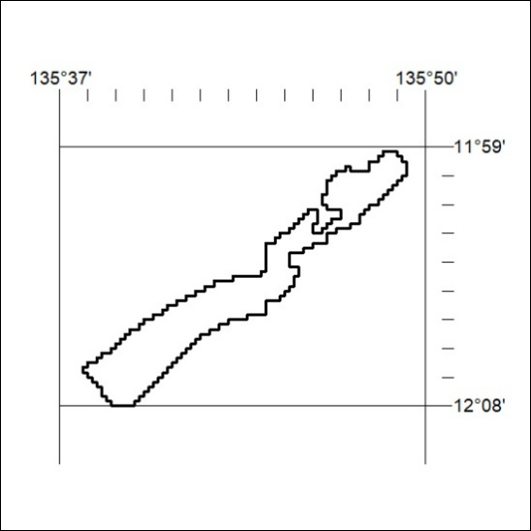
Area granted is indicated above. The titleholder is not permitted to exercise occupational rights on any land that is subject to a development title, or an application for a development title. Any land the subject of a Reserved Land gazettal under the Mineral Titles Act and all land vested in the Commonwealth of Australia is also excluded by description but not excised from the grant area.

133/26

