Mineral Titles Act 2010
NOTICE OF LAND CEASING TO BE A MINERAL TITLE AREA
Title Type and Number: | Exploration Licence 32796
Area Ceased on: | 19 May 2025
Area: | 115 Blocks, 358.65 km²
Locality: | SEYMOUR
Name of Applicant(s)/Holder(s): | 100% TOMORROW MINERALS PTY LTD [ACN. 651 834 641]
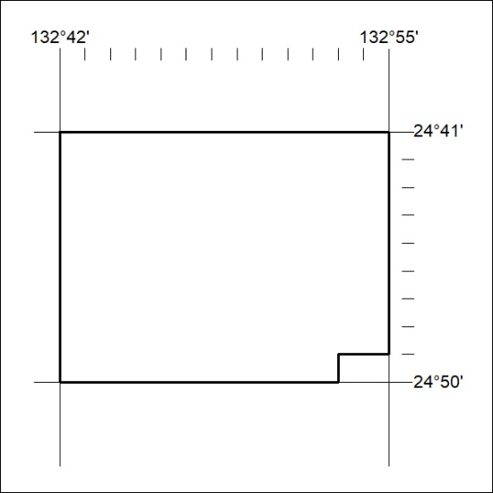

303/25

Mineral Titles Act 2010
NOTICE OF LAND CEASING TO BE A MINERAL TITLE AREA
Title Type and Number: | Exploration Licence 32797
Area Ceased on: | 19 May 2025
Area: | 118 Blocks, 364.41 km²
Locality: | HENBURY
Name of Applicant(s)/Holder(s): | 100% TOMORROW MINERALS PTY LTD [ACN. 651 834 641]
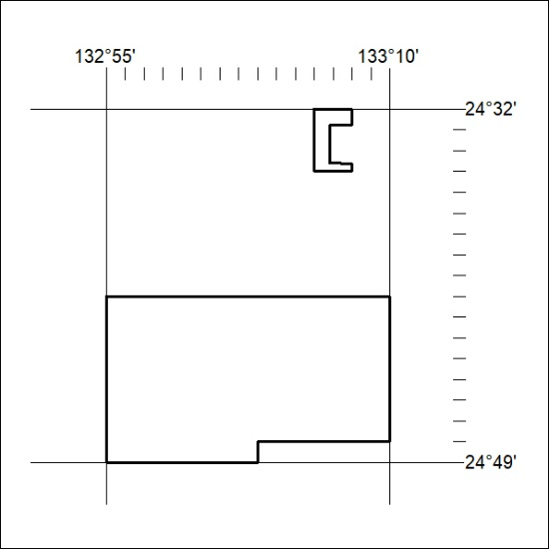

304/25

Mineral Titles Act
NOTICE OF GRANT OF A MINERAL TITLE
Title Type and Number: | Exploration Licence 34013
Granted: | 16 May 2025, for a period of 6 Years
Area: | 229 Blocks, 643.46 km²
Locality: | WATERHOUSE
Name of Holder/s: | 100% TRACHRE PTY LTD [ACN. 629 914 656]
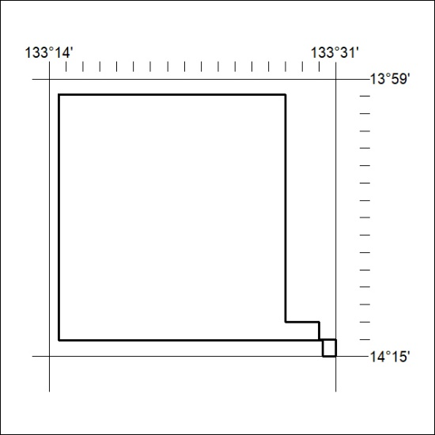
Area granted is indicated above. The titleholder is not permitted to exercise occupational rights on any land that is subject to a development title, or an application for a development title. Any land the subject of a Reserved Land gazettal under the Mineral Titles Act and all land vested in the Commonwealth of Australia is also excluded by description but not excised from the grant area.

305/25

