Mineral Titles Act 2010
NOTICE OF LAND CEASING TO BE A MINERAL TITLE AREA
Title Type and Number: | Extractive Mineral Permit 32150
Area ceased on: | 26 March 2025
Area: | 15.00 Hectare
Locality: | VICTORIA RIVER DOWNS
Name of Applicants(s)Holder(s): | 100% FUTURE ENERGY MINERALS LIMITED [ACN. 678 599 230]
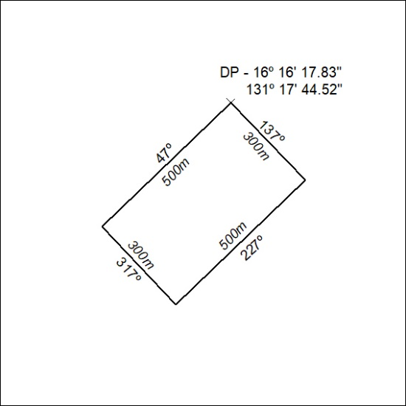

230/25

Mineral Titles Act
NOTICE OF GRANT OF A MINERAL TITLE
Title Type and Number: | Exploration Licence 33942
Granted: | 26 March 2025, for a period of 6 Years
Area: | 61 Blocks, 185.96 km²
Locality: | BARROW
Name of Holder/s: | 100% BAUDIN RESOURCES PTY LTD [ACN. 618 455 593]
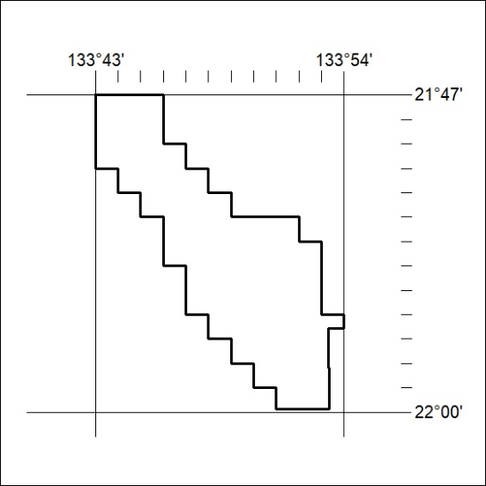
Area granted is indicated above. The titleholder is not permitted to exercise occupational rights on any land that is subject to a development title, or an application for a development title. Any land the subject of a Reserved Land gazettal under the Mineral Titles Act and all land vested in the Commonwealth of Australia is also excluded by description but not excised from the grant area.

231/25

