Mineral Titles Act 2010
NOTICE OF LAND CEASING TO BE A MINERAL TITLE AREA
Title Type and Number: | Exploration Licence 24865
Area Ceased on: | 30 December 2024
Area: | 2 Blocks, 6.44 km²
Locality: | FRANKENIA
Name of Applicant(s)/Holder(s): | 100% NEWMONT TANAMI PTY LTD* [ACN. 007 688 093]
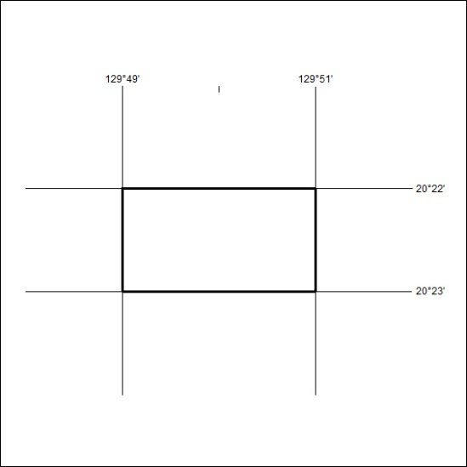

01/25

Mineral Titles Act 2010
NOTICE OF LAND CEASING TO BE A MINERAL TITLE AREA
Title Type and Number: | Exploration Licence 25012
Area Ceased on: | 30 December 2024
Area: | 2 Blocks, 6.44 km²
Locality: | FRANKENIA
Name of Applicant(s)/Holder(s): | 100% NEWMONT TANAMI PTY LTD* [ACN. 007 688 093]
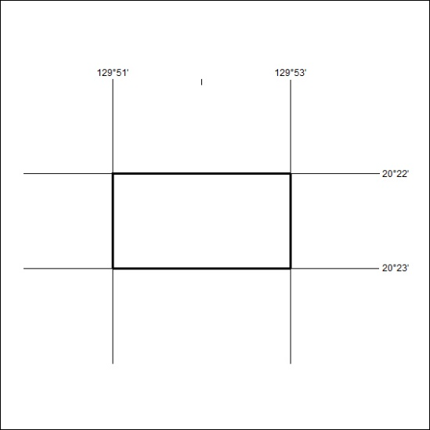

02/25

Mineral Titles Act 2010
NOTICE OF LAND CEASING TO BE A MINERAL TITLE AREA
Title Type and Number: | Exploration Licence 31487
Area Ceased on: | 07 November 2024
Area: | 13 Blocks, 36.17 km²
Locality: | PINE CREEK
Name of Applicant(s)/Holder(s): | 100% BACCHUS RESOURCES PTY LTD [ACN. 606 340 872]
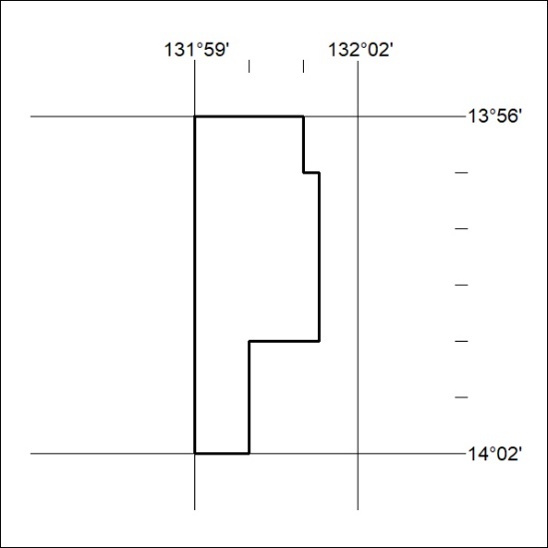

03/25

Mineral Titles Act 2010
NOTICE OF LAND CEASING TO BE A MINERAL TITLE APPLICATION AREA
Title Type and Number: | Exploration Licence 33462
Area Ceased on: | 24 December 2024
Area: | 13 Blocks, 28.92 km²
Locality: | HOWSHIP
Name of Applicant(s)/Holder(s): | 100% ROX 1 PTY LTD [ACN. 649 500 916]
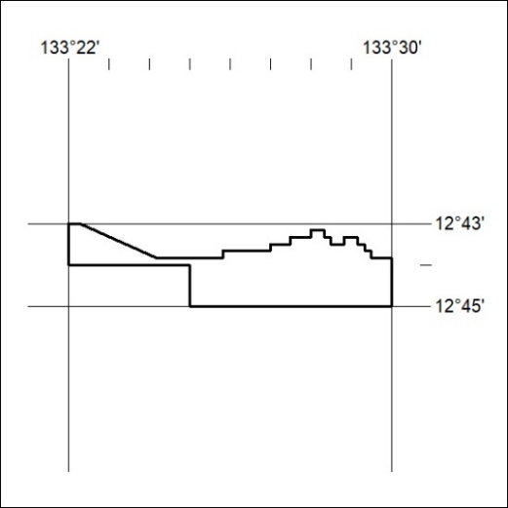

04/25

Mineral Titles Act 2010
NOTICE OF LAND CEASING TO BE A MINERAL TITLE APPLICATION AREA
Title Type and Number: | Exploration Licence 33683
Area Ceased on: | 24 December 2024
Area: | 108 Blocks, 346.75 km²
Locality: | WINNALL
Name of Applicant(s)/Holder(s): | 100% ROX 1 PTY LTD [ACN. 649 500 916]
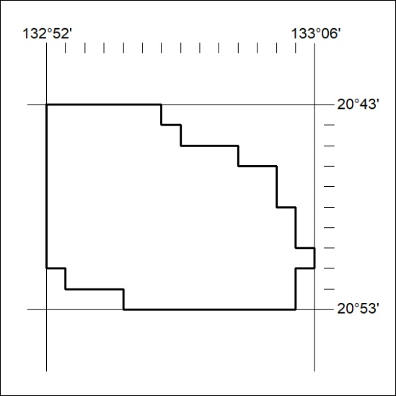

05/25

Mineral Titles Act
NOTICE OF GRANT OF A MINERAL TITLE
Title Type and Number: | Extractive Mineral Exploration Licence 33947
Granted: | 02 January 2025, for a period of 2 Years
Area: | 4 Blocks, 13.15 km²
Locality: | WARRAMBAN
Name of Holder/s: | 100% DALY WATERS SAND PTY LTD [ACN. 679 771 736]
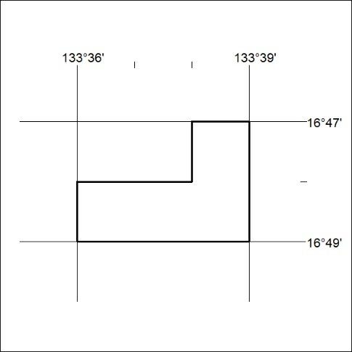
Area granted is indicated above. The titleholder is not permitted to exercise occupational rights on any land that is subject to a development title, or an application for a development title. Any land the subject of a Reserved Land gazettal under the Mineral Titles Act and all land vested in the Commonwealth of Australia is also excluded by description but not excised from the grant area.

06/25

Mineral Titles Act
NOTICE OF GRANT OF A MINERAL TITLE
Title Type and Number: | Extractive Mineral Exploration Licence 33948
Granted: | 02 January 2025, for a period of 2 Years
Area: | 4 Blocks, 13.15 km²
Locality: | WARRAMBAN
Name of Holder/s: | 100% DALY WATERS SAND PTY LTD [ACN. 679 771 736]
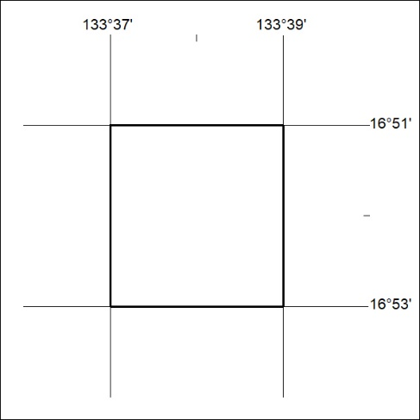
Area granted is indicated above. The titleholder is not permitted to exercise occupational rights on any land that is subject to a development title, or an application for a development title. Any land the subject of a Reserved Land gazettal under the Mineral Titles Act and all land vested in the Commonwealth of Australia is also excluded by description but not excised from the grant area.

07/25

Mineral Titles Act
NOTICE OF GRANT OF A MINERAL TITLE
Title Type and Number: | Extractive Mineral Exploration Licence 33949
Granted: | 02 January 2025, for a period of 2 Years
Area: | 4 Blocks, 13.15 km²
Locality: | WARRAMBAN
Name of Holder/s: | 100% DALY WATERS SAND PTY LTD [ACN. 679 771 736]
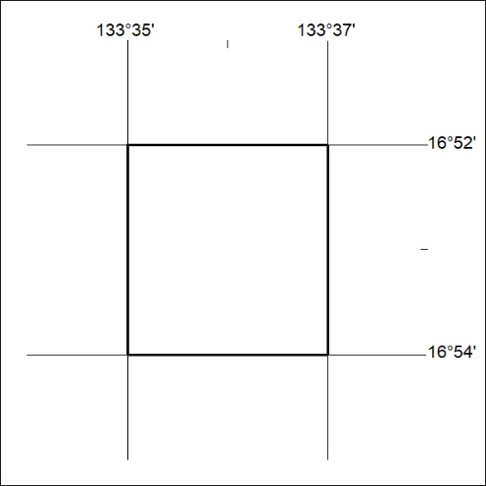
Area granted is indicated above. The titleholder is not permitted to exercise occupational rights on any land that is subject to a development title, or an application for a development title. Any land the subject of a Reserved Land gazettal under the Mineral Titles Act and all land vested in the Commonwealth of Australia is also excluded by description but not excised from the grant area.

08/25

Mineral Titles Act
NOTICE OF GRANT OF A MINERAL TITLE
Title Type and Number: | Extractive Mineral Exploration Licence 33950
Granted: | 02 January 2025, for a period of 2 Years
Area: | 4 Blocks, 13.15 km²
Locality: | WARRAMBAN
Name of Holder/s: | 100% DALY WATERS SAND PTY LTD [ACN. 679 771 736]
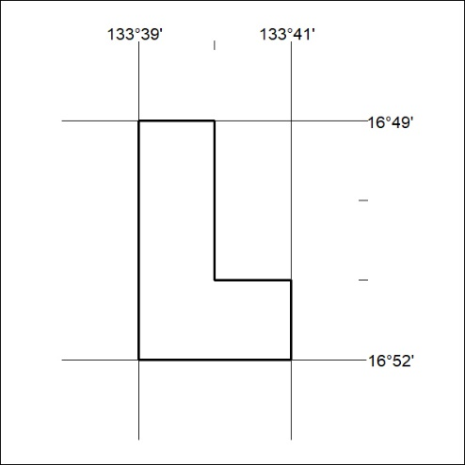
Area granted is indicated above. The titleholder is not permitted to exercise occupational rights on any land that is subject to a development title, or an application for a development title. Any land the subject of a Reserved Land gazettal under the Mineral Titles Act and all land vested in the Commonwealth of Australia is also excluded by description but not excised from the grant area.

09/25

Mineral Titles Act
NOTICE OF GRANT OF A MINERAL TITLE
Title Type and Number: | Extractive Mineral Exploration Licence 33951
Granted: | 02 January 2025, for a period of 2 Years
Area: | 4 Blocks, 13.15 km²
Locality: | WARRAMBAN
Name of Holder/s: | 100% DALY WATERS SAND PTY LTD [ACN. 679 771 736]
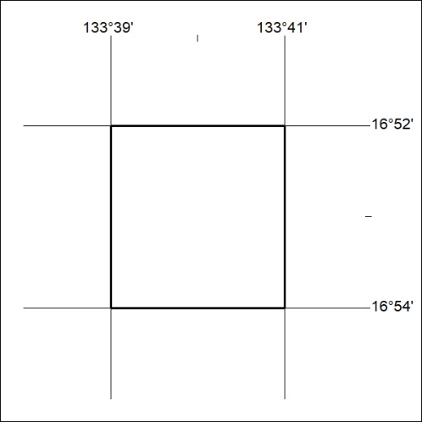
Area granted is indicated above. The titleholder is not permitted to exercise occupational rights on any land that is subject to a development title, or an application for a development title. Any land the subject of a Reserved Land gazettal under the Mineral Titles Act and all land vested in the Commonwealth of Australia is also excluded by description but not excised from the grant area.

10/25

Mineral Titles Act
NOTICE OF GRANT OF A MINERAL TITLE
Title Type and Number: | Extractive Mineral Exploration Licence 33952
Granted: | 02 January 2025, for a period of 2 Years
Area: | 4 Blocks, 13.15 km²
Locality: | WARRAMBAN
Name of Holder/s: | 100% DALY WATERS SAND PTY LTD [ACN. 679 771 736]
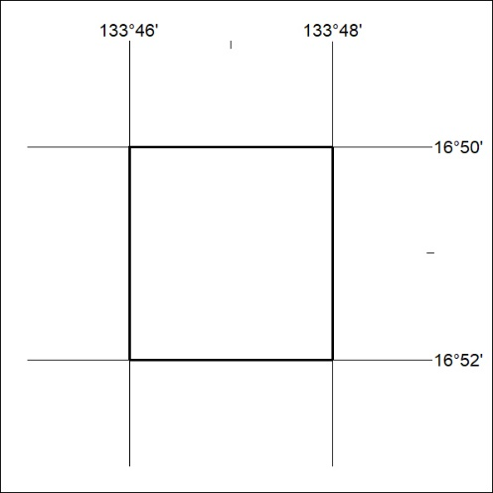
Area granted is indicated above. The titleholder is not permitted to exercise occupational rights on any land that is subject to a development title, or an application for a development title. Any land the subject of a Reserved Land gazettal under the Mineral Titles Act and all land vested in the Commonwealth of Australia is also excluded by description but not excised from the grant area.

11/25

