Mineral Titles Act 2010
NOTICE OF LAND CEASING TO BE A MINERAL TITLE AREA
Title Type and Number: | Exploration Licence 33060
Area Ceased on: | 18 October 2024
Area: | 121 Blocks, 363.71 km²
Locality: | WOODGREEN
Name of Applicant(s)/Holder(s): | 100% BAUDIN RESOURCES PTY LTD [ACN. 618 455 593]
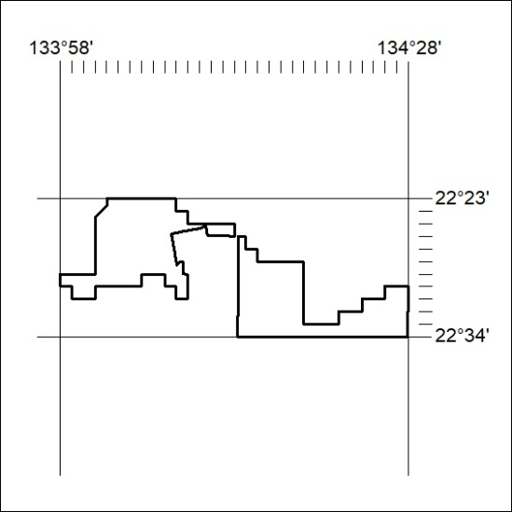

381/24

Mineral Titles Act 2010
NOTICE OF LAND CEASING TO BE A MINERAL TITLE AREA
Title Type and Number: | Exploration Licence 29859
Area Ceased on: | 20 October 2024
Area: | 36 Blocks, 115.55 km²
Locality: | INNINGARRA
Name of Applicant(s)/Holder(s): | 100% PRODIGY GOLD NL* [ACN. 009 127 020]
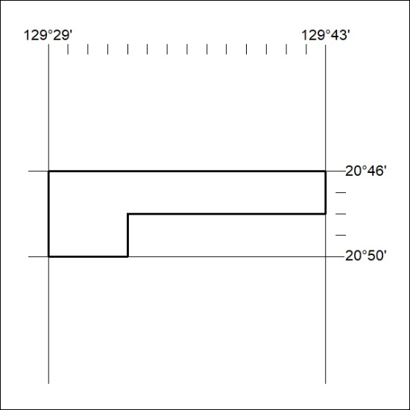

382/24

