Mineral Titles Act
NOTICE OF GRANT OF A MINERAL TITLE
Title Type and Number: | Extractive Mineral Lease 33506
Granted: | 13 August 2024, for a period of 10 Years
Area: | 15.48 Hectares
Locality: | SANTA TERESA
Name of Holder/s: | 100% ALDEBARAN CONTRACTING PTY LTD [ACN. 128 020 299]
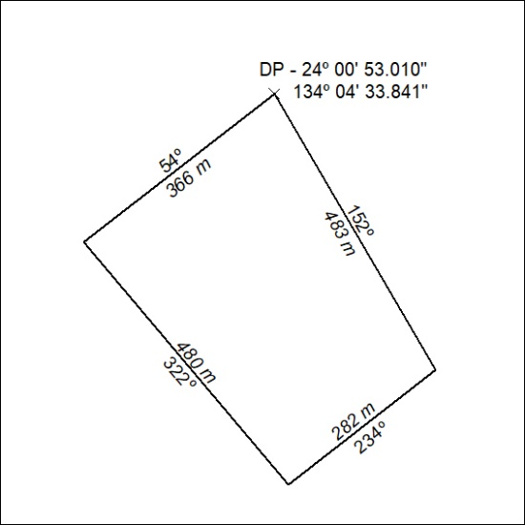

297/24

