Mineral Titles Act 2010
NOTICE OF LAND CEASING TO BE A MINERAL TITLE AREA
Title Type and Number: | Exploration Licence 25399
Area Ceased on: | 29 February 2024
Area: | 13 Blocks, 43.40 km²
Locality: | McKINLAY RIVER
Name of Applicant(s)/Holder(s): | 100% ISMINS PTY LTD [ACN. 141 217 343]
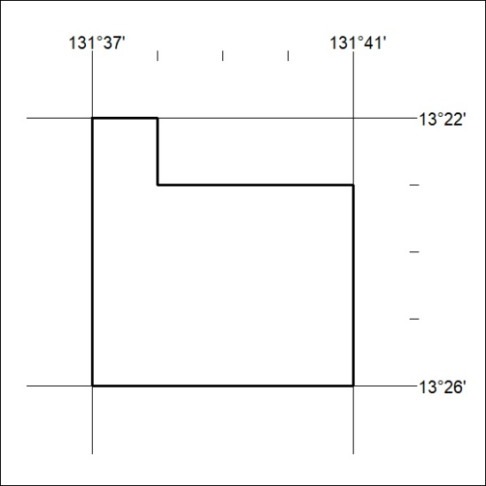

48/24

Mineral Titles Act 2010
NOTICE OF LAND CEASING TO BE A MINERAL TITLE AREA
Title Type and Number: | Exploration Licence 25436
Area Ceased on: | 27 February 2024
Area: | 2 Blocks, 6.68 km²
Locality: | McKINLAY RIVER
Name of Applicant(s)/Holder(s): | 100% ISMINS PTY LTD [ACN. 141 217 343]
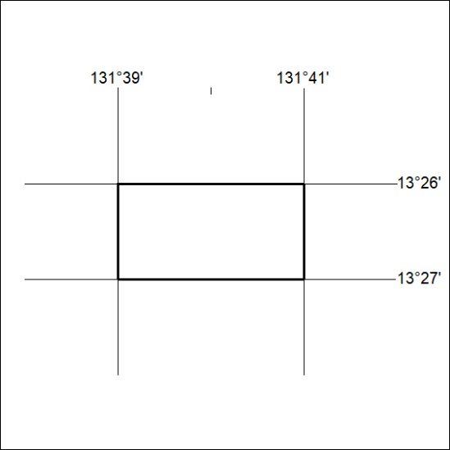

49/24

Mineral Titles Act 2010
NOTICE OF LAND CEASING TO BE A MINERAL TITLE AREA
Title Type and Number: | Exploration Licence 31794
Area Ceased on: | 28 February 2024
Area: | 80 Blocks, 252.76 km²
Locality: | LEISLER
Name of Applicant(s)/Holder(s): | 100% CASTILE RESOURCES LTD* [ACN. 124 314 085]
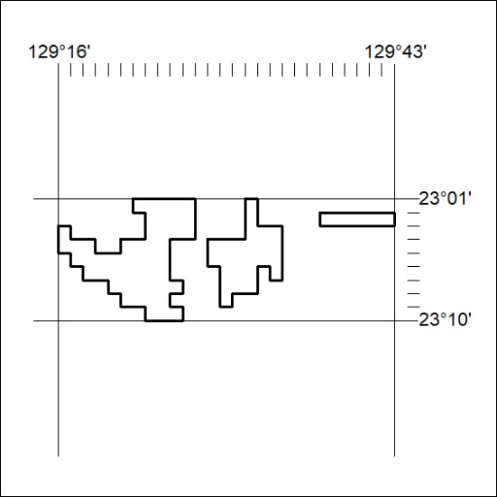

50/24

