Mineral Titles Act 2010
NOTICE OF LAND CEASING TO BE A MINERAL TITLE AREA
Title Type and Number: | Mineral Lease 30231
Area ceased on: | 17 February 2024
Area: | 72.00 Hectare
Locality: | FLORA
Name of Applicants(s)Holder(s): | 50% TARRANT Leon Michael, 50% WATT Michael James
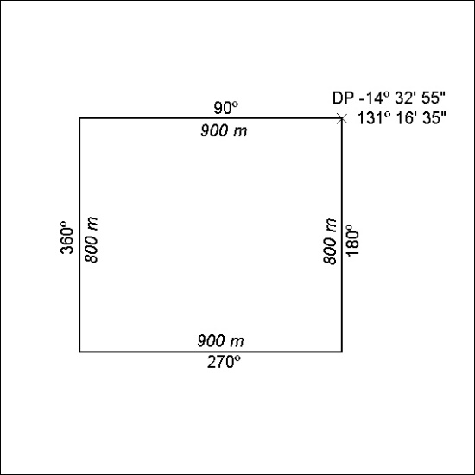

40/24

