1. Introduction
This guide outlines the requirements for fitting out a food premises in the Northern Territory (NT). The NT Food Act 2004 requires a person to register the premises where food intended for sale is handled or sold.
This guide is intended for food businesses that operate from a permanent fixed commercial location or shopfront i.e. café’s, hotels, pubs/bars, restaurants, take away outlets, caterers, corner stores and supermarkets. This guide is not intended for mobile food vehicles, temporary food premises (market stalls) or home based food businesses. These types of food businesses have specific guidelines available on the Northern Territory Government – Home-based and mobile food businesses webpage.
The specifications to fit-out a food premises is a legal requirement, and is detailed in the Australia New Zealand Food Standards Code – Standard 3.2.3 – food premises and equipment. The requirements in this standard are ‘outcome based’, which means that they do not provide prescriptive specifications such as types of surfaces/finishes, measurements, or detail specific cooking and cleaning equipment. Instead, these requirements provide an outcome that must be achieved such as, the ability for a surface to be able to be cleaned appropriately and withstand the use of chemicals.
Food Standards Australia New Zealand provide a detailed guide to the Australia New Zealand Food Standards Code - Safe Food Australia – 4th Edition, February 2023 – A Guide to the Food Safety Standards.
This guide is intended to provide a summary of Safe Food Australia as it relates to the fit-out of a food premises, to assist NT food businesses with understanding the key requirements. This guide follows the same flow as Safe Food Australia and standard 3.2.3. For further detail refer to Safe Food Australia or speak with a NT Health Environmental Health Officer (EHO). Note that requirements for fit-out are relative to the type of food handling being undertaken, an EHO can provide tailored advice.
This guide does not cover the food safety requirements for the day to day operations of a food business.

2. Building permits
It is important to be aware that there are building permit requirements for significant renovations and fit-out of food premises. These are separate to the fit-out requirements under the NT Food Act 2004. It is the proprietor’s responsibility to ensure they have obtained any required building permits before commencing works. Contact Building Advisory Services (BAS) who can provide you with information on requirements for getting a building permit.

3. Fit-out requirements

3.1. General requirements
The intended outcome is that food premises are designed and constructed to:
- be appropriate for the purposes for which they are used
- provide adequate space for food production and equipment
- facilitate cleaning, sanitising and maintenance
- prevent access by and harbourage of pests
- keep out dust, dirt, fumes, smoke and other contaminants.
It is important when a food premises is being designed that the type and volume of food handling is understood. The food premises needs to have sufficient room for the different types of food storage including dry, cold, hot and frozen. There also needs to be appropriate room and facilities to undertake food handling practices safely. For example, smaller food premises may be able to use a stand up fridge for adequate storage of foods, where larger food businesses will require a cool room to accommodate safe cold storage of food.
A premises needs to be designed to be sealed and protected from access by pests. Solid construction and physical barriers are the best defence against pests.

3.2. Water supply
The intended outcomes are that potable water is available for activities including washing food, cooking, making ice, cleaning, sanitising and personal hygiene, and that non-potable water is used only where it will not affect food safety.
Where a food premises is connected to a reticulated town water supply, the water is generally considered potable as the supply is managed by a water authority. If a food premises does not have access to town water, the water will come from a private supply such as a bore. This will generally only apply to food premises located in rural or remote locations.
For food premises on a private water supply, the proprietor is responsible to ensure the water supply meets the guidelines for private water supplies.
It is also important to note that a food premises requires access to a sufficient supply (volume and pressure) of hot water to be used for hand washing and cleaning/sanitising purposes.

3.3. Sewage and wastewater disposal
The intended outcomes are that sewage and waste water are disposed of effectively and there is no contamination of food or the water supply from the disposal system.
Where a food premises is connected to reticulated sewer, wastewater disposal will meet requirements providing all plumbing is in good working order. If a food premises does not have connection to sewer, the wastewater disposal will be via an onsite wastewater management system. This will generally only apply to food premises located in rural or remote locations. Where a food business is connected to sewer, the proprietor must contact the relevant power and water utility to determine trade waste requirements. Power and Water Corporation can provide information on approval to discharge trade waste to sewerage.
For food premises serviced by an onsite wastewater management system, it is important that the system complies with the NT Code of Practice for Wastewater Management and that the system is being regularly maintained and serviced. A plumber experienced in wastewater management and/or a hydraulic consultant can be engaged for advice regarding these systems.

3.4. Storage of garbage and recyclable matter
The intended outcomes are that storage facilities for garbage and recyclable matter:
- are suitable for the volume and types of garbage and recyclable material produced by the food business
- do not provide a breeding ground for pests
- are able to be easily and effectively cleaned.
A suitable location is to be made available onsite for storage of garbage so that it is separate from food handling activities, and will not cause odour concerns to the public. Adequate receptacles with lids are required so that pests including vermin and birds cannot access and spread the contents. It is important that there is enough capacity to hold all garbage generated at this business, and the frequency of collection by a contractor should be set so that receptacles are never overflowing. Capacity and frequency can be adjusted accordingly depending on demand.
Facilities need to be available to adequately rinse and clean any bins (including bins from inside the premises) to ensure they are kept in a clean state. The area needs to be separated from areas where food is handled to avoid contamination, and designed so that any water used is drained to waste and does not pool on the ground or cause odours.
Arrangements need to be put in place for appropriate storage and disposal of liquid or chemical wastes that may be generated at the food premises such as cooking oil. Speak to a waste contractor for available options.

3.5. Ventilation
The intended outcome is that natural or mechanical ventilation minimises the likelihood of airborne contamination of food.
Under the Building Code of Australia, there are ventilation requirements for specific equipment in commercial settings such as deep frying or cooking equipment above a certain power input (8kW for electrical or 29MJ/h for gas). Where a building permit is needed, the certifier will state requirements for ventilation. Advice should be sought from a building certifier about any such requirements.
Where building permits are not required, it is important to ensure there is sufficient ventilation to be able to remove all odours, smoke and steam. Effective ventilation will prevent accumulation of grease, fumes, and condensation on surfaces. Where natural ventilation is not sufficient, a mechanical ventilation system will need to be installed. Natural ventilation is generally only appropriate in a premises that is doing little, to no cooking.

3.6. Lighting
The intended outcome is that the food premises has sufficient natural and/or artificial light for staff to carry out food handling operations, cleaning and sanitising and other activities.
It is important that the lighting is sufficient throughout the premises so that food handlers can check all areas and equipment are clean, monitor for signs of pests and to clearly see the food and equipment they are handling. Where this cannot be achieved in any part of the premises, additional artificial lighting will need to be installed.
In dining or drinking areas, a proprietor may prefer dimmer lighting for ambience. This is permitted in these areas only, however additional lighting must be able to be provided when food handlers monitor cleanliness and pest control as well as undertake cleaning in these areas.

3.7. Floors
The intended outcomes are that floors are appropriate for the area, able to be effectively cleaned, impervious to grease, food particles and water and do not provide harbourage for pests.
The type of flooring is not specified, however the floor must be able to withstand its intended use including the type of cleaning to be undertaken. For example, large scale food manufacturing facilities or bakeries, where flushing or hosing with water is required for cleaning, the flooring surface needs to be durable and able to withstand large volumes of water and chemicals. In this instance, a graded floor to a floor waste should also be installed to ensure water can effectively drain and does not pool. Coving at the floor to wall junction is also advisable for premises where flushing or hosing with water is carried out.
Small food premises such as cafes, where the floor is mopped for cleaning, would not require the same level of durability. It is important to consider the practicalities of cleaning textured floor finishes, as some of the coarser non-slip surfaces may shred mops and be problematic to clean.
Floor surfaces must be a finish that does not absorb grease or water. Absorbent surfaces that are not suitable include carpets, bare cement or unsealed timber. Painted surfaces are not recommended as they tend to wear easily and can be complicated to recoat once equipment is in place.
Examples of acceptable floor surfaces include; ceramic tiles with flush epoxy grouting, sealed quarry tiles, polyvinyl sheeting, laminated thermosetting plastic sheeting, epoxy resins, and non-slip stainless steel.
All flooring is to be laid or finished so that it is free of any gaps or crevices where food matter or dust can accumulate, or may provide harbourage for pests. Any joins need to be appropriately sealed with a waterproof solution.
Flooring in dining or drinking areas, or customer areas where food is not handled are not required to meet the same standard. However, they must be able to be effectively cleaned.

3.8. Walls and ceilings
The intended outcomes are that all walls and ceilings:
- are appropriate for the area and are provided where they are necessary to protect food
- do not provide places for pests to hide
- are able to be effectively cleaned
- where provided to protect food, are:
  - sealed to prevent dirt, dust and pests getting into the area and
  - impervious to grease, food particles and water
  - easy to clean effectively.
Walls and ceilings are required in areas where unpackaged food is handled, in order to provide protection from insects, dust, dirt or other airborne material.
The type of wall surface is not specified, however it must be appropriate for the intended area and use. Walls in wet areas or behind cooking equipment need to be a more durable finish to withstand heat, exposure to water, and food/oil splatter.
Walls that are subject to impact need to be of a more durable finish to withstand any damage i.e. corners where trolleys are used.
Wall surfaces must be maintained in a sound condition so that they do not provide access or harbourage for pests, or present a contamination risk to food i.e. flaking paint.
All walls need to be able to withstand the required cleaning method, frequency and chemical. i.e. walls in wet areas should be a more durable finish than a wall in a dry store area.
In low traffic areas where walls require minimal cleaning, a painted finish is acceptable.
Painted plasterboard ceilings are generally acceptable, however a more durable finish is more appropriate in areas that are exposed to high amounts of steam.
For painted plasterboard walls and ceilings, ensure that a good quality washable paint is used (preferably a semi-gloss or higher finish) to facilitate cleaning and withstand moisture. Kitchen and bathroom paints with mould inhibitors are also a good idea in a food premises.
More durable wall and ceiling finishes include ceramic tiles, stainless steel, and laminate.
All walls and ceilings are to be finished so that they are free of any gaps or crevices that food matter or dust can accumulate, or may provide harbourage for pests. Any joins need to be appropriately sealed with a waterproof solution. Walls and ceilings must be of a finish that does not absorb grease or water.
Walls and ceilings in dining or drinking areas, or customer areas where food is not handled are not required to meet the same standard. However, they must be able to be effectively cleaned.

3.9. Fixtures, fittings and equipment (FF&E)
The intended outcomes are that:
- all FF&E are:
  - adequate to produce safe and suitable food and are fit for use
  - designed, constructed, located and installed so that they will not contaminate food, can be easily and effectively cleaned, and do not provide harbourage sites for pests
- adjacent surfaces can be easily and effectively cleaned
- food contact surfaces are made of material that will not contaminate food and are impervious to grease, food particles or water
- can be easily and effectively cleaned and, where necessary, sanitised.
The scope of this requirement is very broad and covers all FF&E in a food premises. Fixtures are anything permanently fixed or fastened to the premises including lights, toilets, sinks, shelving, cool rooms, and range hoods. Fittings include free standing cooking equipment, fridges, freezers, and free standing benches/shelving. Equipment includes anything used for food handling such as utensils, crockery and cutlery.
All FF&E, should be designed for its specific purposes. ‘Make shift’ or ‘home made’ FF&E should not be used.
The surfaces of all FF&E should be able to be effectively cleaned (and sanitised where required), and be free from any small gaps or crevices that are problematic for cleaning or can harbour pests. Finishes that absorb liquids should be avoided for any FF&E, such as unsealed timber.
Fixtures and fittings are to be installed in a way to allow sufficient clearance so that walls behind and flooring underneath can be easily cleaned i.e. shelving and equipment should have enough clearance to be able to sweep and mop the floor underneath. Alternatively fixtures and fitting can be installed on castors so they can easily be moved for regular cleaning. Where fixtures cannot be moved and insufficient clearance is available for cleaning, gaps should be filled and any joins sealed to the adjoining wall, floor or ceiling.

3.9.1. Sinks
Sinks are to be provided in a food premises to effectively clean & sanitise equipment, wash food, and to wash and fill up mop buckets. Hand washing facilities are a separate requirement as discussed in 3.10.
All sinks should be provided with a hot and cold water supply.
The number of sinks required for cleaning and sanitising depends on the process used for sanitising. Where a dishwasher is used for sanitising, a single bowl sink is suitable for rinsing and cleaning and then items can be placed into the dishwasher for sanitising. It is important that the dishwasher can fit the largest piece of equipment that requires sanitising.
Where sanitising is undertaken using chemicals, a double bowl sink is required so that one bowl can be used for cleaning and the second bowl used for submerging in a sanitising solution prior to rinsing and drying.
Where a food premises involves a lot of foods that require washing or submerging in water, a separate food preparation sink should be provided.
A cleaner’s sink is to be provided where mop buckets can be filled and rinsed so that mop buckets are not placed into any other sinks in the food premises. This cleaner’s sink can also be used for rinsing out bins. Cleaner’s sinks should be located away from food handling areas to avoid contamination.

3.10. Hand washing facilities
The intended outcome is that designated, appropriate hand washing facilities are available and accessible for all food handlers.
Hand washing facilities must be sinks dedicated for hand washing only. Each hand washing facility must have a mixer tap with hot and cold water through a single outlet (warm), and have access to liquid soap, single use paper towel and a bin for discarding used paper towel. The hand wash basin must be of a size that allows food handlers to easily move their hands and arms about under the running water to effectively wash them.
Hand washing facilities must be provided in locations throughout the food premises so that they are easily accessible from any area where there is a risk of hands contaminating food. To determine if a hand washing facility is easily accessible in a given area, the layout of the area and the needs of the people working in the area need to be considered. A hand washing facility should not be obstructed by equipment, walls, partitions or doorways that make it harder for a food handler to access. One hand wash facility may be suitable for a small premises with one or two staff working in a single food handling area. However, in a large kitchen with ten staff multiple hand wash facilities would be appropriate.
Where a premises has multiple areas where food is handled, i.e. a production kitchen separate to a serving area where sandwiches are made, hand washing facilities would be required in both areas. A food handler should not be discouraged to wash their hands by having to walk outside of an area to access a facility, or having to wait for other staff to use a facility.
As a general rule, one hand wash facility is required as a minimum in each separate area where unprotected food is handled. Additional hand wash basins may be required in any individual area depending on the size, layout and number of food handlers working in the area.
It is good practice to locate a hand washing facility at the entrance of a food handling area, to encourage food handlers to wash hands upon entering the area.
Hand washing facilities must also be located immediately adjacent to any toilets (or cubicles) that are part of the food premises. A basin in the toilet cubicle or immediately outside the cubicle would generally be suitable.

3.11. Storage facilities
The intended outcome is that adequate storage is available for items likely to be a source of food contamination and that stored items are unlikely to contaminate food or food contact surfaces.
Storage facilities need to be provided to store items that are ancillary to running a business so that they are separate from food and food handling areas and equipment. This includes separate storage areas for chemicals, clothing, office equipment, maintenance tools and equipment, dirty linen, and staff’s personal belongings.

3.12. Toilet facilities
The intended outcome is that toilet facilities for food handlers are available either on the premises or nearby.
A proprietor needs to make sure toilet facilities are available for any food handler working in the business. Toilets facilities for food handlers must be:
- accessible at all times when handling food;
- clean and operating properly;
- supplied with hand washing facilities including warm water, liquid soap and paper towel;
- within reasonable proximity to where staff are working;
- adequate numbers for the amount of staff, so waiting is not unreasonable; and
- separated by a room or airlock from areas where open food is handled.
If a food business is using toilets that are not part of the food premises, they must still ensure these facilities are adequate. For example, if the toilets are in a shopping mall under the control of the mall’s management and are not kept clean, the food business should ensure action is taken so the toilets are clean, or provide access to other toilets.
Toilet requirements for customers are not stipulated in the food standards. These requirements are under the building code of Australia. Contact Building Advisory Services (BAS) for advice regarding customer toilet requirements.

4. Typical food preparation area diagram
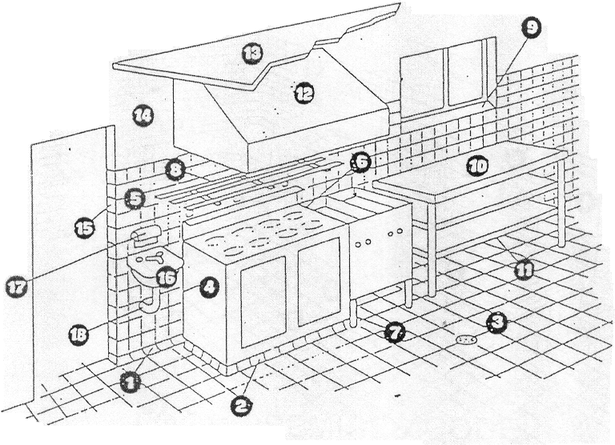
- Floor/wall junction coved to allow cleaning  - Unmovable fixture sealed to floor so that there are no gaps/crevices  - Impervious floor graded & drained to sewer  - Fittings either sealed to wall or allow sufficient clearance for cleaning the wall behind equipment  - Walls tiled with a durable finish to a height that will be subject to regular cleaning  - Gaps sealed between fixtures that cannot be moved  - Clearance under appliance to allow for cleaning flooring underneath  - Open design racks  - Splayed windowsills with clearance above preparation bench to avoid high traffic areas | - Preparation bench – sealed to wall if unable to be moved for cleaning  - Bottom shelf sufficient clearance to allow for cleaning flooring underneath  - Mechanical exhaust ventilation canopy  - Smooth plasterboard ceiling sealed with good quality washable semi-gloss paint  - Smooth plasterboard wall finish above high traffic areas, sealed with good quality washable semi-gloss paint  - Corner in high traffic areas finished with durable finish to withstand impact from trolleys and other equipment  - Hand basin, warm water through a single outlet  - Soap & towel dispenser  - Water & drainage pipes sealed to the wall so there are no gaps or crevices.

5. Typical wash up area diagram
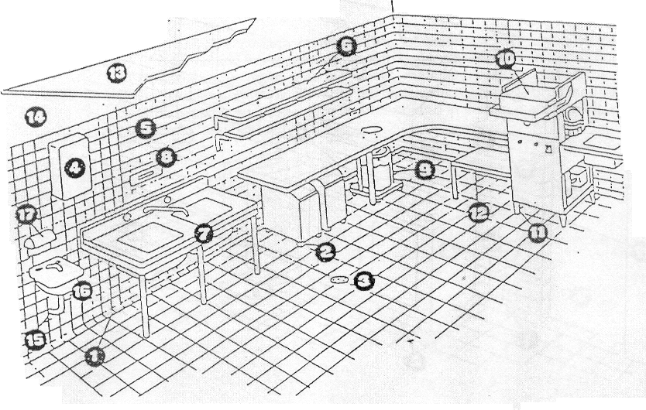
- Floor/wall junction coved to allow cleaning  - Castors to under bench storage containers for ease of movement when cleaning  - Impervious floor graded & drained to sewer  - Hot water heater sealed to wall  - Walls tiled with a durable finish to a height that will be subject to regular cleaning  - Shelving offset from the wall to allow for cleaning  - Double bowl sink – sealed to the wall with clearance to allow for cleaning flooring underneath  - Digital Probe Thermometer  - Garbage receptacle for food waste | - Dishwasher for sanitising equipment  - Legs on equipment provide clearance to allow for cleaning flooring underneath  - Bottom shelf providing clearance to allow for cleaning flooring underneath  - Smooth plasterboard ceiling sealed with good quality washable semi-gloss paint  - Smooth plasterboard wall finish above high traffic areas, sealed with good quality washable semi-gloss paint  - Water & drainage pipes sealed to the wall so there are no gaps or crevices.  - Hand basin with warm water through a single outlet  - Soap and towel dispenser

6. The application and registration process

Step 1. Lodgement of a food business application
Complete the application form and attach a floor plan of the proposed food premises and/or photographs. Include a description about the types of food and processes and attach a copy of your proposed menu. Applications are processed within 30 days from the date you submit.

Step 2. Assessment of application
An Environmental Health Officer (EHO) will contact you within 7 days to acknowledge receipt. The EHO will then assess the information and provide an initial risk classification that applies to the business and whether the proposal is suitable. Further information may be requested. It is recommended that you wait for the assessment before conducting any works or purchasing equipment.

Step 3. Inspection and confirmation of risk classification
An inspection will be arranged with the EHO. You will be advised if the proposal complies with all the requirements. If it does not comply you will be given the option to rectify the issues and arrange a follow up inspection or withdraw the application.

Step 4. Pay fee and decision on registration
When the risk classification is confirmed the registration fee can be paid. Once all necessary inspections have been conducted a decision will be made on registration and a written outcome will be provided to you. If the premises complies with the Food Standards Code you will be granted a Certificate of Registration allowing you to commence trade.

Step 5. Routine inspection and registration requirements
Registered food businesses are subject to routine inspections by an Environmental Health Officer. Food business registration is valid for 12 months. You must submit a renewal application at least 30 days before your registration expires. If you change your business’s name, proprietor details, premises location or sell/close the business you must notify NT Health within 14 days. If you wish to change your food activities or a registration condition you must apply to NT Health prior to changes being made.

https://nt.gov.au/industry/hospitality/accommodation-and-food-businesses/food-safety-and-regulations/market-stalls-and-food-trucks/mobile-food-vehicles
https://www.legislation.gov.au/F2008B00577/latest/text
https://www.foodstandards.gov.au/publications/safefoodaustralia
https://nt.gov.au/property/building/build-or-renovate-your-home/building-and-renovating-permits-and-processes/getting-a-building-permit
https://nt.gov.au/environment/water/water-quality-and-supply/private-water-supply
https://www.powerwater.com.au/developers/water-development/trade-waste
https://nt.gov.au/property/building/health-and-safety/wastewater-management/wastewater-management-codes-and-guidelines
https://nt.gov.au/property/building/contacts/contact-building-advisory-services
https://nt.gov.au/industry/hospitality/accommodation-and-food-businesses/register-food-business
https://nt.gov.au/industry/hospitality/accommodation-and-food-businesses/food-business-registration-fees

