Mineral Titles Act 2010
NOTICE OF LAND CEASING TO BE A MINERAL TITLE AREA
Title Type and Number: | Exploration Licence 24716
Area Ceased on: | 29 November 2023
Area: | 59 Blocks, 187.11 km²
Locality: | JERVOIS RANGE
Name of Applicant(s)/Holder(s): | 100% TERRITORY PHOSPHATE PTY LTD [ACN. 130 065 351]
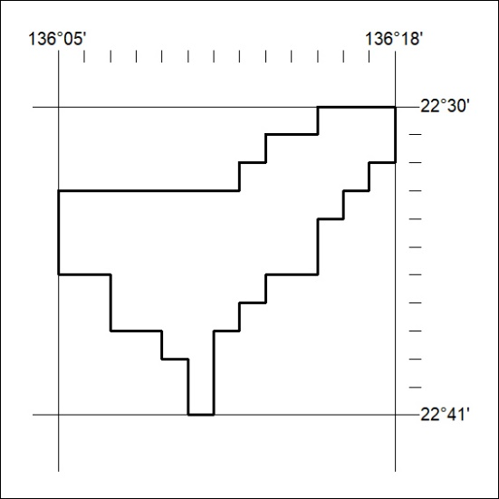

494/23

Mineral Titles Act 2010
NOTICE OF LAND CEASING TO BE A MINERAL TITLE AREA
Title Type and Number: | Exploration Licence 24724
Area Ceased on: | 29 November 2023
Area: | 15 Blocks, 47.57 km²
Locality: | JINKA
Name of Applicant(s)/Holder(s): | 100% TERRITORY PHOSPHATE PTY LTD [ACN. 130 065 351]
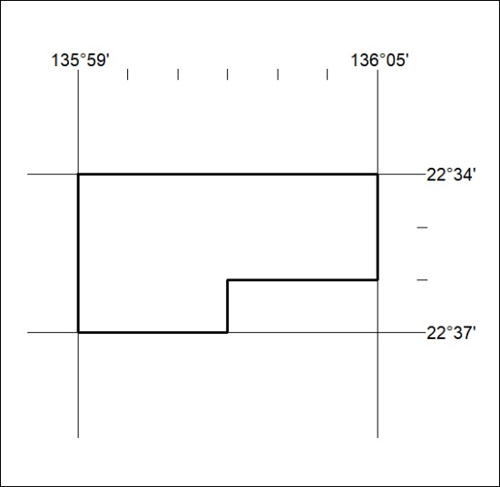

495/23
Mineral Titles Act 2010
NOTICE OF LAND CEASING TO BE A MINERAL TITLE AREA
Title Type and Number: | Exploration Licence 32249
Area Ceased on: | 29 November 2023
Area: | 165 Blocks, 509.88 km²
Locality: | CURTIN
Name of Applicant(s)/Holder(s): | 100% TERRITORY POTASH PTY LTD* [ACN. 116 070 207]
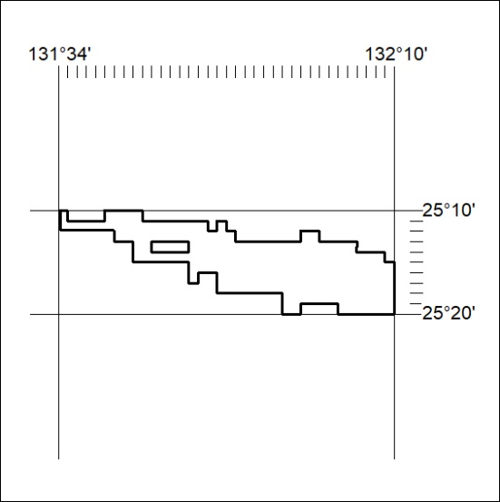

496/23

Mineral Titles Act 2010
NOTICE OF LAND CEASING TO BE A MINERAL TITLE AREA
Title Type and Number: | Exploration Licence 32250
Area Ceased on: | 29 November 2023
Area: | 173 Blocks, 537.05 km²
Locality: | ANGAS
Name of Applicant(s)/Holder(s): | 100% TERRITORY POTASH PTY LTD* [ACN. 116 070 207]
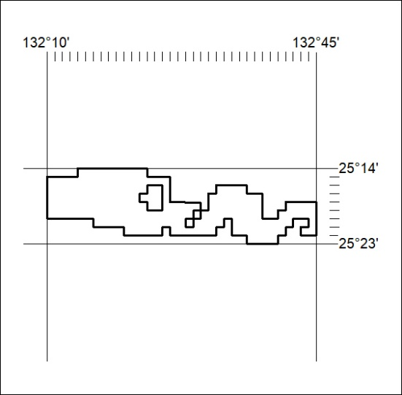

497/23
Mineral Titles Act 2010
NOTICE OF LAND CEASING TO BE A MINERAL TITLE AREA
Title Type and Number: | Exploration Licence 32251
Area Ceased on: | 29 November 2023
Area: | 20 Blocks, 62.08 km²
Locality: | EBENEZER
Name of Applicant(s)/Holder(s): | 100% TERRITORY POTASH PTY LTD* [ACN. 116 070 207]
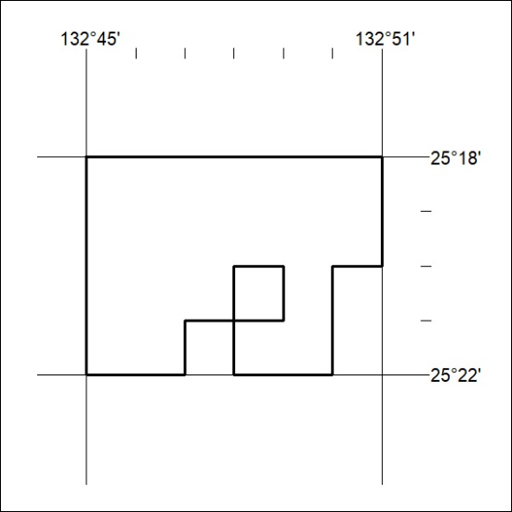

498/23

Mineral Titles Act
NOTICE OF GRANT OF A MINERAL TITLE
Title Type and Number: | Extractive Mineral Permit 33482
Granted: | 28 November 2023, for a period of 5 Years
Area: | 32.00 Hectares
Locality: | LARRIMAH
Name of Holder/s: | 100% TERRITORY SANDS PTY LTD [ACN. 632 797 972]
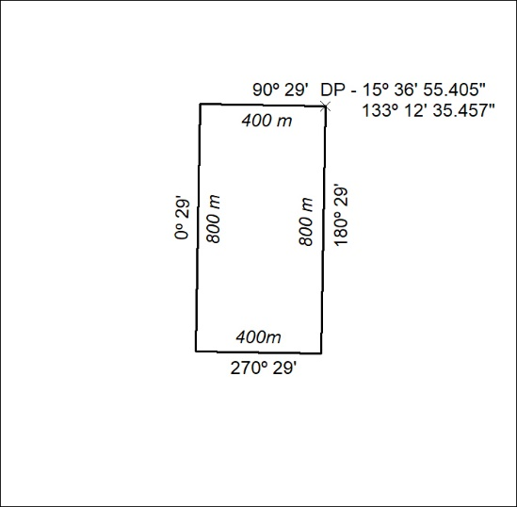

499/23

Mineral Titles Act
NOTICE OF GRANT OF A MINERAL TITLE
Title Type and Number: | Exploration Licence 33467
Granted: | 28 November 2023, for a period of 6 Years
Area: | 101 Blocks, 323.42 km²
Locality: | BLOODWOOD CREEK
Name of Holder/s: | 100% GREEN CRITICAL MINERALS LIMITED* [ACN. 118 788 846]
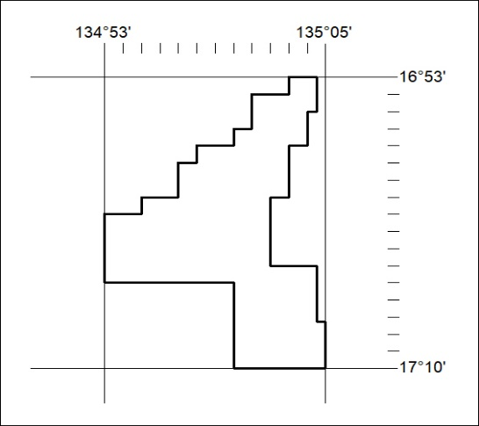
Area granted is indicated above. The titleholder is not permitted to exercise occupational rights on any land that is subject to a development title, or an application for a development title. Any land the subject of a Reserved Land gazettal under the Mineral Titles Act and all land vested in the Commonwealth of Australia is also excluded by description but not excised from the grant area.

500/23

