https://nt.gov.au/__data/assets/pdf_file/0007/1262293/mn089-23.pdfMineral Titles Act
NOTICE OF GRANT OF A MINERAL TITLE
Title Type and Number: | Exploration Licence 33443
Granted: | 08 August 2023, for a period of 6 Years
Area: | 247 Blocks, 784.97 km²
Locality: | HELEN
Name of Holder/s: | 100% PVW TANAMI PTY LTD [ACN. 626 175 586]
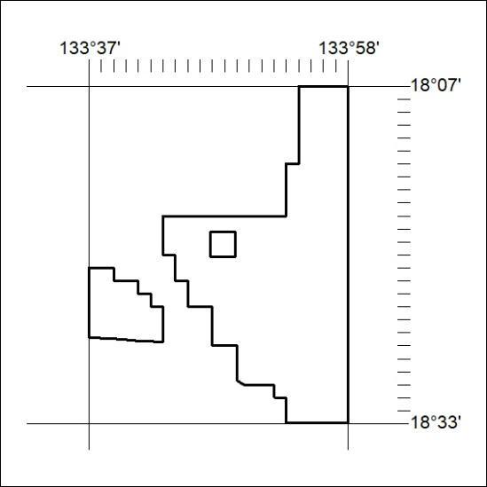
Area granted is indicated above. The titleholder is not permitted to exercise occupational rights on any land that is subject to a development title, or an application for a development title. Any land the subject of a Reserved Land gazettal under the Mineral Titles Act and all land vested in the Commonwealth of Australia is also excluded by description but not excised from the grant area.
336/23

Mineral Titles Act
NOTICE OF GRANT OF A MINERAL TITLE
Title Type and Number: | Exploration Licence 33444
Granted: | 08 August 2023, for a period of 6 Years
Area: | 248 Blocks, 807.45 km²
Locality: | MONMOONA
Name of Holder/s: | 100% PVW TANAMI PTY LTD [ACN. 626 175 586]
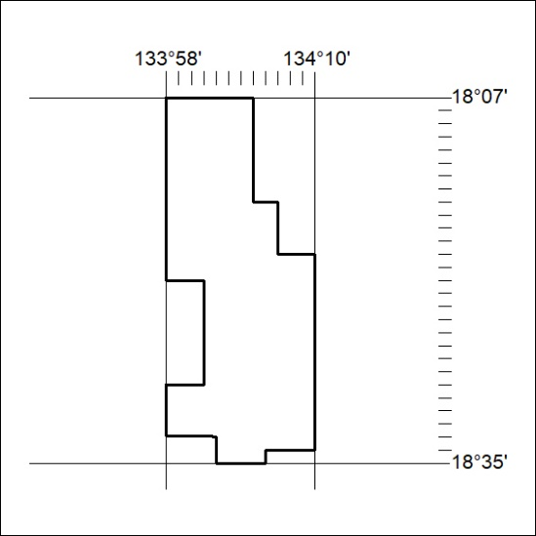
Area granted is indicated above. The titleholder is not permitted to exercise occupational rights on any land that is subject to a development title, or an application for a development title. Any land the subject of a Reserved Land gazettal under the Mineral Titles Act and all land vested in the Commonwealth of Australia is also excluded by description but not excised from the grant area.
337/23

