Mineral Titles Act 2010
NOTICE OF LAND CEASING TO BE A MINERAL TITLE AREA
Title Type and Number: | Exploration Licence 32528
Area Ceased on: | 03 July 2023
Area: | 249 Blocks, 811.18 km²
Locality: | LIMBUNYA
Name of Applicant(s)/Holder(s): | 100% TRANSITION MINERALS LIMITED* [ACN. 641 565 139]
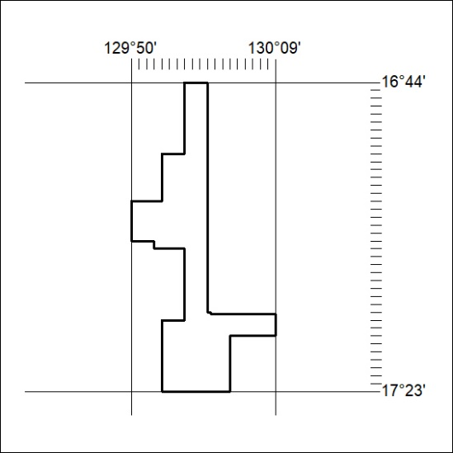

239/23

Mineral Titles Act 2010
NOTICE OF LAND CEASING TO BE A MINERAL TITLE AREA
Title Type and Number: | Exploration Licence 32533
Area Ceased on: | 03 July 2023
Area: | 249 Blocks, 813.27 km²
Locality: | NAPIER
Name of Applicant(s)/Holder(s): | 100% TRANSITION MINERALS LIMITED* [ACN. 641 565 139]
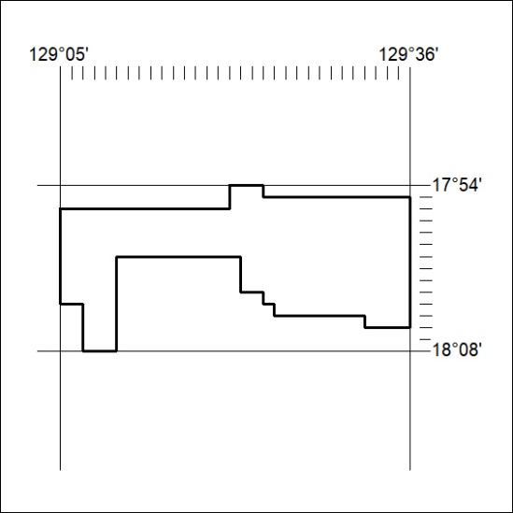

240/23

Mineral Titles Act 2010
NOTICE OF LAND CEASING TO BE A MINERAL TITLE AREA
Title Type and Number: | Exploration Licence 32536
Area Ceased on: | 03 July 2023
Area: | 249 Blocks, 797.62 km²
Locality: | MOUNT BARTON
Name of Applicant(s)/Holder(s): | 100% TRANSITION MINERALS LIMITED* [ACN. 641 565 139]
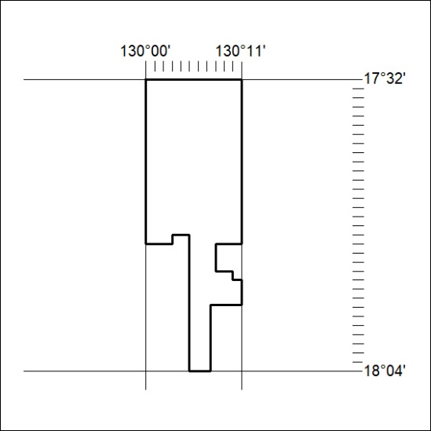

241/23

Mineral Titles Act 2010
NOTICE OF LAND CEASING TO BE A MINERAL TITLE AREA
Title Type and Number: | Exploration Licence 32537
Area Ceased on: | 03 July 2023
Area: | 249 Blocks, 795.03 km²
Locality: | MOUNT BARTON
Name of Applicant(s)/Holder(s): | 100% TRANSITION MINERALS LIMITED* [ACN. 641 565 139]
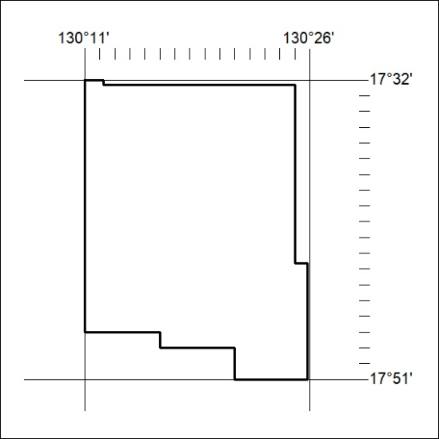

242/23

Mineral Titles Act 2010
NOTICE OF LAND CEASING TO BE A MINERAL TITLE AREA
Title Type and Number: | Exploration Licence 32538
Area Ceased on: | 03 July 2023
Area: | 249 Blocks, 814.75 km²
Locality: | JUNJAMINJI
Name of Applicant(s)/Holder(s): | 100% TRANSITION MINERALS LIMITED* [ACN. 641 565 139]
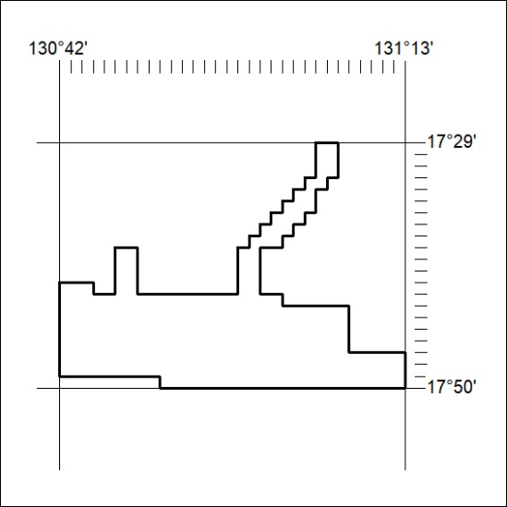

243/23

Mineral Titles Act 2010
NOTICE OF LAND CEASING TO BE A MINERAL TITLE AREA
Title Type and Number: | Exploration Licence 32539
Area Ceased on: | 03 July 2023
Area: | 249 Blocks, 813.83 km²
Locality: | WATSON
Name of Applicant(s)/Holder(s): | 100% TRANSITION MINERALS LIMITED* [ACN. 641 565 139]
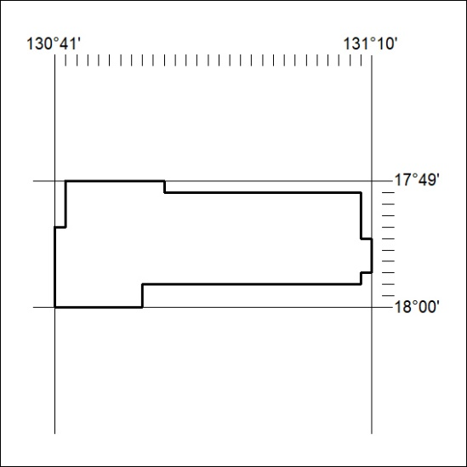

244/23

Mineral Titles Act 2010
NOTICE OF LAND CEASING TO BE A MINERAL TITLE AREA
Title Type and Number: | Exploration Licence 32540
Area Ceased on: | 03 July 2023
Area: | 249 Blocks, 812.44 km²
Locality: | BIRRINDUDU
Name of Applicant(s)/Holder(s): | 100% TRANSITION MINERALS LIMITED* [ACN. 641 565 139]
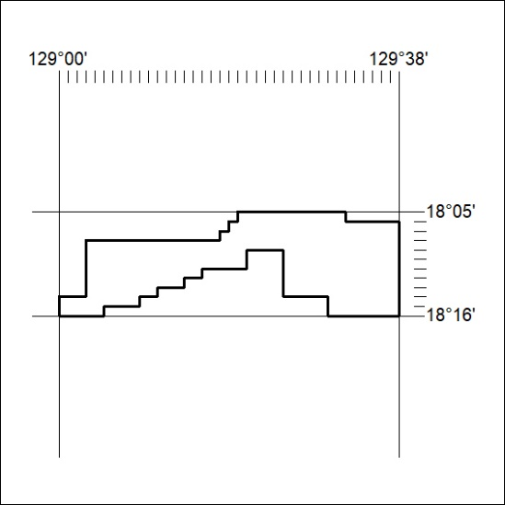

245/23

Mineral Titles Act 2010
NOTICE OF LAND CEASING TO BE A MINERAL TITLE AREA
Title Type and Number: | Exploration Licence 32541
Area Ceased on: | 03 July 2023
Area: | 249 Blocks, 812.13 km²
Locality: | NONGRA
Name of Applicant(s)/Holder(s): | 100% TRANSITION MINERALS LIMITED* [ACN. 641 565 139]
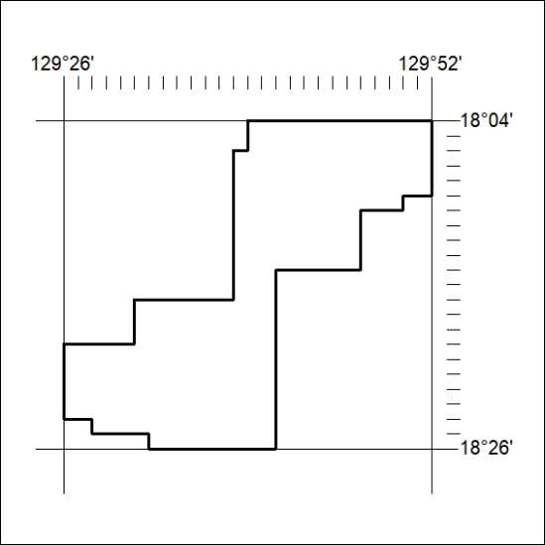

246/23

Mineral Titles Act 2010
NOTICE OF LAND CEASING TO BE A MINERAL TITLE AREA
Title Type and Number: | Exploration Licence 32542
Area Ceased on: | 03 July 2023
Area: | 249 Blocks, 811.09 km²
Locality: | NONGRA
Name of Applicant(s)/Holder(s): | 100% TRANSITION MINERALS LIMITED* [ACN. 641 565 139]
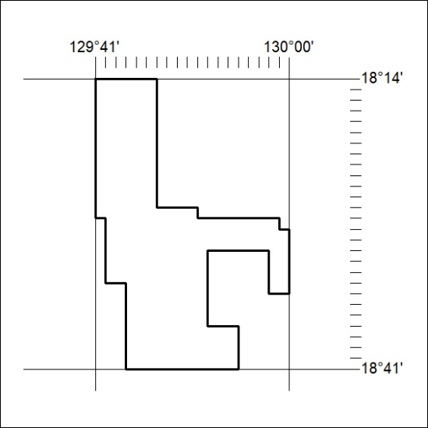

247/23

Mineral Titles Act 2010
NOTICE OF LAND CEASING TO BE A MINERAL TITLE AREA
Title Type and Number: | Exploration Licence 32543
Area Ceased on: | 03 July 2023
Area: | 249 Blocks, 813.89 km²
Locality: | INVERWAY
Name of Applicant(s)/Holder(s): | 100% TRANSITION MINERALS LIMITED* [ACN. 641 565 139]
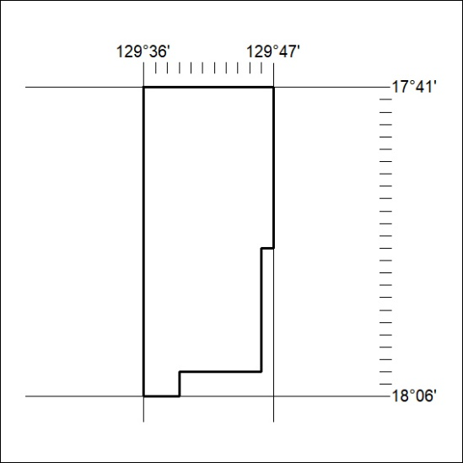

248/23

Mineral Titles Act
NOTICE OF GRANT OF A MINERAL TITLE
Title Type and Number: | Exploration Licence 33359
Granted: | 30 June 2023, for a period of 6 Years
Area: | 28 Blocks, 88.58 km²
Locality: | AILERON
Name of Holder/s: | 100% HANN PROSPECTING PTY LTD [ACN. 644 958 547]
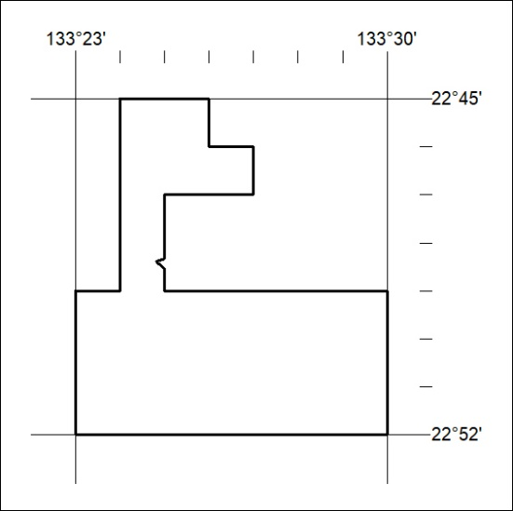
Area granted is indicated above. The titleholder is not permitted to exercise occupational rights on any land that is subject to a development title, or an application for a development title. Any land the subject of a Reserved Land gazettal under the Mineral Titles Act and all land vested in the Commonwealth of Australia is also excluded by description but not excised from the grant area.

249/23

