Mineral Titles Act 2010
NOTICE OF LAND CEASING TO BE A MINERAL TITLE AREA
Title Type and Number: | Exploration Licence 32051
Area Ceased on: | 28 June 2023
Area: | 161 Blocks, 521.19 km²
Locality: | NONGRA
Name of Applicant(s)/Holder(s): | 100% OAKAJEE EXPLORATION PTY LTD [ACN. 629 544 912]
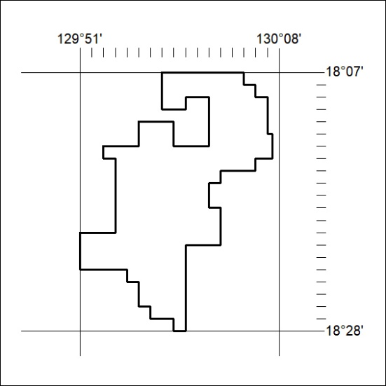

231/23

Mineral Titles Act 2010
NOTICE OF LAND CEASING TO BE A MINERAL TITLE AREA
Title Type and Number: | Exploration Licence 32052
Area Ceased on: | 14 November 2022
Area: | 69 Blocks, 184.93 km²
Locality: | MT WINNECKE
Name of Applicant(s)/Holder(s): | 100% OAKAJEE EXPLORATION PTY LTD [ACN. 629 544 912]
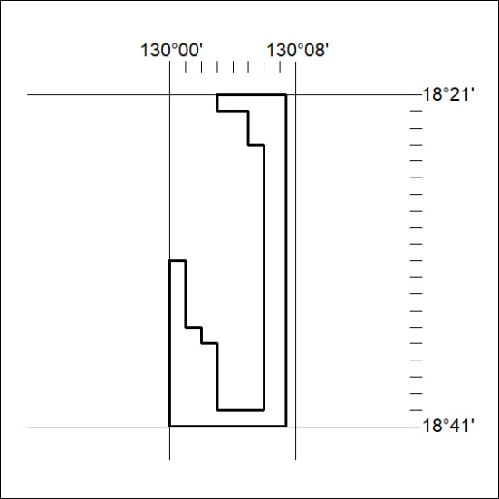

232/23

Mineral Titles Act 2010
NOTICE OF LAND CEASING TO BE A MINERAL TITLE AREA
Title Type and Number: | Exploration Licence 32939
Area Ceased on: | 28 June 2023
Area: | 75 Blocks, 236.59 km²
Locality: | DOREEN
Name of Applicant(s)/Holder(s): | 100% KURSK ENERGY PTY LTD [ACN. 654 105 414]
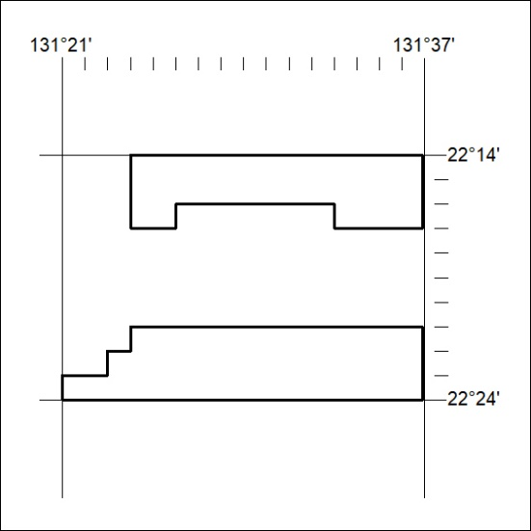

233/23

Mineral Titles Act 2010
NOTICE OF LAND CEASING TO BE A MINERAL TITLE AREA
Title Type and Number: | Exploration Licence 32940
Area Ceased on: | 28 June 2023
Area: | 25 Blocks, 79.47 km²
Locality: | VAUGHAN
Name of Applicant(s)/Holder(s): | 100% KURSK ENERGY PTY LTD [ACN. 654 105 414]
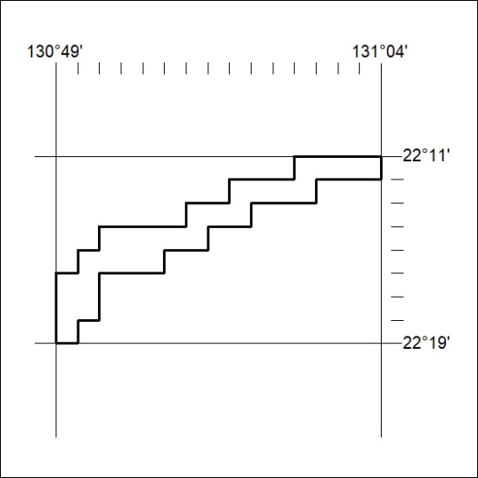

234/23

