Mineral Titles Act 2010
NOTICE OF LAND CEASING TO BE A MINERAL TITLE AREA
Title Type and Number: | Extractive Mineral Permit 31644
Area ceased on: | 23 May 2023
Area: | 22.00 Hectare
Locality: | KOOLPINYAH
Name of Applicants(s)Holder(s): | 100% MOUSELLIS & SONS PTY. LTD. [ACN. 009 654 791]
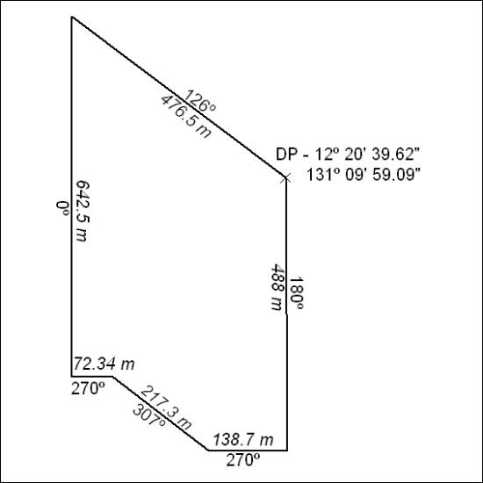

163/23

Mineral Titles Act 2010
NOTICE OF LAND CEASING TO BE A MINERAL TITLE AREA
Title Type and Number: | Extractive Mineral Permit 31645
Area ceased on: | 23 May 2023
Area: | 42.00 Hectare
Locality: | KOOLPINYAH
Name of Applicants(s)Holder(s): | 100% MOUSELLIS & SONS PTY. LTD. [ACN. 009 654 791]
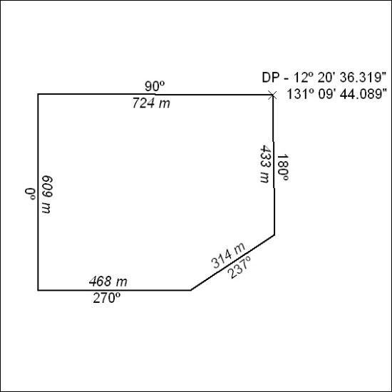

164/23

Mineral Titles Act 2010
NOTICE OF LAND CEASING TO BE A MINERAL TITLE AREA
Title Type and Number: | Extractive Mineral Permit 31661
Area ceased on: | 23 May 2023
Area: | 17.00 Hectare
Locality: | KOOLPINYAH
Name of Applicants(s)Holder(s): | 100% MOUSELLIS & SONS PTY. LTD. [ACN. 009 654 791]
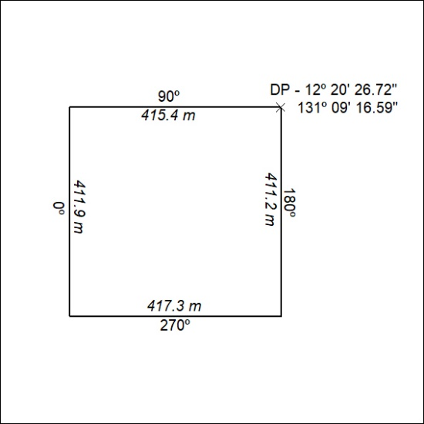

165/23

Mineral Titles Act
NOTICE OF GRANT OF A MINERAL TITLE
Title Type and Number: | Exploration Licence 33144
Granted: | 24 May 2023, for a period of 6 Years
Area: | 98 Blocks, 308.81 km²
Locality: | QUARTZ
Name of Holder/s: | 100% COPPEROZ PTY LTD [ACN. 603 957 124]
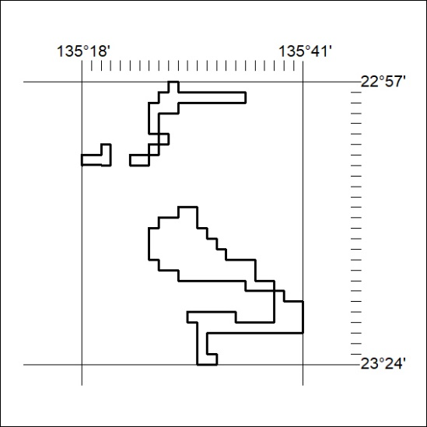
Area granted is indicated above. The titleholder is not permitted to exercise occupational rights on any land that is subject to a development title, or an application for a development title. Any land the subject of a Reserved Land gazettal under the Mineral Titles Act and all land vested in the Commonwealth of Australia is also excluded by description but not excised from the grant area.

166/23

