Mineral Titles Act 2010
NOTICE OF LAND CEASING TO BE A MINERAL TITLE APPLICATION AREA
Title Type and Number: | Exploration Licence 27664
Area Ceased on: | 28 April 2023
Area: | 425 Blocks, 1430.74 km²
Locality: | JAHLEEL
Name of Applicant(s)/Holder(s): | 100% RIO TINTO EXPLORATION PTY LIMITED [ACN. 000 057 125]
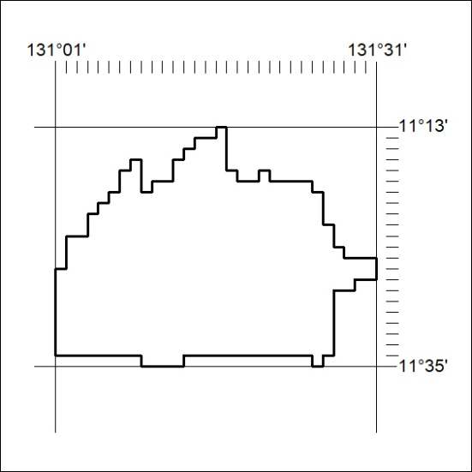

116/23

Mineral Titles Act 2010
NOTICE OF LAND CEASING TO BE A MINERAL TITLE APPLICATION AREA
Title Type and Number: | Exploration Licence 28617
Area Ceased on: | 28 April 2023
Area: | 429 Blocks, 1387.68 km²
Locality: | SNAKE BAY
Name of Applicant(s)/Holder(s): | 100% RIO TINTO EXPLORATION PTY LIMITED [ACN. 000 057 125]
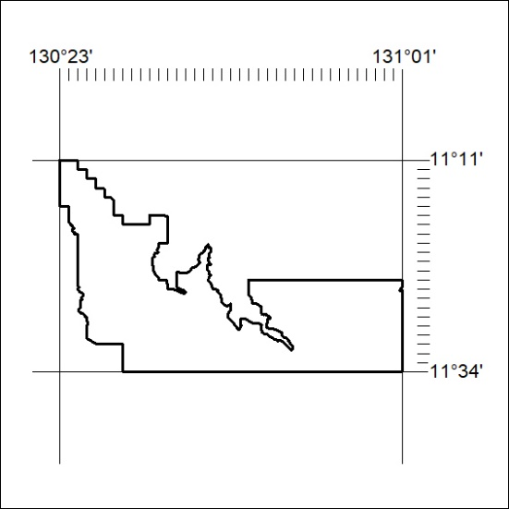

117/23
Mineral Titles Act 2010
NOTICE OF LAND CEASING TO BE A MINERAL TITLE APPLICATION AREA
Title Type and Number: | Exploration Licence 29244
Area Ceased on: | 28 April 2023
Area: | 142 Blocks, 477.31 km²
Locality: | MELVILLE
Name of Applicant(s)/Holder(s): | 100% RIO TINTO EXPLORATION PTY LIMITED [ACN. 000 057 125]
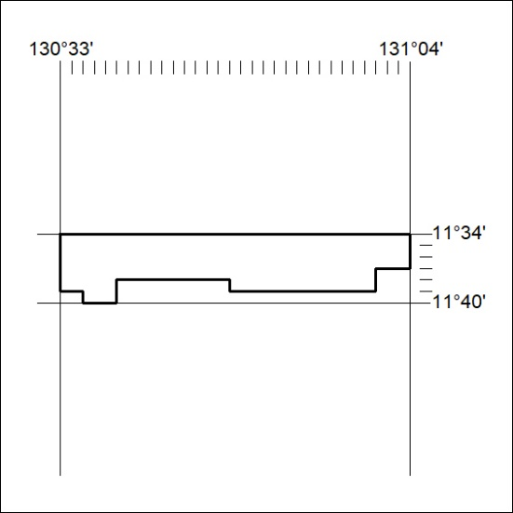

118/23

Mineral Titles Act 2010
NOTICE OF LAND CEASING TO BE A MINERAL TITLE AREA
Title Type and Number: | Exploration Licence 32241
Area Ceased on: | 28 April 2023
Area: | 52 Blocks, 164.79 km²
Locality: | MURRAY DOWNS
Name of Applicant(s)/Holder(s): | 100% KALK EXPLORATION PTY LTD [ACN. 634 749 429]
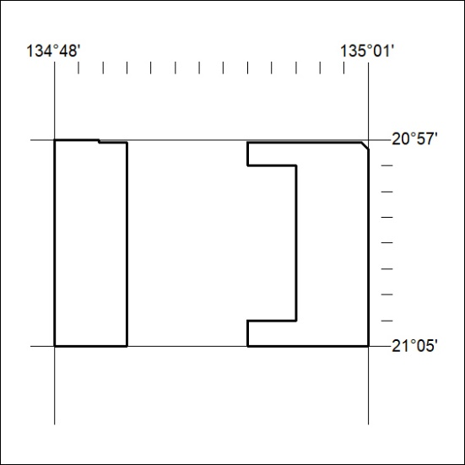

119/23

