Mineral Titles Act 2010
NOTICE OF LAND CEASING TO BE A MINERAL TITLE APPLICATION AREA
Title Type and Number: | Exploration Licence 33299
Area Ceased on: | 20 February 2023
Area: | 12 Blocks, 37.09 km²
Locality: | FERGUSSON RANGE
Name of Applicant(s)/Holder(s): | 100% GEMPART (NT) PTY LTD* [ACN. 081 859 896]
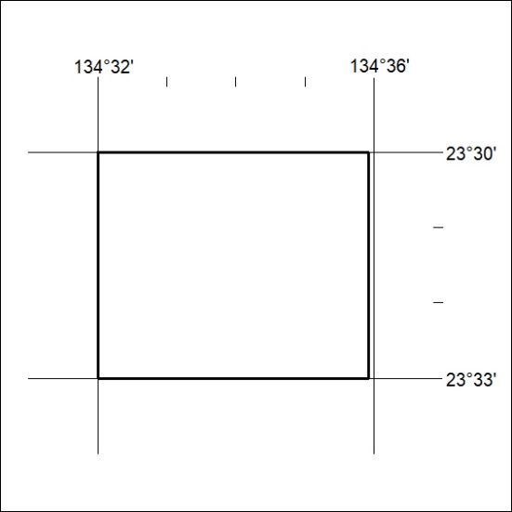

041/23

