  - Information Bulletin

Introduction
In the Northern Territory, it has been recognised that non-compliance with the minimum tow coupling height requirements was common with step deck type trailers, where, by design and necessity, the fitment of the drawbar-type coupling would not meet the minimum height requirement and require an exemption.

Purpose
The purpose of this bulletin is to clarify the conditions of the exemption (refer Attachment – Gazette Notice G50, 2020) offered to operators of a road train vehicle and the heavy vehicle industry, to ensure the requirements of the exemption are complied with.

Compliance with the Conditions of the Exemption

Exempt Class
The exemption applies to the ‘Exempt Class’ which means that an individual permit of exemption is not required for each operator of a road train vehicle with a rear drawbar-type coupling.
Rather, a vehicle which satisfies all of the following criteria is within the exempt class:
- the vehicle is a “road train” (as defined in Item 2 of the Schedule); and
- the vehicle is fitted with a “rear drawbar-type coupling” (as defined in Item 2 of the Schedule); and
- the rear drawbar-type coupling fitted to the vehicle is built and positioned so:
- it is at a height of at least 600 millimetres, but not over 950 millimetres, from the ground, when the vehicle is unloaded and parked on level ground; and
- when the vehicle is moving, the drawbar can move at least 15 degrees upwards or downwards from the position it occupies when the road train is parked on level ground.

Note, refer to the Defined Terms section of this Vehicle Information Bulletin for relevant definitions.

Determining the height of the drawbar-type coupling
To determine the height of the drawbar-type coupling from the ground, the road train must be unloaded and parked on level ground. The points of measurement should be from the middle of the drawbar-type coupling to the ground.
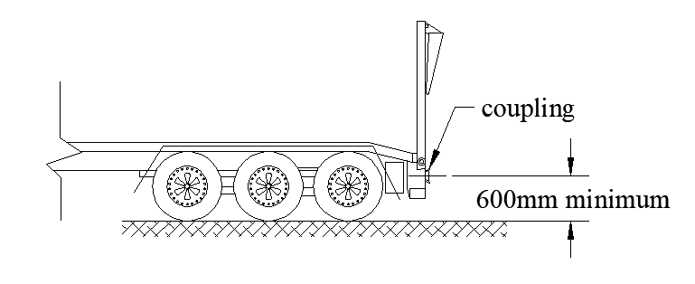
This measurement should be of a height of at least 600 millimetres, but not over a height of 950 millimetres from the ground, in order to be compliant and deemed a vehicle in the Exempt Class, for the purposes of the exemption.
The lower minimum tow coupling height of 600 millimetres was ascertained through a review of manufacturer tow coupling design and the range of movement which the couplings catered for had sufficient movement for the drawbar eye to move in an upwards and downwards direction. The design of the tow couplings combined with the correct dolly drawbar length, ensures national fleet safety, interchangeability of the vehicle combination components and distribution of dynamic forces evenly through the trailer, drawbar and couplings.

Determining whether the drawbar will be able to move at least 15 degrees
In order to determine whether, while the road train is moving, the drawbar will be capable of moving at least 15 degrees upwards or downwards from the position it occupies when the road train is parked on level ground, the following factor can be used as a guide:
- A common drawbar-type coupling provides an opening of at least 20 degrees.
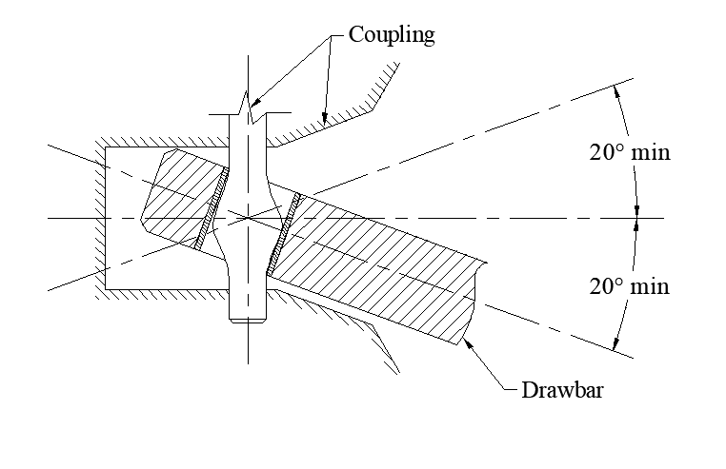
- If a drawbar-type coupling of this design is used, the drawbar angle must be substantially level (i.e. no more than ± 5 degrees to the horizontal) when the combination is parked on level ground. The drawbar being substantially level when parked on level ground, will allow the drawbar to move at least 15 degrees upwards or downwards from this position, when the road train is moving.
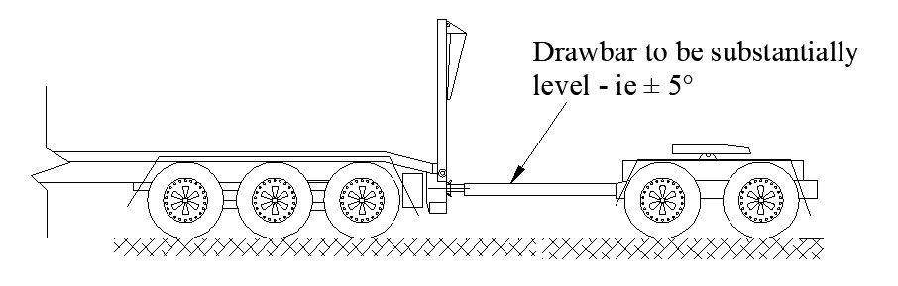
- If a drawbar-type coupling has an opening measurement of more than 20 degrees, the drawbar angle may be slightly more than substantially level (i.e. more than ± 5 degrees to the horizontal), as the wide opening of the coupling may still allow the drawbar to move at least 15 degrees upwards or downwards from this position, when the road train is moving.

Pivot point position of the drawbar-type coupling
The pivot point of the coupling can be over 300 millimetres forward of the rear of the trailer to which it is attached, however there should be discretion by the operator with regard to this positioning, to ensure that when the road train is moving, the drawbar can move at least 15 degrees upwards or downwards from the position it occupies when the road train is parked on level ground.
Historically, the requirement of 300 millimetres forward of the rear of the trailer, was to ensure the work, health and safety of operators connecting vehicle combinations. Removing this requirement is not deemed to have any major safety concerns. However, will improve the dynamic performance of a combination allowing the coupling to be closer to the rear axle.

Defined terms
- Australian Design Rule 63/00 is a third edition ADR of that number which applies to the vehicle pursuant to rule 20 of Schedule 6 of the Motor Vehicles (Standards) Regulations 2003.
- Converter dolly means a trailer with 1 axle group or single axle, and a fifth wheel coupling, designed to convert a semi-trailer into a dog trailer.
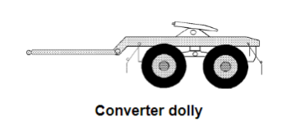

- Dog trailer means a trailer (including a trailer consisting of a semi-trailer and converter dolly) with, 1 axle group or a single axle at the front that is steered by connection to the towing vehicle by and drawbar, and 1 axle group or single axle at the rear.
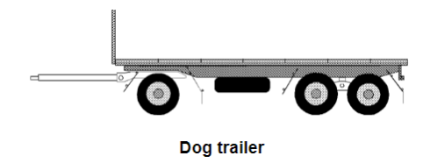
- Drawbar means a part of a trailer (except a semi-trailer) connecting the trailer body to a coupling for towing purposes.
- Semi-trailer means a trailer (including a pole-type trailer) that has 1 axle group or single axle to the rear and a means of attachment to the prime mover that results in some of the load being imposed on the prime mover.
- rear drawbar-type coupling means a drawbar-type tow coupling at the rear of the vehicle, which is designed to be connected to the drawbar of a converter dolly or a dog trailer (as defined in Schedule 6 of the Motor Vehicles (Standards) Regulations 2003).
- road train means a vehicle which:
- has a vehicle plate affixed to it displaying the words “ROAD TRAIN” in accordance with the requirements under –
- the Motor Vehicle Standards Act 1989 (Cth); or
- the Road Vehicle Standards Act 2018 (Cth); or
- has a modification plate affixed to it displaying the code “S8” or “S11” in accordance with the requirements under the heavy vehicle modification scheme in the state or territory where the modification plate was affixed.

References
- Australian Vehicle Standards Rules - Rule 20 – Compliance with third edition Australian Design Rules (ADR) specific to ADR 63.5.1.2 Tow Coupling Height and ADR 63.5.1.3 Coupling Pivot Positioning – all other requirements under rule 20 must be complied with.
- Australian Vehicle Standards Rules - Rule 169 – Attachment of couplings and drawbar eyes on road trains.

More information
For more information, contact the department on 08 8924 7157 or email vehiclestandards.mvr@nt.gov.au

Attachment – the Northern Territory Gazette No. G50, 16 December 2020 (copy)

NORTHERN TERRITORY OF AUSTRALIA

Motor Vehicles Act 1949
Road Train – Tow Coupling Height and Coupling Pivot Positioning Exemption

I, SIMON PHILLIP SAUNDERS, Registrar of Motor Vehicles, under section 59(2) of the Motor Vehicles Act 1949, exempt the class of vehicles identified in Item 1 of the Schedule to this instrument from the requirements of rule 169 of Schedule 6 of the Motor Vehicles (Standards) Regulations 2003; and from the requirements of clauses 63.5.1.2 and 63.5.1.3 of Australian Design Rule 63/00 (as defined in Item 2 of the Schedule to this instrument).

Dated 2 December 2020
S.P. Saunders
Registrar of Motor Vehicles

Schedule

- Exempt Class. A vehicle which satisfies all of the following criteria is within the exempt class:
- the vehicle is a “road train” (as defined in Item 2 of this Schedule); and
- the vehicle is fitted with a “rear drawbar-type coupling” (as defined in Item 2 of this Schedule); and
- the rear drawbar-type coupling fitted to the vehicle is built and positioned so:
      - it is at a height of at least 600 millimetres, but not over 950 millimetres, from the ground, when the vehicle is unloaded and parked on level ground; and
      - when the vehicle is moving, the drawbar can move at least 15 degrees upwards or downwards from the position it occupies when the road train is parked on level ground.
- Defined terms. In this instrument:
- Australian Design Rule 63/00 is a third edition ADR of that number which applies to the vehicle pursuant to rule 20 of Schedule 6 of the Motor Vehicles (Standards) Regulations 2003.
- rear drawbar-type coupling means a drawbar-type tow coupling at the rear of the vehicle, which is designed to be connected to the drawbar of a converter dolly or a dog trailer (as defined in Schedule 6 of the Motor Vehicles (Standards) Regulations 2003).
- road train means a vehicle which:
- has a vehicle plate affixed to it displaying the words “ROAD TRAIN” in accordance with the requirements under –
- the Motor Vehicle Standards Act 1989 (Cth); or
- the Road Vehicle Standards Act 2018 (Cth); or
    - has a modification plate affixed to it displaying the code “S8” or “S11” in accordance with the requirements under the heavy vehicle modification scheme in the state or territory where the modification plate was affixed.

